Campbell Essential Biology (w/ Physiology chapters), 7e (Simon)
Chapter 1 Learning About Life

1.1 Multiple Choice Questions

1) In what way(s) is the science of biology related to our society?
A) by helping us understand the genetics of our pets
B) by examining the importance of biodiversity
C) through the study of green energy
D) all of the answers are correct
Answer: D
Topic: Biology and Society
Skill: Remember/Understand
Learning Outcome: 1.1
Global LO: 5, 7

2) What is biology?
A) the scientific study of life
B) the scientific study of the environment
C) the scientific study of DNA
D) the scientific study of ecosystems
Answer: A
Topic: Biology and Society
Skill: Remember/Understand
Learning Outcome: 1.2

3) Which function is NOT a property of life?
A) Populations of organisms rarely change over time.
B) Living things exhibit complex but ordered organization.
C) Organisms take in energy and use it to perform all of life's activities.
D) Organisms reproduce their own kind.
Answer: A
Topic: 1.2 The Properties of Life
Skill: Remember/Understand
Learning Outcome: 1.5
Global LO: 7

4) What are the two main processes upon which ecosystems depend?
A) speciation and evolution
B) nutrient recycling and energy flow
C) decomposition and nutrient recycling
D) sunlight and photosynthesis
Answer: B
Topic: 1.3 Major Themes in Biology
Skill: Remember/Understand
Learning Outcome: 1.12
5) Which substance is NOT recycled but rather is lost from ecosystems?
A) nitrogen
B) energy
C) magnesium
D) carbon
Answer: B
Topic: 1.3 Major Themes in Biology
Skill: Remember/Understand
Learning Outcome: 1.12

6) Which structure can perform all the activities required for life?
A) DNA molecules
B) cells
C) organelles
D) nuclei
Answer: B
Topic: 1.3 Major Themes in Biology
Skill: Remember/Understand
Learning Outcome: 1.13

7) What name is given to the functional compartments of a cell?
A) genomes
B) nuclei
C) genes
D) organelles
Answer: D
Topic: 1.3 Major Themes in Biology
Skill: Remember/Understand
Learning Outcome: 1.13

8) What are genes composed of?
A) insulin
B) organelles
C) tissues
D) DNA
Answer: D
Topic: 1.3 Major Themes in Biology
Skill: Remember/Understand
Learning Outcome: 1.11

9) What is a gene?
A) a type of cell
B) an organelle that houses DNA
C) a type of hormone
D) a unit of inheritance
Answer: D
Topic: 1.3 Major Themes in Biology
Skill: Remember/Understand
Learning Outcome: 1.11
10) Which concept was proposed by Darwin?
A) energy flow
B) ecosystem structure
C) ocean warming
D) natural selection
Answer: D
Topic: 1.3 Major Themes in Biology
Skill: Remember/Understand
Learning Outcome: 1.8

11) Which of these is required for natural selection to occur?
A) inheritance
B) unequal reproductive success
C) individual variation
D) all of the answers are correct
Answer: D
Topic: 1.3 Major Themes in Biology
Skill: Remember/Understand
Learning Outcome: 1.9

12) What does "adaptation" mean in an evolutionary context?
A) the way an individual's body adjusts to its environment
B) the accumulation of favorable variations in a population over time
C) the ability of organisms to alter their appearance under changing environmental conditions
D) all of the answers are correct
Answer: B
Topic: 1.3 Major Themes in Biology
Skill: Remember/Understand
Learning Outcome: 1.8
Global LO: 7

13) What process accounts for the different breeds of domesticated dogs?
A) overproduction
B) natural selection
C) competition
D) artificial selection
Answer: D
Topic: 1.3 Major Themes in Biology
Skill: Remember/Understand
Learning Outcome: 1.9
Global LO: 5

14) Over a span of two decades in the 1900s, scientists measured changes in the beak size of a population of Galápagos ground finches. These data could provide ________.
A) evidence of natural selection in action.
B) an example of artificial selection.
C) an example of overproduction.
D) evidence used by Darwin for his theory of evolution
Answer: A
Topic: 1.3 Major Themes in Biology
Skill: Evaluate/Create
Learning Outcome: 1.9
15) Science is ________.
A) the inquiry-based effort to describe and explain nature
B) the search for truth
C) an organized set of principles for how to behave ethically and morally
D) all of the answers are correct
Answer: A
Topic: 1.1 The Scientific Study of Life
Skill: Remember/Understand
Learning Outcome: 1.2
Global LO: 1

16) Which of these statements is CORRECT?
A) Scientific ideas are subjected to repeated testing.
B) Science can be used to prove or disprove the idea that deities or spirits cause earthquakes and other natural disasters.
C) Science does not require observations that other people can confirm.
D) Only exploratory science can lead to important conclusions about nature.
Answer: A
Topic: 1.1 The Scientific Study of Life
Skill: Remember/Understand
Learning Outcome: 1.2
Global LO: 1

17) Which statement is a valid scientific hypothesis?
A) Human history is determined by a series of supernatural events.
B) Humans should help in the conservation of other animal species.
C) Humans are controlled by forces beyond our understanding.
D) Humans and bacteria share a common genetic code.
Answer: D
Topic: 1.1 The Scientific Study of Life
Skill: Apply/Analyze
Learning Outcome: 1.3
Global LO: 1, 2

18) A hypothesis is a(n) ________.
A) a proposed explanation for a set of observations
B) guess made in order to determine what observations and explorations are necessary
C) observation made in order to determine a theory
D) theory determined after data collection
Answer: A
Topic: 1.1 The Scientific Study of Life
Skill: Remember/Understand
Learning Outcome: 1.3
Global LO: 1
19) You try to start your car, but it does not start. Which of these is a prediction?
A) My car's battery is dead.
B) If I recharge the battery, then my car will start.
C) My car is too old to function properly.
D) What is wrong with my car?
Answer: B
Topic: 1.1 The Scientific Study of Life
Skill: Apply/Analyze
Learning Outcome: 1.2
Global LO: 1, 2

20) Which sequence shows the steps of the process of science in an order in which they might occur?
A) experiment, conclusion, exploration, application
B) question, observation, experiment, analysis, prediction
C) exploration, hypothesis, prediction, experiment
D) exploration, question, opinion, conclusion, hypothesis
Answer: C
Topic: 1.1 The Scientific Study of Life
Skill: Remember/Understand
Learning Outcome: 1.2

21) How do hypotheses differ from theories?
A) Theories are more comprehensive than hypotheses.
B) Theories must be testable; hypotheses do not need to be testable.
C) Hypotheses are educated guesses, and theories are tentative explanations.
D) Hypotheses are derived from experimentation, whereas theories are derived from observation.
Answer: A
Topic: 1.1 The Scientific Study of Life
Skill: Remember/Understand
Learning Outcome: 1.3
Global LO: 1

22) Antibiotic resistance evolves in bacteria when ________.
A) the presence of antibiotics favors bacteria that already have genes for resistance
B) farmers do not use enough antibiotics in animal feed
C) the antibiotics create resistance genes in bacteria
D) the bacteria realize that they need to avoid the antibiotic
Answer: A
Topic: 1.3 Major Themes in Biology
Skill: Remember/Understand
Learning Outcome: 1.9
Global LO: 5
23) Which information flow is disrupted when diabetes destroys insulin-producing cells?
A) The body is unable to respond to signals that indicate the amount of glucose in the blood.
B) Cells in the bladder are no longer able to send signals when the bladder fills.
C) The pancreas is unable to produce enzymes to break down proteins.
D) Appetite signals no longer regulate feeding.
Answer: A
Topic: 1.3 Major Themes in Biology
Skill: Remember/Understand
Learning Outcome: 1.11

24) Information flow in biological systems is necessary for negative (regulative) feedback to operate. Which of these examples does NOT involve flow of information providing feedback?
A) Heat receptors send signals to promote sweating.
B) Low blood sugar causes the liver to convert starch to sugar to be released in the blood.
C) Drought kills many trees.
D) Bacterial genes for breaking down lactose are activated in the presence of lactose.
Answer: C
Topic: 1.3 Major Themes in Biology
Skill: Evaluate/Create
Learning Outcome: 1.11
Global LO: 2, 7

25) Which results should occur if climate change leads to increased warming global temperatures?
A) Species competition will result in slower evolution in the tropics.
B) The tree line (at which it is too cold for trees to grow) moves toward the north and south poles.
C) Winters will be longer toward the poles.
D) Land animals will suffer fewer consequences than marine animals.
Answer: B
Topic: 1.3 Major Themes in Biology
Skill: Evaluate/Create
Learning Outcome: 1.13
Global LO: 2, 5, 7
1.2 Art Questions

1) This figure shows the branching tree of life for bears. Which bear species is most distantly related to the sun bear?

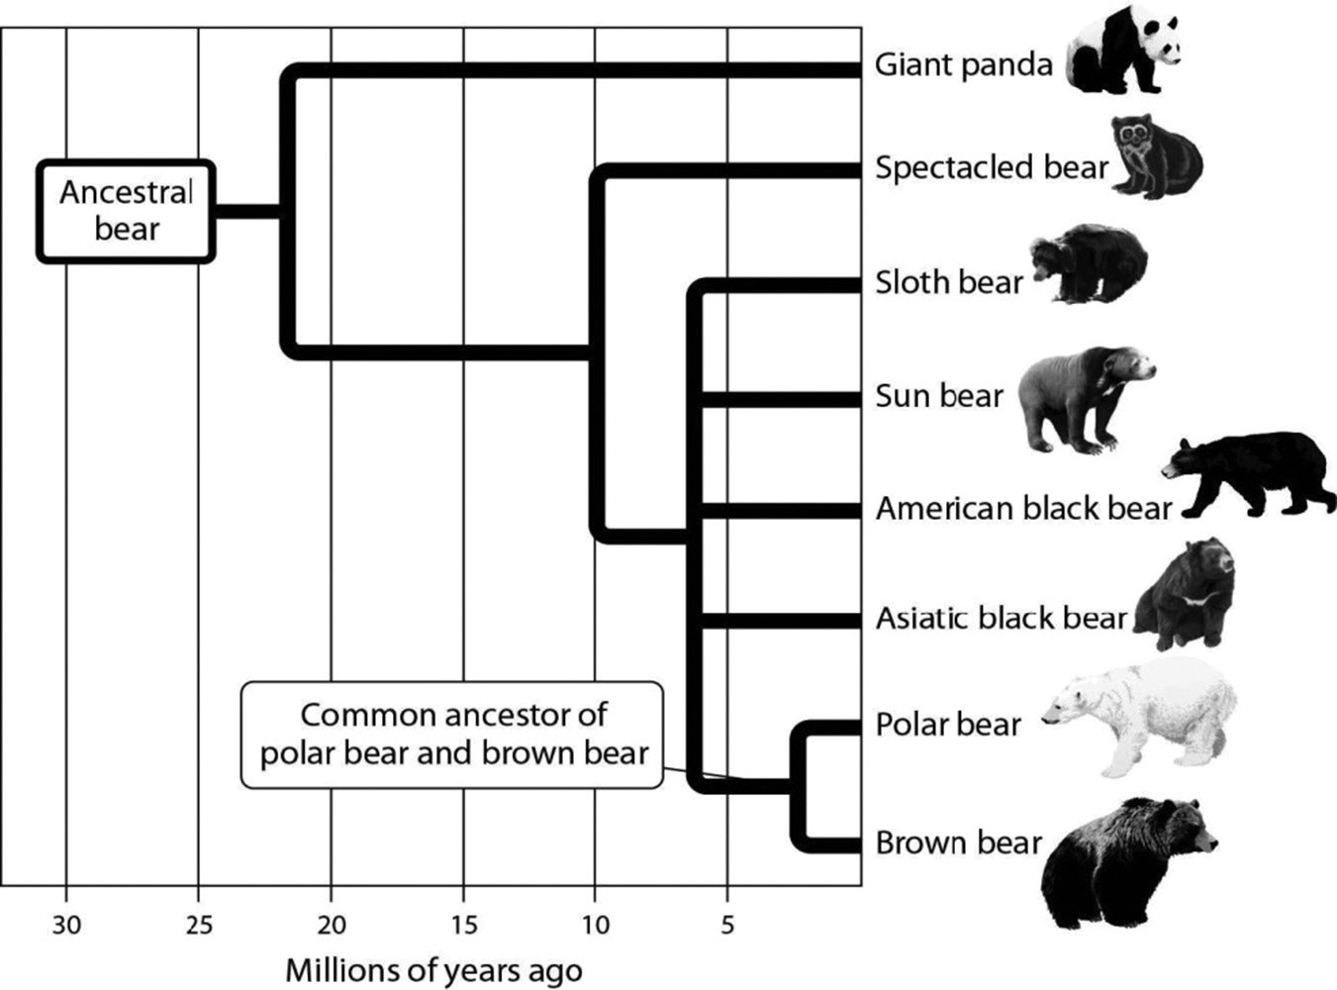

A) brown bear
B) sloth bear
C) spectacled bear
D) giant panda
Answer: D
Topic: Evolution Connection: Swimming with the Turtles
Skill: Evaluate/Create
Learning Outcome: 1.4
Global LO: 2, 3
2) In the process of evolution by natural selection illustrated in this figure, what is the mechanism or agent of natural selection?

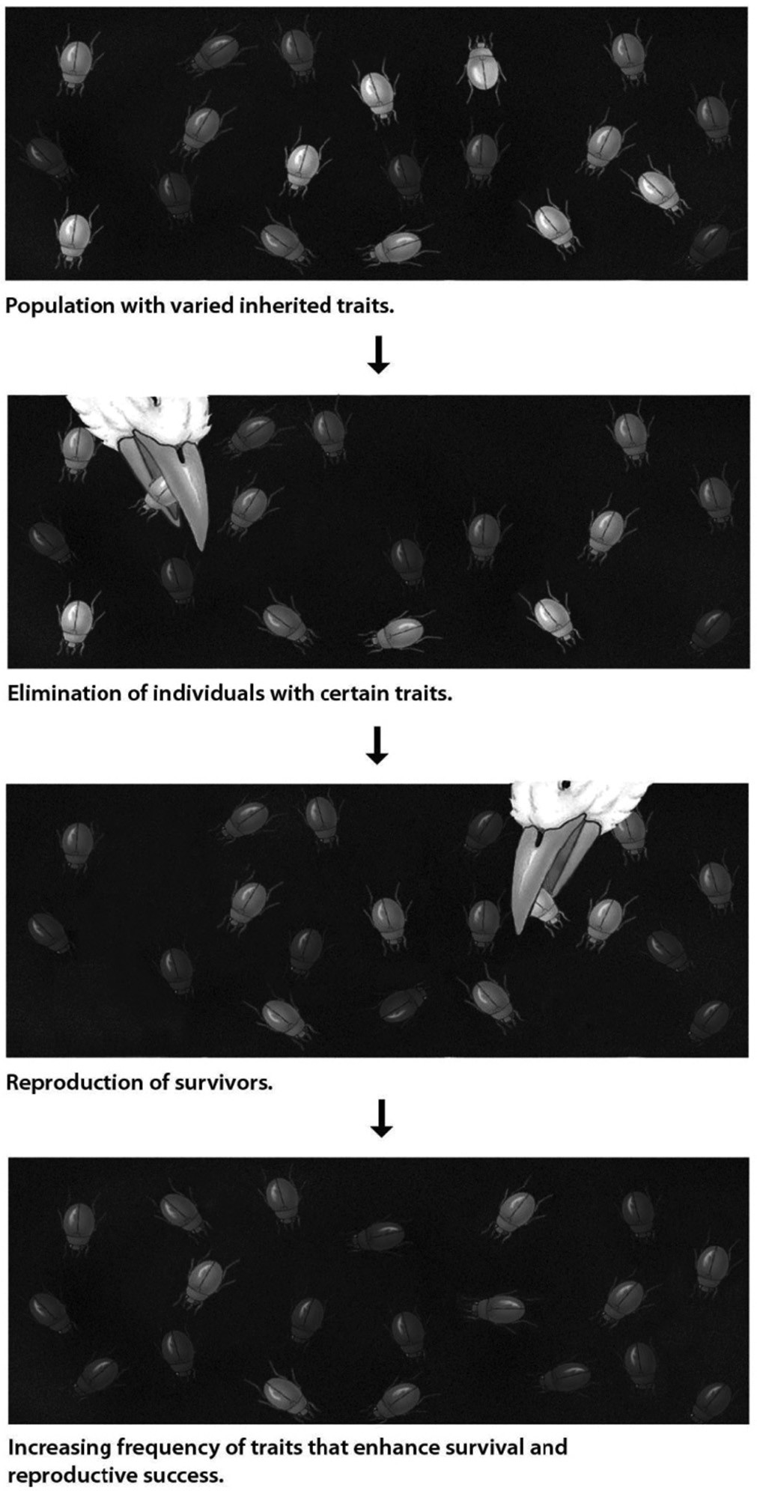

A) artificial selection
B) selective breeding
C) selective predation
D) genetic drift
Answer: C
Topic: 1.3 Major Themes in Biology
Skill: Apply/Analyze
Learning Outcome: 1.9
Global LO: 2
1.3 Scenario Questions

Please use this information to answer the following question(s).
The collared lizard is a species found in the Desert Southwest. Male collared lizards show considerable color variation, ranging from brightly colored to a very dull pattern. Your goal is to determine the function, if any, of male color patterns in collared lizards, using the scientific method. Your tentative explanation is that male color plays a role in attracting females for mating purposes. You predict that females will preferentially choose brightly colored males over dull-colored ones. To test your prediction, you observed the interactions of female collared lizards with their male counterparts. You selected males that were the same age and size, and that differed only in their coloration pattern. You placed equal numbers of the two types of male lizards, bright and dull, in aquariums, along with one female lizard per aquarium. Out of 350 aquariums observed, the female chose to mate with the brightly colored male 277 times, and the dull-colored male 70 times. In three instances, the females did not mate with either type.
Create a bar graph of your data, plotting the type of male (dull-or brightly colored) on the x-axis. On the y-axis, plot the frequency with which each type of male was chosen by females. Using this graph, answer the following questions.

1) Do the data support the conclusion that female collared lizards prefer more brightly colored male lizards over dull-colored males?
A) Yes, this conclusion is supported by the data.
B) No, this conclusion is not supported by the data.
C) The data does not clearly indicate a preference one way or the other.
Answer: A
Topic: 1.1 The Scientific Study of Life
Skill: Evaluate/Create
Learning Outcome: 1.3
Global LO: 2, 3, 4, 9

2) Dull-colored males were used in this experiment to ________.
A) serve as a comparison (control) group to the brightly colored males.
B) be sure that females could recognize the gender of the other lizards.
C) give the experiment more trials so that the data would be more persuasive.
D) be sure all females had a male with which they could mate.
Answer: A
Topic: 1.1 The Scientific Study of Life
Skill: Evaluate/Create
Learning Outcome: 1.2
Global LO: 1, 2, 9

3) What is the hypothesis of this case study?
A) Male collared lizards exhibit color variation.
B) Dull-colored males are less likely to be eaten by predators.
C) A function of male coloration is to attract females.
D) Males prefer brightly colored females.
Answer: C
Topic: 1.1 The Scientific Study of Life
Skill: Evaluate/Create
Learning Outcome: 1.3
Global LO: 1, 2
4) "Male collared lizards show considerable color variation" This is a(n) ________.
A) hypothesis
B) conclusion
C) observation
D) result
Answer: C
Topic: 1.1 The Scientific Study of Life
Skill: Apply/Analyze
Learning Outcome: 1.2
Global LO: 1, 2

5) What conclusion can be drawn from the data?
A) Dull-colored females are more likely to choose dull-colored males.
B) Dull-colored males are likely to choose dull-colored females.
C) Brightly colored males are stronger and more fertile than dull-colored males
D) Females do not always choose brightly colored males.
Answer: D
Topic: 1.1 The Scientific Study of Life
Skill: Evaluate/Create
Learning Outcome: 1.4
Global LO: 1, 2, 3, 4

6) If the proportion of brightly colored male lizards increased steadily in future generations, this would ________.
A) reject the original hypothesis
B) be an example of evolution due to natural selection
C) illustrate the relationship between structure and function
D) demonstrate the flow of energy through a system
Answer: B
Topic: 1.1 The Scientific Study of Life, 1.3 Major Themes in Biology
Skill: Evaluate/Create
Learning Outcome: 1.3, 1.4, 1.9, 1.10, 1.12
Global LO: 2, 7

Scenario:
Kenneth and Catherine Lohmann of the University of North Carolina explored the orientation or direction-finding abilities of loggerhead sea turtle hatchlings under varying magnetic conditions. Hatchlings were placed in a tank of water in a laboratory either in the natural magnetic field of the earth OR in a reversed magnetic field in which north and south were flipped. The researchers then measured the direction that the hatchlings swam. The experiments were carried out in the dark and at night since that is when most newly hatched turtles migrate from their sandy nests into the ocean.

7) What is the variable being tested in this experiment?
A) time of day
B) amount of light
C) magnetic field
D) time of hatching
Answer: C
Topic: 1.1 The Scientific Study of Life
Skill: Apply/Analyze
Learning Outcome: 1.3
Global LO: 1, 2
8) What can be tested with this experimental design?
A) Turtles only hatch at night.
B) Hatchlings prefer sandy beaches to rocky beaches.
C) Hatchlings have the ability to orient using magnetic fields while swimming.
D) While crawling across the beach, hatchlings use the earth's magnetic field to find the sea.
Answer: C
Topic: 1.1 The Scientific Study of Life
Skill: Evaluate/Create
Learning Outcome: 1.3
Global LO: 1, 2, 3, 9

9) In the experiment, hatchlings swam in one direction when exposed to the natural magnetic field of the earth, but in a different direction when exposed to the reversed magnetic field? What conclusion can be drawn from this?
A) The orientation of turtle migration is unrelated to the magnetic field.
B) It is now proven that all turtles use an inborn magnetic compass to orient their migration.
C) Turtle hatchlings can detect magnetic fields.
D) Hatchlings orient differently according to the direction of a light source.
Answer: C
Topic: 1.1 The Scientific Study of Life
Skill: Evaluate/Create
Learning Outcome: 1.4
Global LO: 1, 2

10) After concluding their experiments, the biologists probably
A) announced that they had proven a new theory of animal migration.
B) shared their data with colleagues to obtain feedback on the work.
C) filed away the data in case anyone should ever ask about these experiments and then went on to other types of experiments.
Answer: B
Topic: 1.1 The Scientific Study of Life
Skill: Evaluate/Create
Learning Outcome: 1.3
Global LO: 1, 2, 9

11) The results of the Lohmanns' experiments are most likely to be considered credible if
A) the Lohmanns are famous scientists.
B) the experiments were funded by a government grant.
C) the results were published in a peer-reviewed journal.
D) a great deal of time had been spent collecting hatchlings and running experiments.
Answer: C
Topic: 1.1 The Scientific Study of Life
Skill: Apply/Analyze
Learning Outcome: 1.3, 1.4
Global LO: 1, 2
12) In determining factors that influence sea turtle migration, the exploration phase might include
A) testing the influence of light and ocean current on migration.
B) publishing experimental results in a journal where studies are reviewed by other experts in the field.
C) using tracking devices to follow migration patterns.
D) performing statistical analyses of experimental results.
Answer: C
Topic: 1.1 The Scientific Study of Life
Skill: Apply/Analyze
Learning Outcome: 1.3
Global LO: 1, 2

13) A study may be pseudoscience if
A) the evidence is anecdotal.
B) the results are published in a journal where studies are reviewed by other experts in the field.
C) the experimenters used controlled experiments.
D) statistical analyses are performed on experimental results.
Answer: A
Topic: 1.1 The Scientific Study of Life
Skill: Apply/Analyze
Learning Outcome: 1.3
Global LO: 1, 2

14) A reliable source about the usefulness of an herbal supplement is likely to be recognizable by all but one of these characteristics. Choose the exception.
A) The information is in a primary source.
B) The information is published in a peer-reviewed journal.
C) Many references are cited.
D) The authors are employed by the manufacturer of the supplement.
Answer: C
Topic: 1.1 The Scientific Study of Life
Skill: Remember/Understand
Learning Outcome: 1.3
Global LO: 1, 9
15) In the figure shown, which animals are most closely related?

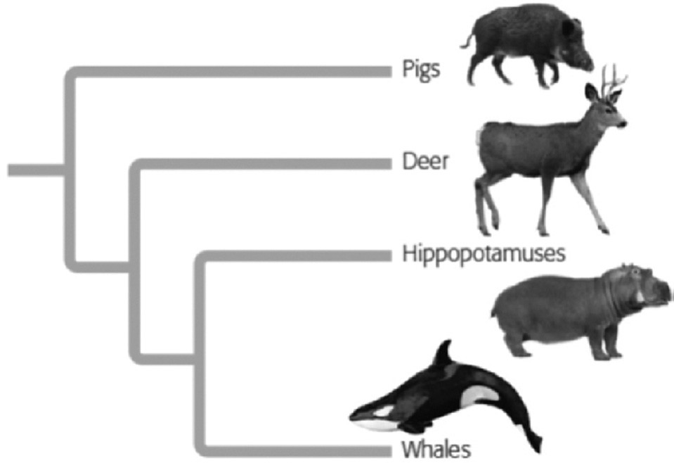

A) pigs and Hippopotamuses
B) deer and Hippopotamuses
C) whale and Hippopotamuses.
D) pigs and Whales.
Answer: C
Topic: Evolution Connection: Swimming with the Turtles
Skill: Apply/Analyze
Learning Outcome: 1.4
Global LO: 1, 2, 3

16) The phrase "Most ecosystems are solar powered" refers to the fact that
A) the sun shines on most ecosystems on earth
B) energy in sunlight is turned into (becomes) sugars
C) most organisms seek sunlight.
D) solar energy is converted to chemical energy by photosynthesis.
Answer: D
Topic: 1.3 Major Themes in Biology
Skill: Remember/Understand
Learning Outcome: 1.12

17) Suppose a scientist wanted to determine if a substance retrieved from outer space alive. Which of these properties of the substance would NOT help her make that determination?
A) having a clear orderly arrangement.
B) maintaining a constant temperature in an environment in which the temperature is variable
C) being multicolored.
D) being made of cells.
Answer: C
Topic: 1.2 The Properties of Life
Skill: Apply/Analyze
Learning Outcome: 1.6
18) Which properties of life are possessed by viruses and green turtles?
A) a clear orderly arrangement and ability to reproduce.
B) being made of cells and able to process energy
C) being able to reproduce and able to process energy.
D) being made of cells and having an orderly structure.
Answer: A
Topic: 1.2 The Properties of Life
Skill: Apply/Analyze
Learning Outcome: 1.7

