Human Anatomy & Physiology, 7e (Marieb)
Chapter 2 Chemistry Comes Alive

MATCHING QUESTIONS

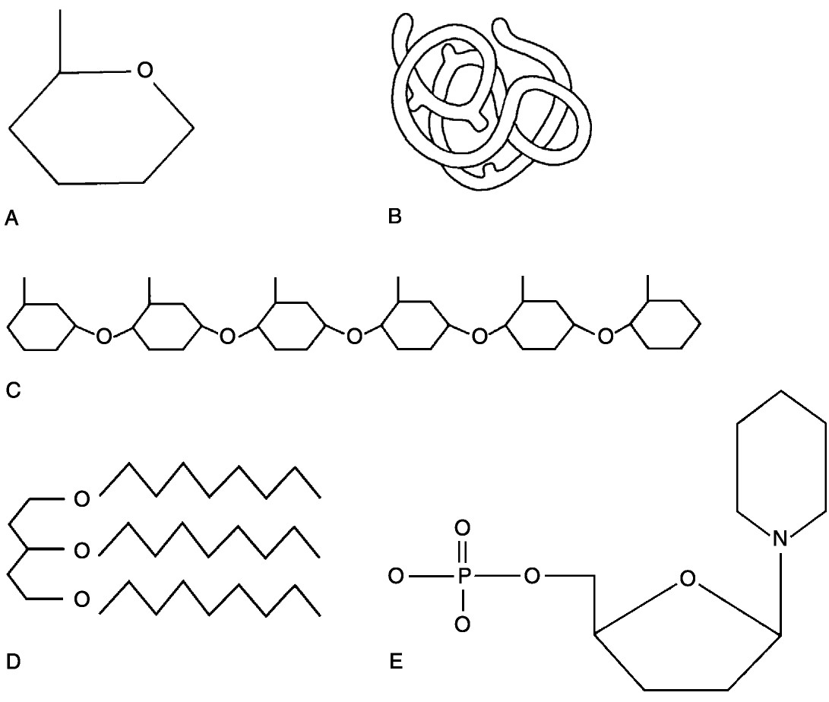

Figure 2.1

Using Figure 2.1, match the following:

1)

Lipid.

Answer:

D

Diff: 2

Page Ref: 46-47; Fig. 2.15

2)

Functional protein.

Answer:

B

Diff: 2

Page Ref: 50; Fig. 2.19a

3)

Nucleotide.

Answer:

E

Diff: 2

Page Ref: 55; Fig. 2.22a

4)

Polysaccharide.

Answer:

C

Diff: 2

Page Ref: 45; Fig. 2.14a

5)

Monosaccharide.

Answer:

A

Diff: 2

Page Ref: 44; Fig. 2.14a

6)

Polymer

Answer:

C

Diff: 2

Page Ref: 44

7)

Tertiary (protein) structure

Answer:

B

Diff: 2

Page Ref: 51; Fig. 2.18

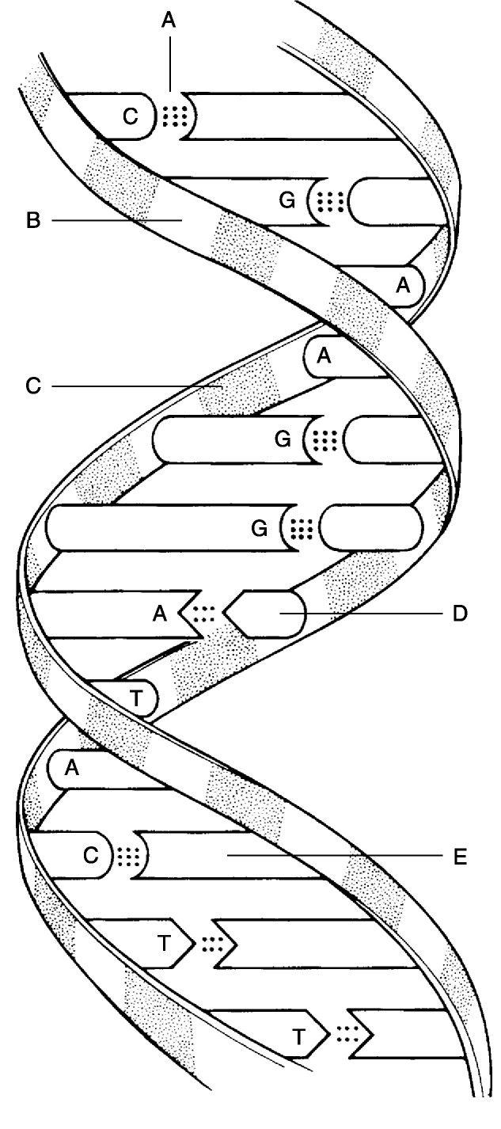
Figure 2.2

Using Figure 2.2, match the following:

8)

Deoxyribose sugar.

Answer:

B

Diff: 2

Page Ref: 55-57; Fig. 2.22

9)

Thymine.

Answer:

D

Diff: 2

Page Ref: 55-57; Fig. 2.22

10)

Guanine.

Answer:

E

Diff: 2

Page Ref: 55-57; Fig. 2.22

11)

Phosphate.

Answer:

C

Diff: 2

Page Ref: 55-57; Fig. 2.22

12)

Hydrogen bonds.

Answer:

A

Diff: 3

Page Ref: 55-57; Fig. 2.22

Match the following:

13)

A bond in which electrons are shared unequally.
A)
Hydrogen bond

Answer:

D
B)
Nonpolar covalent bond

Diff: 1

Page Ref: 34

C)
Ionic bond

14)

A bond in which electrons are completely lost or gained by the atoms involved.

D)

Polar covalent bond

Answer:

C

Diff: 1

Page Ref: 33

15)

A bond in which electrons are equally shared.

Answer:

B

Diff: 1

Page Ref: 34

16)

A type of bond important in tying different parts of the same molecule together into a three-dimensional structure.

Answer:

A

Diff: 2

Page Ref: 36

Match the following:

17)

Electrically charged particle due to loss of an electron.
A)
Cation

Answer:

A
B)
Neutron

Diff: 1

Page Ref: 33

C)
Molecule

18)

Neutral subatomic particle.

Answer:

B
D)
Atom

Diff: 1

Page Ref: 27

19)

Smallest particle of an element that retains its properties.

Answer:

D

Diff: 1

Page Ref: 27

20)

Smallest particle of a compound that still retains its properties.

Answer:

C

Diff: 2

Page Ref: 30

Match the following:

21)

Water.
A)
Element

Answer:

C

Diff: 1

Page Ref: 30
B) Mixture

22)

Carbon.
C)
Compound

Answer:

A

Diff: 1

Page Ref: 27

23)

Dry ice (frozen carbon dioxide).

Answer:

C

Diff: 1

Page Ref: 30

24)

Blood.

Answer:

B

Diff: 1

Page Ref: 30-31

Match the following:

25)

Can be measured only by its effects on matter.
A)
Mass

Answer:

C
B)
Matter

Diff: 1

Page Ref: 25-26

C)
Energy

26)

Anything that occupies space and has mass.

Answer:

B
D)
Weight

Diff: 1

Page Ref: 25

27)

Although a man who weighs 175 pounds on Earth would be lighter on the moon and heavier on Jupiter, his ________ would not be different.

Answer:

A

Diff: 1

Page Ref: 25

28)

Is a function of, and varies with, gravity.

Answer:

D

Diff: 2

Page Ref: 25

Match the following:

29)

Legs moving the pedals of a bicycle.
A)
Chemical energy

Answer:

D
B)
Electrical energy

Diff: 1

Page Ref: 26

C)
Radiant energy

30)

When the bonds of ATP are broken, energy is released to do cellular work.

D)

Mechanical energy

Answer:

A

Diff: 1

Page Ref: 25

31)

Energy that travels in waves. Part of the electromagnetic spectrum.

Answer:

C

Diff: 1

Page Ref: 26

32)

Represented by the flow of charged particles along a conductor, or the flow of ions across a membrane.

Answer:

B

Diff: 1

Page Ref: 25-26

Match the following:

33)

Heterogeneous, will not settle.
A)
Solutions

Answer:

C

Diff: 1

Page Ref: 31
B) Suspensions

34)

Heterogeneous, will settle.
C)
Colloids

Answer:

B

Diff: 1

Page Ref: 31

35)

Homogeneous, will not settle.

Answer:

A

Diff: 1

Page Ref: 30-31

36)

Will not scatter light.

Answer:

A

Diff: 1

Page Ref: 30-31

TRUE/FALSE QUESTIONS

1)

The atomic weight is only an average of relative weights of an atom and its isotopes, and it may vary from the weight of a specific isotope.

Answer:

True
False

Diff: 2

Page Ref: 29

2)

Emulsions and colloids are the same thing.

Answer:

True
False

Diff: 1

Page Ref: 31

3)

Chemical properties are determined primarily by neutrons.

Answer:

True
False

Diff: 1

Page Ref: 27

4)

A charged particle is generally called an ion.

Answer:

True
False

Diff: 1

Page Ref: 33

5)

Isotopes differ from each other only in the number of electrons contained.

Answer:

True
False

Diff: 1

Page Ref: 29

6)

About 60 to 80% of the volume of most living cells consists of organic compounds.

Answer:

True
False

Diff: 1

Page Ref: 40

7)

Lipids are a poor source of stored energy.

Answer:

True
False

Diff: 1

Page Ref: 46-47

8)

Current information theorizes that Omega-3 fatty acids decrease the risk of heart disease.

Answer:

True
False

Diff: 1

Page Ref: 47

9)

Glucose is an example of a monosaccharide.

Answer:

True
False

Diff: 1

Page Ref: 44

10)

A molecule consisting of one carbon atom and two oxygen atoms is correctly written as CO2.

Answer:

True
False

Diff: 1

Page Ref: 34-36; Fig. 2.8

11)

The lower the pH, the higher the hydrogen ion concentration.

Answer:

True
False

Diff: 1

Page Ref: 42

12)

Covalent bonds are generally less stable than ionic bonds.

Answer:

True
False

Diff: 2

Page Ref: 33-36

13)

Hydrogen bonds are comparatively strong bonds.

Answer:

True
False

Diff: 1

Page Ref: 36

14)

The fact that no chemical bonding occurs between the components of a mixture is the chief difference between mixtures and compounds.

Answer:

True
False

Diff: 1

Page Ref: 30

15)

Alpha particles, although relatively weak energy particles, are second only to smoking as a cause of lung cancer.

Answer:

True
False

Diff: 1

Page Ref: 30

16)

No chemical bonding occurs between the components of a mixture.

Answer:

True
False

Diff: 1

Page Ref: 31

17)

All organic compounds contain carbon.

Answer:

True
False

Diff: 1

Page Ref: 43-44

18)

A dipeptide can be broken into two amino acids by dehydration synthesis.

Answer:

True
False

Diff: 1

Page Ref: 49

MULTIPLE-CHOICE QUESTIONS

1)

Which of the following is necessary for proper conduction of nervous impulses?

A)

Fe

B)

I

C)

P

D)

Na

Answer:

D

Diff: 2

Page Ref: 26; Tbl. 2.1

2)

A phospholipid is usually ________.

A)

partially polar and partially nonpolar

B)

completely nonpolar

C)

completely polar

D)

neither polar nor nonpolar

Answer:

A

Diff: 2

Page Ref: 47

3)

In general, the category of lipids that we refer to as oils have ________.

A)

a high water content

B)

long fatty acid chains

C)

a high degree of saturated bonds

D)

a high degree of unsaturated bonds

Answer:

D

Diff: 2

Page Ref: 46

4)

The genetic information is coded in DNA by ________.

A)

the regular alteration of sugar and phosphate molecules

B)

the sequence of the nucleotides

C)

the three-dimensional structure of the double helix

D)

the arrangement of the histones

Answer:

B

Diff: 2

Page Ref: 55

5)

Which of the following is not true of proteins?

A)

They may be denatured or coagulated by heat or acidity.

B)

Some types are called enzymes.

C)

They appear to be the molecular carriers of the coded hereditary information.

D)

Their function depends on the three-dimensional shape.

Answer:

C

Diff: 2

Page Ref: 48-54

6)

The single most abundant protein in the body is ________.

A)

DNA

B)

hemoglobin

C)

collagen

D)

glucose

Answer:

C

Diff: 1

Page Ref: 50

7)

Carbohydrates are stored in the liver and muscles in the form of ________.

A)

glucose

B)

triglycerides

C)

glycogen

D)

cholesterol

Answer:

C

Diff: 2

Page Ref: 46

8)

Coenzymes are ________.

A)

organic molecules derived from vitamins

B)

two enzymes that perform the same function

C)

metal ions

D)

enzymes that work together

Answer:

A

Diff: 2

Page Ref: 53

9)

The speed or rate of a chemical reaction is influenced by all of the following except ________.

A)

the concentration of the reactants

B)

the temperature

C)

the presence of catalysts or enzymes

D)

the presence or absence of carbon

Answer:

D

Diff: 2

Page Ref: 39-40

10)

A chemical reaction in which bonds are broken is usually associated with ________.

A)

the release of energy

B)

the consumption of energy

C)

a synthesis

D)

forming a larger molecule

Answer:

A

Diff: 2

Page Ref: 38-39

11)

Salts are always ________.

A)

ionic compounds

B)

single covalent compounds

C)

double covalent compounds

D)

hydrogen bonded

Answer:

A

Diff: 2

Page Ref: 41

12)

The numbers listed represent the first, second, and third energy levels, respectively. On this basis, which of the following is an unstable or reactive atom?

A)

2, 8, 8

B)

2, 8

C)

2

D)

2, 8, 1

Answer:

D

Diff: 3

Page Ref: 32-33

13)

A solution that has a pH of 2 could best be described as being ________.

A)

acidic

B)

basic

C)

neutral

D)

slightly acidic

Answer:

A

Diff: 2

Page Ref: 41-42

14)

Which of the following is the major positive ion outside cells?

A)

nitrogen

B)

hydrogen

C)

potassium

D)

sodium

Answer:

D

Diff: 2

Page Ref: 28; Tbl. 2.1

15)

Which of the following would be regarded as an organic molecule?

A)

H2O

B)

NaCl

C)

NaOH

D)

CH4

Answer:

D

Diff: 1

Page Ref: 43

16)

A chain of 25 amino acids would be called a ________.

A)

polypeptide

B)

nucleotide

C)

protein

D)

starch

Answer:

A

Diff: 2

Page Ref: 49

17)

A long chain of simple sugars would be a ________.

A)

monosaccharide

B)

polysaccharide

C)

protein

D)

nucleic acid

Answer:

B

Diff: 1

Page Ref: 44-46

18)

The coiling of the protein chain backbone into an alpha helix is referred to as the ________.

A)

primary structure

B)

secondary structure

C)

tertiary structure

D)

quaternary structure

Answer:

B

Diff: 1

Page Ref: 50; Fig 2.18

19)

Carbohydrates and proteins are built up from their basic building blocks by the ________.

A)

addition of a water molecule between each two units

B)

addition of a carbon atom between each two units

C)

removal of a water molecule between each two units

D)

removal of a nitrogen atom between each two units

Answer:

C

Diff: 2

Page Ref: 44-46

20)

Which statement about enzymes is false?

A)

Enzymes raise the activation energy needed to start a reaction.

B)

Enzymes are composed mostly of protein.

C)

Enzymes are organic catalysts.

D)

Enzymes may be damaged by high temperature.

Answer:

A

Diff: 2

Page Ref: 52-54

21)

Many plasma proteins may function as _________.

A)

antibodies

B)

structural proteins

C)

buffers

D)

oxygen transport vesicles

Answer:

C

Diff: 1

Page Ref: 52; Tbl. 2.3

22)

Which of the following is true regarding the concentration of solutions?

A)

Percent solutions are parts per 1000 parts.

B)

Molarity is one mole of solute per 1000 ml of solution.

C)

To calculate molarity, one must know the atomic number of the solute.

D)

To calculate molarity, one must know the atomic weight of the solvent.

Answer:

B

Diff: 2

Page Ref: 30

23)

Select the statement about mixtures that is correct.

A)

A solution contains solvent in large amounts and solute in smaller quantities.

B)

Solutions contain particles that settle out in time.

C)

Suspensions can change reversibly from liquid to solid.

D)

Suspensions are homogeneous mixtures of two or more components.

Answer:

A

Diff: 2

Page Ref: 30-31

24)

HCO3- is _________.

A)

a bicarbonate ion

B)

common in the liver

C)

a weak acid

D)

a proton donor

Answer:

A

Diff: 1

Page Ref: 41

25)

Select which reactions will usually be irreversible regarding chemical equilibrium in living systems.

A)

glucose to CO2 & H2O

B)

ADP + Pi to make ATP

C)

H2O + CO2 to make H2CO3

D)

glucose molecules joined to make glycogen

Answer:

A

Diff: 3

Page Ref: 39

26)

In redox reactions ________.

A)

both decomposition and electron exchange occur

B)

the electron acceptor is oxidized

C)

the electron donor is reduced

D)

the reaction is always easily reversible

Answer:

A

Diff: 2

Page Ref: 38

27)

Fibrous proteins ________.

A)

rarely exhibit secondary structure

B)

are very stable and insoluble in water

C)

are usually called enzymes

D)

are cellular catalysts

Answer:

B

Diff: 2

Page Ref: 50

28)

The ATP molecule is not used in ___________.

A)

chemical work

B)

mechanical work

C)

transport

D)

pigments

Answer:

D

Diff: 1

Page Ref: 57, 59

29)

Select the most correct statement regarding nucleic acids.

A)

Three forms exist: DNA, RNA, and tDNA.

B)

DNA is a long, double-stranded molecule made up of A, T, G, and C bases.

C)

RNA is a long, single-stranded molecule made up of the bases A, T, G, and C.

D)

TDNA is considered a molecular slave of DNA.

Answer:

B

Diff: 2

Page Ref: 55-57

30)

________ is a suspension.

A)

Cytoplasm

B)

Saltwater

C)

Rubbing alcohol

D)

Blood

Answer:

D

Diff: 2

Page Ref: 31

31)

Select the correct statement about isotopes.

A)

Isotopes of the same element have the same atomic number but differ in their atomic mass.

B)

All the isotopes of an element have the same number of neutrons.

C)

All the isotopes of an element are radioactive.

D)

Isotopes occur only in the heavier elements.

Answer:

A

Diff: 2

Page Ref: 29

32)

The four elements that make up about 96% of body matter are ________.

A)

carbon, oxygen, phosphorus, calcium

B)

nitrogen, hydrogen, calcium, sodium

C)

carbon, oxygen, hydrogen, nitrogen

D)

sodium, potassium, hydrogen, oxygen

Answer:

C

Diff: 2

Page Ref: 27; Tbl. 2.1

33)

An example of a coenzyme is ________.

A)

copper

B)

riboflavin (vitamin B2)

C)

iron

D)

zinc

Answer:

B

Diff: 1

Page Ref: 53

34)

________ is fat-soluble, produced in the skin on exposure to UV radiation, and necessary for normal bone growth and function.

A)

Vitamin K

B)

Cortisol

C)

Vitamin A

D)

Vitamin D

Answer:

D

Diff: 1

Page Ref: 48; Tbl. 2.2

35)

In liquid XYZ, you notice that light is scattered as it passes through. There is no precipitant in the bottom of the beaker, though it has been sitting for several days. This liquid must be a ________.

A)

solution

B)

suspension

C)

colloid

D)

mixture

Answer:

C

Diff: 3

Page Ref: 31

36)

Atom X has seventeen protons. How many electrons are in its valence shell?

A)

3

B)

5

C)

7

D)

10

Answer:

C

Diff: 3

Page Ref: 32-33

37)

If an atom were to have two protons, then it would ________.

A)

have a valence of 0

B)

be very stable

C)

be chemically active

D)

have three electrons

Answer:

B

Diff: 3

Page Ref: 27

38)

If atom X has an atomic number of 74 it would have ________.

A)

37 protons and 37 neutrons

B)

37 electrons

C)

74 protons and no neutrons

D)

74 protons and roughly the same number of neutrons

Answer:

D

Diff: 2

Page Ref: 28

39)

The formula C6H12O6 means ________.

A)

there are 6 calcium, 12 hydrogen, and 6 oxygen atoms

B)

there are 12 hydrogen, 6 carbon, and 6 oxygen atoms

C)

the molecular weight is 24

D)

the substance is a colloid

Answer:

B

Diff: 2

Page Ref: 31

40)

Two good examples of a colloid would be Jell-O® or ________.

A)

blood

B)

toenails

C)

urine

D)

cytosol

Answer:

D

Diff: 2

Page Ref: 31

41)

An atom with a valance of 3 may have a total of ________ electrons.

A)

3

B)

8

C)

13

D)

17

Answer:

C

Diff: 3

Page Ref: 32-33

42)

An atom with ________ electrons could be an anion when ionically bonded.

A)

3

B)

6

C)

9

D)

15

Answer:

C

Diff: 3

Page Ref: 33

43)

The chemical symbol OO means ________.

A)

zero equals zero

B)

both atoms are bonded and have zero electrons in the outer orbit

C)

the atoms are double bonded

D)

this is an ionic bond with two shared electrons

Answer:

C

Diff: 1

Page Ref: 34

44)

Dipole is ________.

A)

a type of bond

B)

a polar molecule

C)

a type of reaction

D)

an organic molecule

Answer:

B

Diff: 2

Page Ref: 35

45)

CH4 means ________.

A)

there is one carbon and four hydrogen atoms

B)

there are four carbon and four hydrogen atoms

C)

this is an inorganic molecule

D)

this was involved in a redox reaction

Answer:

A

Diff: 1

Page Ref: 36-37

46)

Amino acids joining together to make a peptide is a good example of a ________ reaction.

A)

synthesis

B)

decomposition

C)

exchange

D)

reversible

Answer:

A

Diff: 1

Page Ref: 37

47)

________ is not considered to be a factor in influencing a reaction.

A)

Temperature

B)

Concentration

C)

Particle size

D)

Time

Answer:

D

Diff: 2

Page Ref: 39

48)

Which of the following is not an electrolyte?

A)

HCl

B)

Ca2CO3

C)

H2O

D)

NaOH

Answer:

C

Diff: 1

Page Ref: 41

49)

Human blood has a pH of ________.

A)

8.35-8.55

B)

7.70-8.00

C)

7.35-7.45

D)

6.80-7.00

Answer:

C

Diff: 2

Page Ref: 42; Fig. 2.13

50)

__________ is a heavy metal normally found in the body.

A)

Lead

B)

Mercury

C)

Arsenic

D)

Iron

Answer:

D

Diff: 1

Page Ref: 60

51)

Sucrose is a ________.

A)

monosaccharide

B)

disaccharide

C)

polysaccharide

D)

triglyceride

Answer:

B

Diff: 1

Page Ref: 44

52)

Neutral fats have a ________ ratio of fatty acids to glycerol.

A)

1:1

B)

2:1

C)

3:1

D)

4:1

Answer:

C

Diff: 1

Page Ref: 46

53)

In a DNA molecule, the phosphate serves ________.

A)

as a code

B)

to hold the molecular backbone together

C)

to bind the sugars to their bases

D)

as nucleotides

Answer:

B

Diff: 1

Page Ref: 55-56; Fig. 2.22

54)

Most fibrous proteins in the body contain all of these except:

A)

keratin

B)

elastin

C)

eledin

D)

collagen

Answer:

C

Diff: 2

Page Ref: 50

55)

Heat shock proteins (hsp) are a type of protein called ________.

A)

coenzymes

B)

cofactors

C)

eicosanoids

D)

chaperonins

Answer:

D

Diff: 2

Page Ref: 53

56)

_________ bonds often bind different parts of a molecule into a specific 3-dimensional shape.

A)

Carbon

B)

Hydrogen

C)

Oxygen

D)

Amino acid

Answer:

B

Diff: 2

Page Ref: 36

FILL-IN-THE-BLANK/SHORT ANSWER QUESTIONS

1)

The atomic number is equal to the number of ________.

Answer:

protons (and electrons)

Diff: 1

Page Ref: 28-29

2)

Tritium is a ________.

Answer:

radioisotope

Diff: 1

Page Ref: 29-30

3)

Molecules such as methane that are made of atoms that share electrons have ________ bonds.

Answer:

covalent

Diff: 1

Page Ref: 34

4)

An atom with three electrons would have a valence of ________.

Answer:

one

Diff: 2

Page Ref: 32-33

5)

AB → A + B is an example of a ________ reaction.

Answer:

decomposition

Diff: 2

Page Ref: 37

6)

________ have a bitter taste, feel slippery, and are proton acceptors.

Answer:

Bases

Diff: 1

Page Ref: 41

7)

Polysaccharides with long chains of similar units are more generally called ________.

Answer:

polymers

Diff: 2

Page Ref: 44

8)

A holoenzyme is composed of an apoenzyme and a ________.

Answer:

cofactor

Diff: 2

Page Ref: 53

9)

In a DNA molecule guanine would connect to ________.

Answer:

cytosine

Diff: 1

Page Ref: 56

10)

The ________ molecule directly provides energy for cellular work.

Answer:

ATP

Diff: 1

Page Ref: 57-59

11)

Hydrogen bonds are more like a type of weak ________ than true bonds.

Answer:

attraction

Diff: 2

Page Ref: 36

12)

Weak acids and bases make good ________.

Answer:

buffers

Diff: 2

Page Ref: 43

13)

Starch is the stored carbohydrate in plants while ________ is the stored carbohydrate in animals.

Answer:

glycogen

Diff: 2

Page Ref: 46

14)

AMP would have ________ phosphate(s) attached to it.

Answer:

one

Diff: 2

Page Ref: 57; Fig. 2.23

15)

________ metals have a toxic effect on the body.

Answer:

Heavy

Diff: 2

Page Ref: 60

16)

The polar end of a phospholipid contains a ________.

Answer:

phosphorus-containing group

Diff: 1

Page Ref: 47

17)

Explain the difference between potential and kinetic energy.

Answer:

Potential energy is inactive stored energy that has potential to do work. Kinetic energy is energy in action.

Diff: 3

Page Ref: 25

18)

How can phospholipids form a film when mixed in water?

Answer:

Phospholipids have both polar and nonpolar ends. The polar end interacts with water, leaving the nonpolar end oriented in the opposite direction.

Diff: 3

Page Ref: 47-48; Tbl. 2.2

19)

What properties does water have that make it a very versatile fluid?

Answer:

High heat capacity, high heat of vaporization, polarity and solvent properties, reactivity, and cushioning.

Diff: 3

Page Ref: 40-41

20)

What advantages does ATP have in being the energy currency molecule?

Answer:

Its energy is easy to capture and store; it releases just the right amount of energy for the cell's needs so it is protected from excessive energy release. A universal energy currency is efficient because a single system can be used by all the cells in the body.

Diff: 3

Page Ref: 57-59

21)

Explain why chemical reactions in the body are often irreversible.

Answer:

Chemical reactions that release energy cannot be reversed unless energy is put back into the system. Also, the body may use the chemicals solely for its energy, such as glucose, or some reactions produce molecules in excessive quantities (like CO2 and NH4) that the body needs to discard.

Diff: 3

Page Ref: 39

22)

When a set of electrodes connected to a lightbulb is placed in a solution of dextrose and a current is applied, the lightbulb does not light up. When the same unit is placed in HCl, it does. Why?

Answer:

HCl ionizes to form current-conducting electrolytes. Dextrose does not ionize, and therefore does not conduct current.

Diff: 3

Page Ref: 34-36

23)

Describe the factors that affect chemical reaction rates.

Answer:

Temperature increases kinetic energy and therefore the force of molecular collisions. Particle size: smaller particles move faster at the same temperature and therefore collide more frequently; also, smaller particles have more surface area given the same concentration of reactants. Concentration: the higher the concentration, the greater the chance of particles colliding. Catalysts increase the rate of the reaction at a given temperature. Enzymes are biological catalysts.

Diff: 3

Page Ref: 39-40

24)

Protons and electrons exist in every atom nucleus except hydrogen. Is this statement true or false and why?

Answer:

FalseHydrogen has one proton and one electron. It is the neutron that hydrogen does not have.

Diff: 3

Page Ref: 27-28

25)

A chemical bond never occurs in a mixture. Discuss this.

Answer:

Mixtures come in three forms solutions, colloids, and suspensions. Components of these mixtures always retain their original makeup and can be separated into their individual components, therefore no chemical bonding has taken place.

Diff: 3

Page Ref: 30-31

26)

All chemical reactions are theoretically reversible. Comment on this statement.

Answer:

It is possible to reverse any reaction if the products are still present. Those that are only slightly exergonic are easily reversible. Some would require an enormous amount of energy to reverse. In the simple reaction Na + Cl → NaCl the amount of energy it takes to reverse table salt to chlorine gas and sodium metal is enormous. The reversing of the covalently bonded sugar molecule once it is reduced to ATP molecules is even harder or next to impossible.

Diff: 3

Page Ref: 39

27)

Glucose is a monosaccharide classified as a hexose. Comment on this statement.

Answer:

Glucose is a simple sugar with six carbons, forming a single six-sided ring.

Diff: 3

Page Ref: 44

28)

An amino acid may act as a proton acceptor or donor. Explain.

Answer:

Amino acids have two componentsa base group (proton acceptor) and an organic acid part (a proton donor).

Diff: 3

Page Ref: 49

29)

Name at least four things you know about enzymes.

Answer:

1. They are proteins.
2. They have specific binding sites for specific substrates.
3. They lower the activation barrier for a specific reaction.
4. The names end in ase.
5. They can be denatured.
6. They can be used again and again.

Diff: 2

Page Ref: 53-54

CLINICAL QUESTIONS

1)

Mrs. Mulligan goes to her dentist and, after having a couple of cavities filled, her dentist strongly suggests that she reduce her intake of sodas and increase her intake of calcium phosphates in the foods she eats. Why?

Answer:

Sodas are strong acids that can reduce bone and tooth salts. Calcium phosphate makes teeth hard and therefore more resistant to tooth decay.

Diff: 2

Page Ref: 41

2)

Although his cholesterol levels were not high, Mr. Martinez read that cholesterol was bad for his health, so he eliminated all foods and food products containing this molecule. He later found that his cholesterol level dropped only 20%. Why did it not drop more?

Answer:

Cholesterol is produced by the liver, in addition to being ingested in foods.

Diff: 3

Page Ref: 47-48

3)

How can DNA be used to "fingerprint" a suspect in a crime?

Answer:

The DNA of a person is unique to that individual. By obtaining the DNA from nucleated cells from the crime scene (e.g., tissue, sperm), enzymes may be used to break up the DNA into fragments. Because nearly everyone's DNA is different, it also breaks up into fragments differently. When the fragments are separated, they form patterns even more unique than fingerprint patterns. A match of suspect and crime scene DNA is strong evidence.

Diff: 3

Page Ref: 58-59

4)

Why is it possible for us to drink a solution that contains a mixture of equal concentration of a strong acid and a strong base, either of which, separately, would be very caustic?

Answer:

When an acid and base of equal strength are mixed, they undergo a displacement reaction to form a water and a salt.

Diff: 3

Page Ref: 42

5)

A 65-year-old client came to the emergency room with complaints of severe heartburn unrelieved by taking a "large handful" of antacids. Would you expect the pH to be high or low? Explain why.

Answer:

You would expect a high pH. Taking antacids will neutralize the acidic stomach. Taking a "handful" of antacids can cause an alkaloid state. Certain drugs, such as corticosteroids and antacids that contain baking soda, will lead to metabolic alkalosis.

Diff: 3

Page Ref: 42-43

6)

A 23-year-old male was riding his road bike in 100-degree heat, when he suddenly became nauseated and weak. He called 911 from his cell phone. When the ambulance came, the paramedics started intravenous therapy for severe dehydration. Explain the critical role of water to maintain homeostasis.

Answer:

Water is the most abundant and important inorganic compound in living material. It makes up 60 to 80% of the volume of most living cells. The properties of water are: high heat capacity, high heat of vaporization, polar solvent properties, reactivity, and cushioning. In this case the bicyclist lost a large amount of water through perspiration in an effort to cool his body. This caused a disruption in homeostasis.

Diff: 3

Page Ref: 40-41

7)

Brenda is a 26-year-old female who is being discharged from the hospital after a vaginal delivery of an 8-pound healthy infant. Brenda is instructed by the nurse to eat a diet high in fiber and to drink 8 glasses of water per day to prevent constipation. Explain the role of fiber and water to promote defecation.

Answer:

Cellulose is a polysaccharide found in all plant products that adds bulk to the diet to promote feces through the colon. Water acts as a lubricating liquid within the colon, which eases feces through the bowel.

Diff: 3

Page Ref: 40, 46

8)

A 64-year-old man is admitted to the hospital for non-healing pressure ulcers to his heels. He has been bedridden for 10 years because of a degenerative muscle disease. Explain why protein would be an important part of his diet to promote wound healing.

Answer:

Protein composes 10 to 30% of cell mass and is the basic structural material of the body. Proteins regulate body processes. Skin, hair, and eyes are made of protein, as are the enzymes needed for digestion and absorption. Protein is essential for growth, maintenance, and repair of tissue.

Diff: 3

Page Ref: 49

.

