Chapter 1

Multiple choice questions

1. (c) A rolling ball is an example of a physical phenomenon. A point-like object is a simplified model of an object. Acceleration is a physical quantity for describing motion, while free fall is a model of a process.

2. (b) Average speed, path length, and clock reading are all scalar quantities. Displacement and acceleration are examples of vector quantity.

3. (b) A time interval is the difference between two times. Both statements, (2) The lesson lasted for 45 minutes and (4) An astronaut orbited Earth in 4 hours, are examples of time interval.

4. (a) The student should have said: “The distance between my dorm and the lecture hall is 1 km.” There is no indication of the direction (needed for indicating displacement). The path length depends on the path followed and that is also not indicated.

5. (b) Withthe corresponding velocity and acceleration are and Therefore, we see that the object is accelerating with . The speed of the object first decreases, reaches zero at t = 2.0 s, and then increases beyond that. So (b) is not true.

6. (a) The motion of the car is described by graph (a). The non-zero flat part corresponds to the car moving at a constant velocity. The car then begins to slow down (indicated by the negative slope), coming to a stop (v = 0, through the x-axis), and moves in the opposite direction with the same acceleration.

7. (d) The average velocity and instantaneous velocity are equal when the object moves at a constant velocity or does not move (zero velocity).

8. (c) At the instant the second ball is released, the first ball not only has traveled 3 cm, it also has acquired non-zero velocity. Therefore, the distance between the balls will increase with time. Mathematically, the positions of the two balls can be written as and where Δt is the time interval between dropping the first ball and the second. The distance between them is given by (taken downward direction to be positive +y) , which shows clearly that Δy increases with t.

9. (b) The position of the car can be written as where x₀ = +20 m. Since the car is traveling west (−x-axis), With the acceleration a_{x} is positive in order to bring the velocity of the car to zero at the stoplight.

10. (c) The velocity-versus-time graph in (c) describes the motion of the car with v_{0x} = − 12m/s, and a_{x} > 0.

11. (c) velocity-versus-time graph in (c) can be written as with v_{0x} < 0 and a_{x} > 0. The velocity remains negative until the object comes to rest.

12. (c) At the moment the sandbag is released, it has the same upward velocity as the hot air balloon, according to the ground observer 2. Therefore, he sees the sandbag going up first then coming down. On the other hand, observer 1 in the hot air balloon sees the sandbag undergo free fall.

13. (b) The height of the tree is The closest value is (b).

14. (c) Whether you drop the ball or throw it down, the acceleration of the ball is due to gravitational force exerted by Earth, and it remains the same: a_{y} = − g = − 9.8 m/s² (where we have taken upward to be +y). So statement (c) is incorrect.

15. (c) The total flight time of the ball is which is linear in v₀. Thus, the second ball, with twice the initial speed of the first one, will spend twice as much time in flight. Note that the maximum height the ball reaches is given by, which is quadratic in v₀.

16. (a) The total flight time is given by where v₀ is the initial speed. The fact that t is linear in v₀ means that if it takes twice as much time for the second ball to come back, the initial speed of the second ball must be twice that of the first one.

Conceptual questions

17. Both (b) and (e) correctly describe the Armstrong’s motion. Graph (e) corresponds to the fact that his cycling speed is constant, and graph (b) shows that his displacement (from starting point) increases linearly.

18. One scenario is as follows: As the light turns green, the car starts to accelerate from rest. Upon reaching the appropriate speed, the driver stops accelerating and the car moves at a constant speed. Upon seeing a red light some distance ahead, the driver starts to brake. With constant deceleration, the car comes to a complete stop at the light. The velocity-versus-time and acceleration-versus-time graphs are shown below.
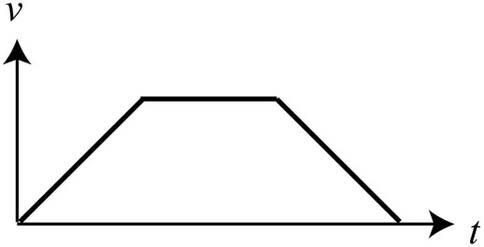 | 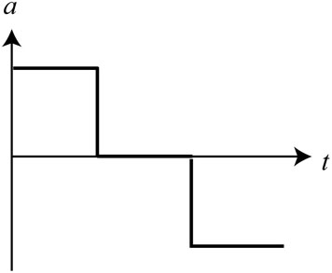
Another possibility is that the car starts from rest with constant acceleration. Seeing another traffic light a short distance ahead, the driver abruptly applies the brake and slows the car to a complete stop. The velocity-versus-time and acceleration-versus-time graphs are shown below.
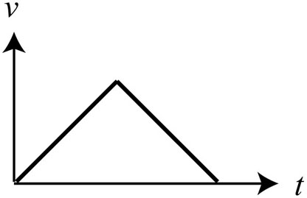 | 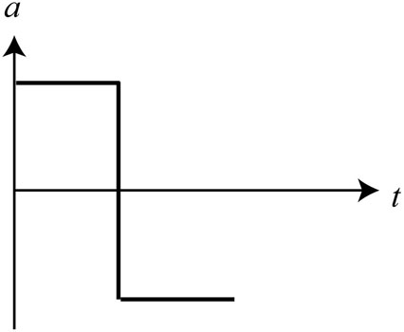

19. Speed is a scalar quantity that characterizes how fast an object moves. An example of speed is 55 mi/h. On the other hand, velocity refers to the rate of change of position; it is a vector quantity that has both magnitude and direction. An example of a velocity vector is 55 mi/h, due north.

The path length is how far an object moves as it travels from its initial position to its final position. Imagine laying a string along the path the object takes; the length of the string is the path length. On the other hand, distance is the magnitude of displacement. Path length is not necessarily equal to distance. To illustrate the distinction, consider a person running from to along the path shown below.
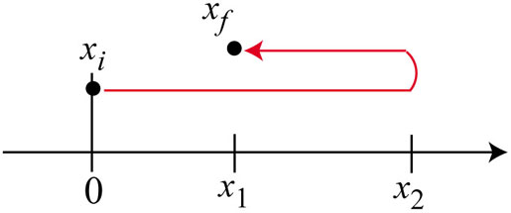 | The distance the person has run is  However, the path length is  .

Displacement is the difference between two positions in space; it is a vector quantity that has both magnitude and direction. For example, if an object moves from its initial position at to its displacement is The displacement is negative since the object moves in the negative x-direction. The distance the object has traveled is 3.0 m, the magnitude of the displacement.

20. Listed below are some examples of physical quantities that are used to describe motion:

Physical quantity | Symbol | SI units | Scalar/vector | What it characterizes
time | t | s | scalar | reading on a clock
time interval | Δt | s | scalar | the difference between two times
position | x, y, z | m | vector | location of an object with respect to a given coordinate system
displacement |  | m | vector | the difference between two positions in space
distance | d | m | scalar | the magnitude of displacement
path length |  | m | scalar | how far an object moves as it travels from its initial position to its final position
velocity |  | m/s | vector | the rate of change of position
speed | v | m/s | scalar | how fast an object moves
acceleration |  | m/s² | vector | the rate of change of velocity

21. In all of the following, we choose a reference frame with Earth as the object of reference.

(a) As the light turns green, a car starts to accelerate from rest. Upon reaching the speed limit, the driver stops accelerating and the car moves at a constant speed. Upon seeing a red light some distance ahead, the driver starts to brake. With constant deceleration, the car comes to a complete stop at the light.

(b) A ball is projected vertically upward with an initial velocity of 40 m/s. About 4.0 seconds later, it reaches a maximum height and its instantaneous velocity is zero. The ball then undergoes free fall to return to its initial position. Its velocity before impacting the ground is –40 m/s.

(c) A ball is initially at rest on a frictionless incline plane. It begins to slide down at a constant acceleration of (positive taken to be upward).

22. (a) The graphs are shown below.
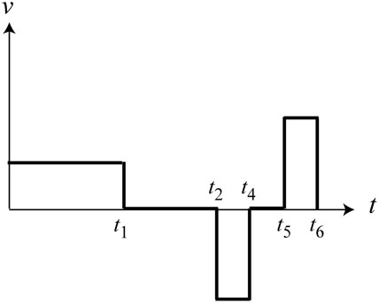 | 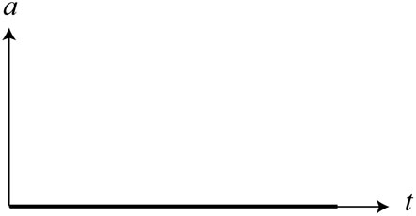  The acceleration is zero throughout.
Note that technically there is non-zero acceleration at t₁, t₂, t₄, t₅, and t₆ because the velocity changes abruptly at these instants. However, we ignore the “endpoints” of each time interval.
(b)  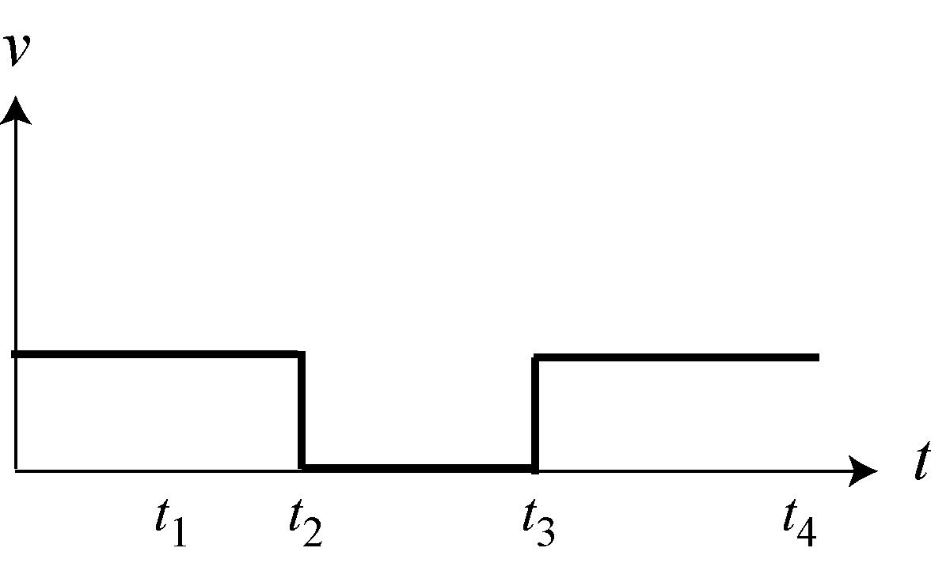 | 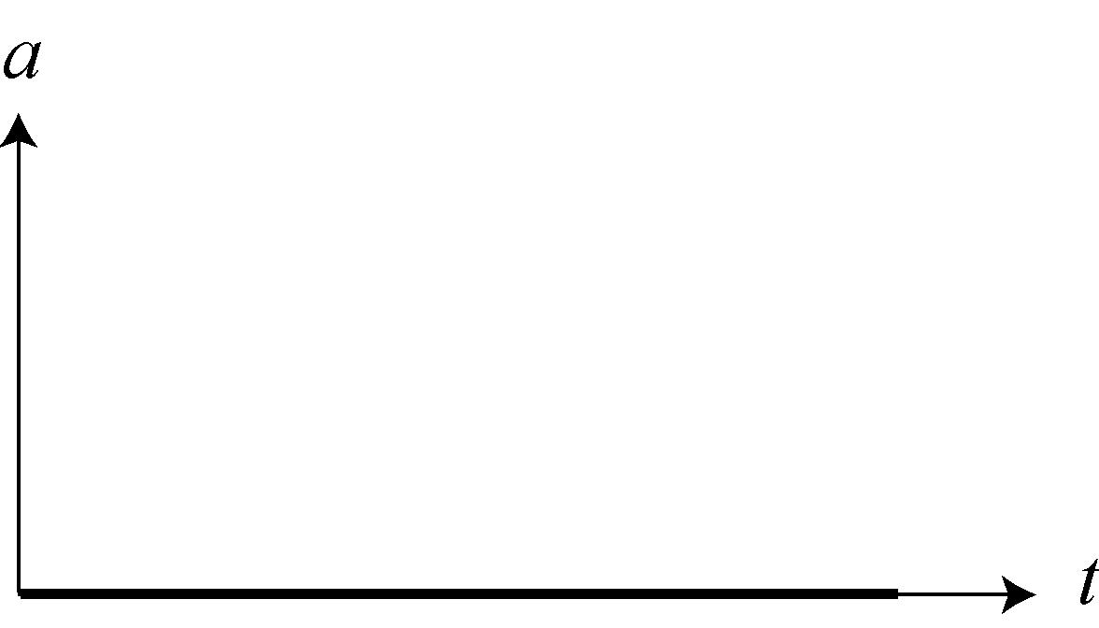  The acceleration is zero throughout.

(c)  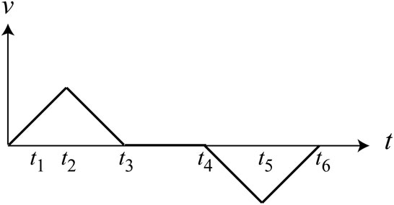 | 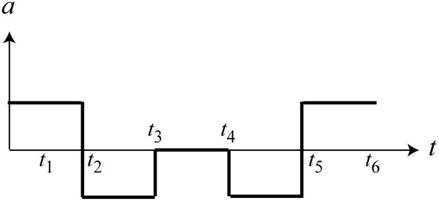

23. Yes. For example, a car driving at a constant speed of 35 mi/h due east has non-zero velocity but zero acceleration, which is defined as the rate of change of velocity.

24. Yes. For example, if you throw a ball vertically upward, when the ball reaches its maximum height, the ball comes to rest momentarily and its instantaneous velocity is zero, but its free-fall acceleration is non-zero.

25. We first measure the distance traveled by the toy truck at regular time intervals. If the truck is moving in a straight line and the distances traveled during each time interval remains unchanged, then we may conclude that the truck is moving at a constant velocity with no acceleration. In this case, we would have a straight line on the position-versus-time graph.

On the other hand, if the distance traveled varies from one time interval to another, then the truck has non-zero acceleration, with changing velocity and speed. In this case, the curve on the position-versus-time graph would not be a straight line, as shown in the figure below.
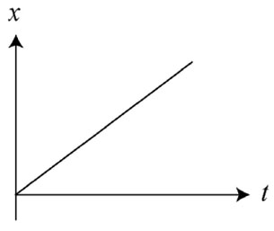
Whether the acceleration is constant or not can be deduced by looking at the velocity-versus-time graph. A straight line would imply a constant acceleration.

26. Disagree with your friend. At the top of the flight, while the instantaneous velocity of the ball reaches zero, its free-fall acceleration is non-zero.

Problems

1. The motion diagram is shown below.

2. (a) The motion diagrams are shown below.
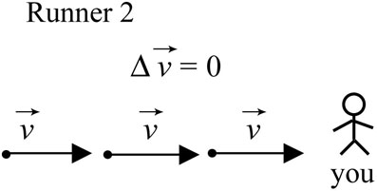 | 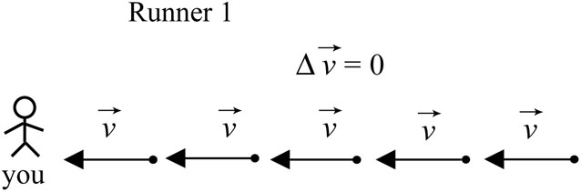

(b) In the reference frame of runner 1, he sees runner 2 coming toward him at a speed equal to
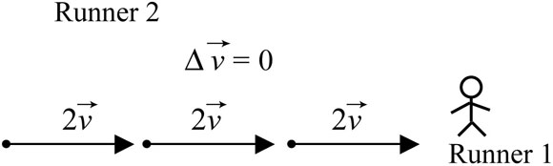

3. The motion diagram is shown below. We choose a reference frame with Earth as the object of reference.
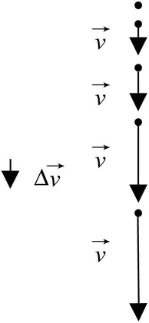
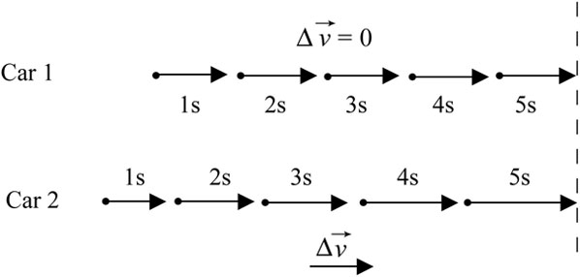

4. The motion diagram of the hat as seen by the man is shown to the right.

5. (a) The motion diagram is shown below.

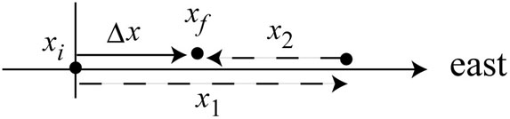
(b) We choose a reference frame with Earth as the object of reference. The origin of the coordinate system is the initial position of the car and the positive direction is toward east. The position of the car when you stop for lunch is

(c) As in (b), we choose Earth to be the object of reference. The origin of the coordinate system is the initial position of the car and the positive direction is toward west. The position of the car when you stop for lunch is

(d) We choose a reference frame with Earth as the object of reference. However, in this case, let the origin of the coordinate system be +50 km due east of the initial position of the car, and the positive direction is toward east. The position of the car when you stop for lunch then becomes

6. We choose a reference frame with Earth as the object of reference. For simplicity, let the motion of the two people be one dimensional, and the positive direction is to the right. Suppose the initial and final positions of the two people are

The corresponding displacements are

Thus, we see that two people starting and ending their trips at different locations can still have the same displacement vectors.

7. Choose Earth to be the object of reference. Let the displacement be positive when moving in the east direction. Thus, the x-component of the displacement vector can be written as On the other hand, if the displacement is defined to be positive when moving in the west direction, then we would have

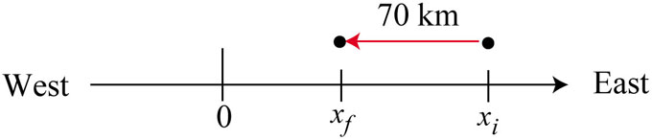

8. (a) You can simply count your steps or use a pedometer, and a watch to record the time.
(b) There are uncertainties associated with the recording of time as well as the number of steps counted as you move from the front door. Both quantities have been rounded to the nearest integer.

(c) Your position (measured in number of steps) relative to the front door as a function of time (in seconds) is shown below.
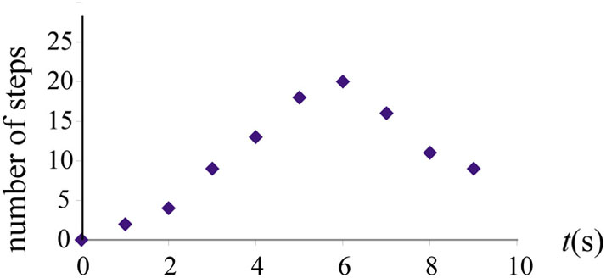

(d) The mailman has just delivered your mail. You’ve been waiting impatiently to receive the new physics textbook you’d ordered. You rushed from the front door of your house to the mailbox located 20 steps away and picked up the mail 6 seconds later. As you hurried back, you started looking through the mail, and were disappointed that the package had not yet arrived.

(e) Assuming the motion to be one-dimensional (along a straight path), the values for x given in Table 1.9 would represent the displacement (relative to the door). In this case, the distance is the same as the path length since both measure the total number of steps walked.

t (s) | 1 | 2 | 3 | 4 | 5 | 6 | 7 | 8 | 9
x (steps) | 2 | 4 | 9 | 13 | 18 | 20 | 16 | 11 | 9
path length  (steps) | 2 | 4 | 9 | 13 | 18 | 20 | 24 | 29 | 31

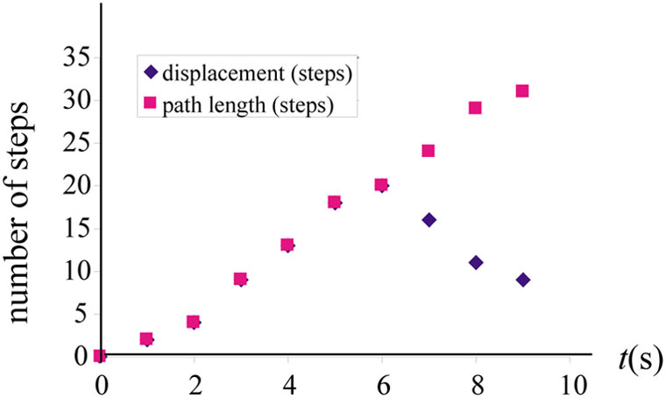

9. To determine the time interval it takes for light to pass through an atomic nucleus, we first need to know the size of the nucleus. The size depends on the atomic mass of the sample you use, but generally is on the order of a few Fermi (1 fm =10⁻¹⁵ m). We also assume that the nucleons (protons and neutrons) have their mass distributed uniformly throughout the nucleus. By further assuming that the speed of light in the nucleus is the same as that in vacuum, we estimate the time taken to pass through the nucleus to be Typically, it takes a few yoctoseconds (10⁻²⁴s) for light to traverse through a nucleus.

10. (a) Using the conversion factors

we have

(b) The speed of the car in mi/h is

11. With the conversion factors for distance and time

we obtain the following conversion factors for speed:

(a)

(b)

(c)
12. Assume that the hair grows at a rate of approximately 1.3 cm in one month, we have

or about 5 nm/s.

13. (a) Take the time interval for 80 heartbeats to be about 1 minute. The speed of the van is then

(b) We choose a reference frame with Earth as the object of reference. For a person standing at the first exit, he notices that the distance of separation between him and the van increases as The position-versus-time graph is shown to the right. | 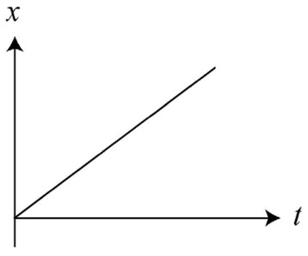

14. (a) An example of the simplified map is shown below.

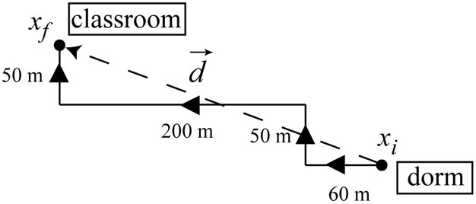
(b) For the map shown, the total path length is given by
Assuming that it takes about 5 minutes to walk from the dorm to the classroom, then the average speed would be about .
15. (a) The story can be: A hiker is 10 km away from his camping ground. He walks along a straight path at a speed of 4.0 km/h to get back to his tent to rest. The time t = 0 corresponds to the moment when the hiker has just begun to walk. The observer is another hiker who is already back at the camping ground.

Another story could be: A father and his child are 10 km away from home (where the mother is). The father then carries the child on his back and starts walking toward the mother at a pace of 4 km/h. However, in the reference frame of the child (the observer), it is the mother who is moving toward them at a speed of 4 km/h.

(b) The equation gives If the value 10 km has just one significant digit, the actual distance could fall between 9.5 km and 15 km. However, if 10 km has two significant digits, then the actual distance would be between 9.0 km and 11 km.

16. The average speed of the hike is

The result above is written in three significant digits, assuming that the value 17,000 has at least three significant digits. However, if the step count by the pedometer is known to only two significant digits, then using scientific notation, we have , and the speed would be This holds true regardless of whether time is given as 2.5 h or 2.50 h.

17. We interpret “four seconds” to be 4.0 s, with two significant digits. The distance between the clouds and the hikers is then

or 1.4 km in two significant digits. To calculate the uncertainty, we write v and t as and Thus, we find the distance to be between and Our result should be quoted as

18. The time it takes for light to reach the Earth from the Sun is

which should be written as in two significant digits. The uncertainties can be included by reporting the result as which means that one could be off by as much as 20 seconds. Note, however, that experimentally both the speed of light and the Sun–Earth distance (the astronomical unit) have been measured to much greater accuracy, and the travel time can be shown to be about 499.2 s.

19. In SI units, 1 light-year is

Therefore, the distance to Proxima Centauri is

where (or ) represents the uncertainty in the calculation.

20. With we find the distance between the Uranus and the Earth to be approximately equal to

This distance is about 28 times that of the distance from the Earth to the Sun. In our calculation, we have assumed that Uranus remains stationary, and Voyager traveled
a straight path. In reality, both the Earth and the Uranus orbit around the Sun, so the Earth–Uranus distance are constantly changing, depending on their relative position in the Solar system. Measurements have shown that the Earth–Uranus distance falls between and

21. Sketch and translate From Figure P1.21, we see that both Gabriele and Xena, the objects of interest, are riding their bicycles at constant speeds, as indicated by the horizontal line in the velocity-versus-time plot.

Simplify and diagram We assume that Gabriele and Xena are point-like objects. We choose a reference frame with Earth as the object of reference. We choose the origin of the coordinate system to be the position of a stationary observer at the parking lot, and the positive direction will be toward the right, in the direction of cycling. The situation is depicted below.
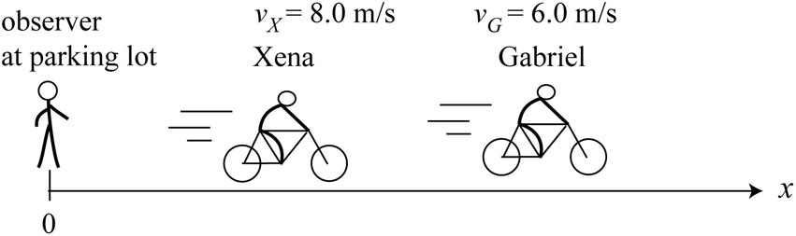
Represent mathematically The positions of Gabriele and Xena with respect to the parking lot as a function of time are given by

where and are the distances between Xena and Gabriele and the observer at time t = 0.

Solve and evaluate
(a) At the displacements with respect to their initial positions are for Gabriele and for Xena.

(b) The relative speed between Xena and Gabriele is

With a separation of the time it takes for Xena to catch up would be

The position of Gabriel as function of time can be written as Thus, when Xena catches up, or Solving for t, we find which agrees with the answer obtained above.

(c) The position of Gabriel relative to Xena as function of time can be written as

Their positions as function of time are plotted below.

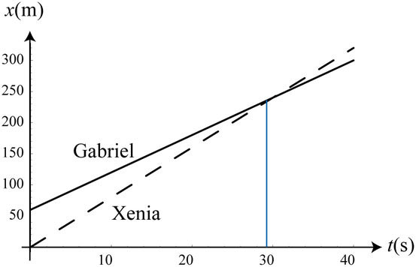

22. (a) The object of reference is the Earth. At t = 0, the person was 80 m east of the post office (taken to be the origin). He wanted to get to school that is located 120 m due west of the post office. He started to walk at a constant speed, passing the post office after 20 seconds, and then got to school at t = 50 s.

(b) The motion diagram is shown below.

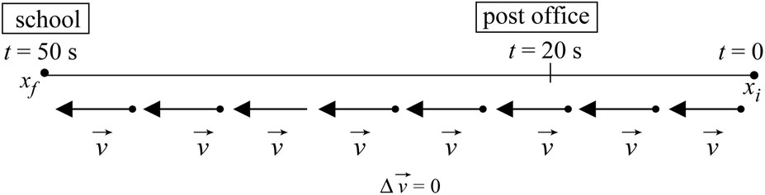

The position as a function of time can be written as and is plotted below.

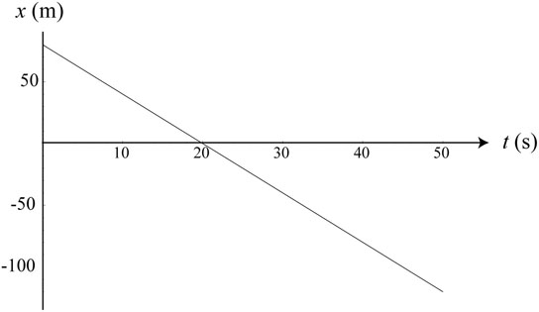

23. (a) The object of reference is Earth, with east as the positive direction. At t = 0, your friend Tom is 200 m due west of the physics building (taken to be the origin). He wants to get to the math building located 200 m east of the physics building. He starts to ride his bicycle at a constant speed, passing the physics building after 25 seconds, and then reaches the math building after another 25 seconds.
(b) The motion diagram is shown below.

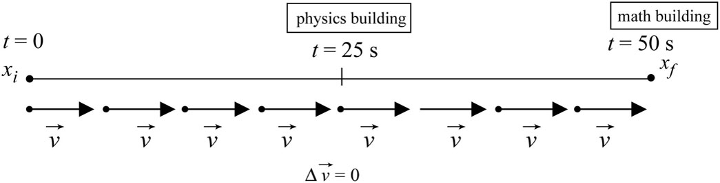
The position as a function of time can be written as and is plotted below.

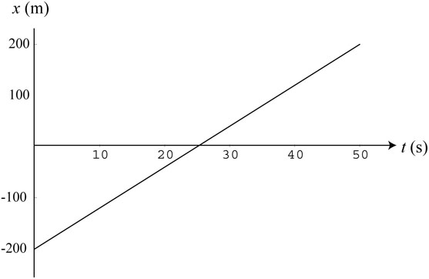

24. The relative speed between you and your friend is

After walking for two minutes (t₀ = 120 s), the initial separation between you and your friend is Therefore, the time it takes for your friend to catch up to you would be

or in two significant digits. In solving the problem, we have assumed that both you and your friends have walked a straight path at a constant speed (no stopping).

25. Sketch and translate Both Gabriele and Xena, the objects of interest, are riding their bicycles at constant speeds, but in opposite directions. We choose a reference frame with Earth as the object of reference.

Simplify and diagram We assume that Gabriele and Xena are point-like objects. The origin of the coordinate system will be the zero mark on the bike path, where an observer stands, and the positive direction will be toward east.

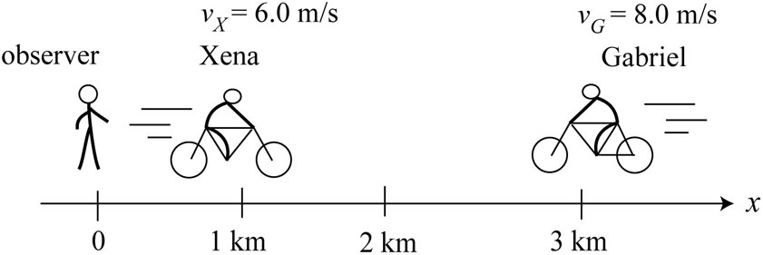

Represent mathematically The positions of Gabriele and Xena with respect to the zero mark of the bike path as a function of time are given by

Solve and evaluate
(a) The functions describing the positions of Gabriele and Xena with respect to Earth are:

(b) The two people meet when Solving the equation gives

or t = 143 s, which leads to or approximately 1.9 km, in two significant digits.

The problem can be solved in three different ways. Besides using Earth as the frame of reference, we could have used either Gabriele or Xena as our frame of reference.

(c) Xena’s position with respect to Gabriele can be written as

The positions of Gabriel and Xena as a function of time are plotted below.

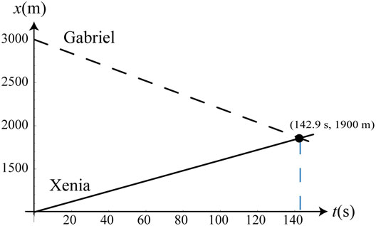

26. The relative speed between Jim and the police car is

With a separation of the time it takes for the police car to catch up to Jim would be

which implies a distance of or 2.7 km.

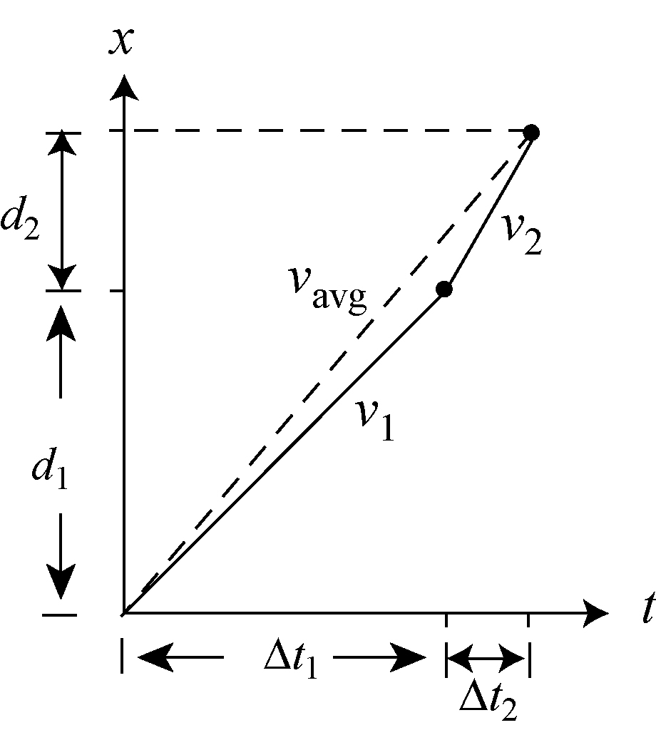
27. Sketch and translate The average speed is the total distance traveled divided by the total time of travel. Let the distance to the top of the hill be d. The time taken for the first part of the hike is where d₁ is the distance and v₁ is the speed. Similarly, for the second part, we have where d₂ is the distance and v₂ is the speed.

Simplify and diagram The total distance traveled is and the total time of travel is The average speed is given by the slope of the straight line connecting the two end points, as shown in the figure.

Represent mathematically The total time of travel can be written as

Thus, the average speed is
Solve and evaluate Given that , , and the above expression simplifies to

28. Using the result from the previous problem, we find the average speed of the race to be (with )

Solving the above expression for v₂, we obtain

29. Sketch and translate Let the time taken for the first part of the trip be where d₁ is the distance traveled and v₁ is the speed. Similarly, for the second part, we have where d₂ is the distance and v₂ is the speed. The total distance traveled is and the total time of travel is

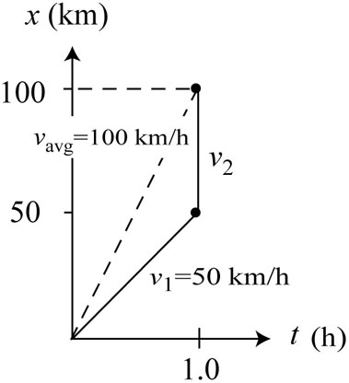
Simplify and diagram Given that , the speed for the first 50 km is and we want the average speed of the 100-km trip to be 100 km/h. The sketch is shown to the right.

Represent mathematically The average speed can be written as

Solving the above equation for v₂ gives

Solve and evaluate With we see that in order to attain an average speed of 100 km/h, the speed for the second part of the trip must be infinite (), as can be seen from the vertical line shown in the figure above. Therefore, we conclude that it is physically impossible to reach this average speed, no matter how fast the driver goes.

30. A stationary observer on the ground sees Jane moving at a speed of 4.0 m/s and Bob at a speed of 3.0 m/s. From Jane’s reference frame, Bob is moving toward her at a speed of 7.0 m/s. Similarly, from Bob’s reference frame, Jane approaches him at a speed of 7.0 m/s. In all three frames, the time elapsed for Bob and Jane to meet up is

or about 14 s in two significant digits. Jane has moved about 57 m, while Bob has moved 43 m.

31. (a) The position functions for the four cases are

(b) For object 1, we have and The object, with an initial displacement of +30 m with respect to a reference point which we take to be the origin, moves at a constant velocity of −8.33 m/s. Object 2 remains at rest at the position Object 3 has an initial displacement of −10 m with respect to the origin, and moves at a constant velocity of +5.0 m/s. Similarly, object 4 has an initial displacement of −10 m with respect to the origin, and moves at a constant velocity of −3.33 m/s. The acceleration is zero in all four cases.

32. The initial speed of the car is and its speed 30 s later is The average acceleration of the car is

33. (a) The truck has an initial velocity With a constant acceleration for t₁ = 5.0 s, its velocity at the end of the time interval is

The distance the truck has traveled while accelerating is

(b) With an acceleration of for t₂ = 3.0 s, the final velocity of the truck is

and the displacement during this time interval is

The distance traveled by the truck as function of time is plotted below.

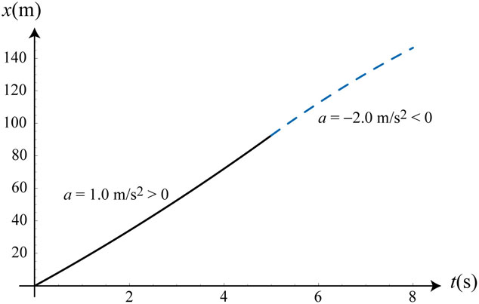

The total distance traveled during the 8-second interval is

34. We assume constant acceleration during the collision process. In the reference frame of a stationary observer on Earth, the velocity change for each car is With the time required for the car to come to a complete stop is

and the corresponding stopping distance is

or about 18 cm.
35. We assume that the bus starts from rest () at the intersection and undergoes constant acceleration with At the end of a 5.0-second interval, the displacement of the bus with respect to the intersection is

On the other hand, if the bus has a non-zero initial velocity then its displacement after 5.0 s would be which is greater than 25 m.

36. The acceleration of the bus is

Since the jogger speeds up at the same acceleration as the bus, his velocity and position as a function of time as observed by a stationary observer (standing at where the bus first passed him) are

37. (a) The motion diagram is shown below

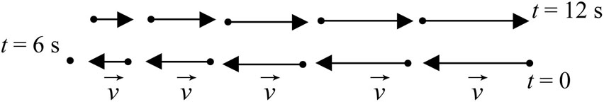

The position, velocity, and acceleration as function of time are given by

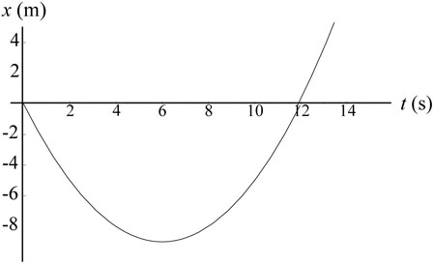 | 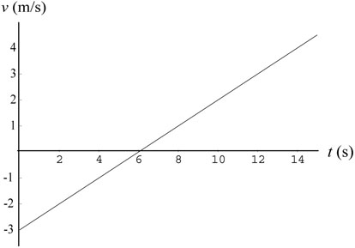 | 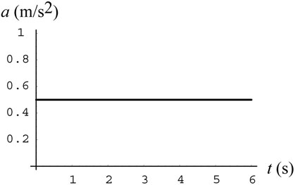
(b) A story for the motion could be as follows: At t = 0, a bicyclist, with an initial speed of 3.0 m/s due west (east taken to be positive), realizes that he’s going in the “wrong” direction and begins to apply the brake. His acceleration is 0.50 m/s² (due east). He comes to a complete stop 6.0 s later at

He then quickly turns around and pedals eastward with the same acceleration as before.

38. Sketch and translate The sketch of the process is shown below. The bicycle is the object of interest and is moving downhill, which we take to be the positive direction with respect to the chosen reference frame.
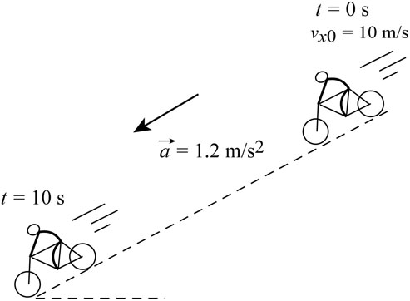

Simplify and diagram With our convention, the components of the bicycle’s velocity along the axis of motion are positive at t = 0 and t = 10 s. The speed of the bicycle (the magnitude of its velocity) increase; it is moving faster in the positive direction.

Represent mathematically The speed of the cyclist at the end of the descent is
Similarly, the distance traveled during this time interval is

Solve and evaluate With and the speed of the cyclist at the end of the descent that lasts for 10 s is

The distance traveled during the 10-s interval is

In arriving at the results above, we have assumed a constant acceleration (ignoring factors such as the air resistance and condition of the road), and a completely straight path for our one-dimensional kinematics analyses to hold.
39. The initial speed of the truck in SI units is With we find the acceleration of the truck during the collision to be

or rounded to two significant digits. The negative sign indicates that the truck is slowing down.

40. (a) Using the time interval required for the speed increase is

(b) Using we find the distance the squid has traveled while accelerating to be
or about 7.5 cm.

41. The initial and final speeds are and respectively. The time it takes for her to reach this speed is so the average acceleration is

On the other hand, to stop in the required acceleration would be

In our calculations, we have assumed one-dimensional motion, where the dragster is taken to be a point-like object. In addition, by ignoring factors such as air resistance and road condition, the acceleration is taken to be constant throughout.

42. Sketch and translate The sprinter’s motion consists of two phases: an accelerating phase that lasts for 1.8 s, attaining a speed of 10.8 m/s, and a constant-speed phase, in which the sprinter maintains a speed of 10.8 m/s until he reaches the finish line.

Simplify and diagram We assume the motion to be one-dimensional, and model the sprinter as a point-like object. We also assume a constant acceleration that ends abruptly upon reaching 10.8 m/s, the speed at which the sprinter maintains for the remaining part of the race. The situation is depicted below.

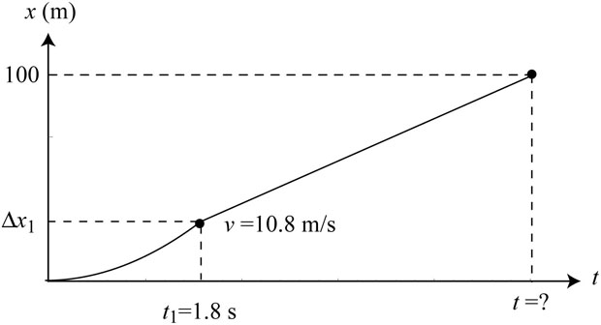

Represent mathematically The acceleration of the sprinter to attain a final speed of
10.8 m/s in 1.8 s is
During this time interval, the sprinter has advanced

and the distance remained for the 100-m race is

Solve and evaluate The time required to finish this segment at a constant speed of
10.8 m/s is
So it took the sprinter to finish the entire race.

43. The motion diagrams for the two runners are shown below.

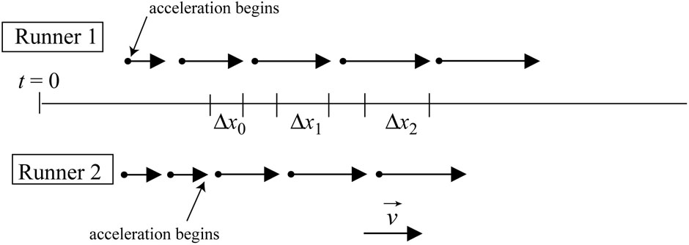

From the diagram, we see that the distance between the two runners will continue to increase with time.

Quantitatively, the positions of the two runners can be represented by

Note that the time origin in the expressions above corresponds to the moment when the second runner also begins to accelerate. The separation between the two runners is

Initially the distance between the two runners is However, the linear term tells us that will increase with time, as shown in the position-versus-time graph below.
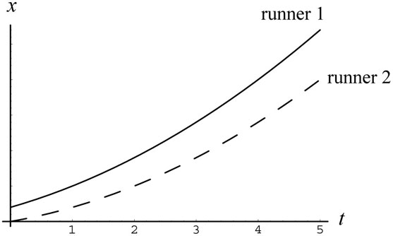

44. (a) Using we find the acceleration of the meteorite to be

which has a magnitude of In the above, we have taken the meteorite to be a point-like object, and applied the one-dimensional kinematics analysis.

(b) The time it takes for the meteorite to come to a complete stop is

45. The acceleration of the froghopper is

The distance moved while accelerating is

or about 2.0 mm.

46. The final speed of the tennis ball is Using the average acceleration of the tennis ball is

The time interval for the racket-ball contact is or about 3.4 ms.

47. To attain a speed of in t₁ = 0.40 s, the acceleration during launch is

After the launch, the time it takes to stop the motion using a catching net with accelerationis

The distance traveled while being stopped by the net is

or about 1.4 m, rounded to two significant digits.

48. With an initial speed of the average acceleration required to stop the motion in 1.4 s is

The negative sign indicates that the velocity is decreasing. The distance traveled as the sled slows down is
or about 200 m.

49. (a) Using we find the acceleration of the sprinter to be

(b) The distance traveled during this time interval is

(c) In our calculations, we have assumed one-dimensional motion, where the sprinter is taken to be a point-like object and the path is a straight line. We also take the acceleration to be constant throughout the interval.

(d) The distance to the finish line is The time required to finish this segment of the race at a constant speed of 11.2 m/s is

(e) It takes the sprinter to finish the entire race. With 2 significant digits, the uncertainty is 0.1 s.

50. Sketch and translate The sprinter’s motion consists of two phases: an accelerating phase that lasts for 1.7 s, attaining a maximum speed , followed by a constant-speed phase, in which the sprinter maintains his maximum speed until he reaches the finish line.
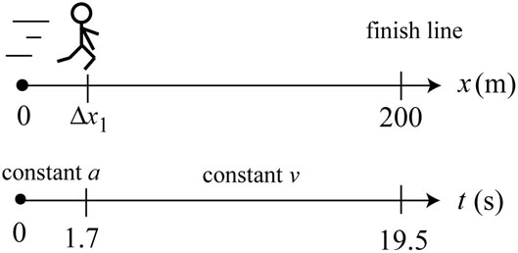

Simplify and diagram We assume the motion to be one-dimensional, and model the sprinter as a point-like object. We also assume a constant acceleration that ends abruptly upon reaching v_{max}. The position and velocity as a function of time are depicted below.

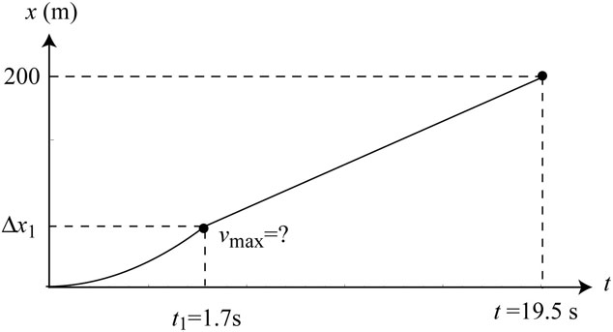 | 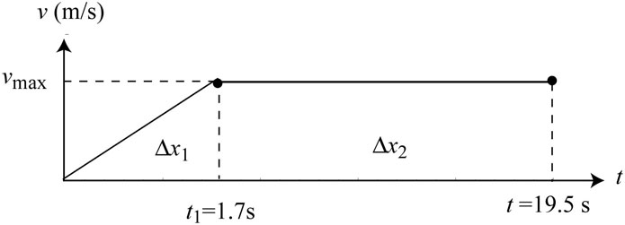

Represent mathematically The average acceleration needed to reach the maximum speed in is During this phase, the sprinter has traveled

Note that Δx₁ is the area of the triangle in the velocity-versus-time graph. Thus, the distance remaining for the 200-m race is

Solve and evaluate In order to tie for the 19.5-s record, he must complete this distance in The two statements together imply

which can be solved to give

51. The initial speed of the bus is Assuming that the bus has a constant acceleration of the distance it travels before coming to a complete stop is

or about 42 m, in two significant digits.

52. We assume the car to be a point-like object and apply one-dimensional kinematics to analyze its motion. The information on the acceleration of the car can be extracted from one of the three formulas: or For example, if we know the time (t) it takes for the car to travel a certain distance (Δx), starting from rest, then the acceleration would be On the other hand, if we know the speed of the car at the end of the accelerating interval, then we can simply use to deduce the acceleration.

53. During the tth second, the displacement is 2t. For the first t second, the total displacement is Since one can readily show that the displacement as a function of time can be written as

Comparing with the standard form for constant acceleration a, we see that the equation above indeed describes a motion with constant acceleration (and ).

54. (a) Using we find the acceleration of the car to be

(b) In this case, the acceleration is .

(c) In (a), the object is moving in the –x-direction, with acceleration also in the –x-direction (a < 0). On the other hand, in (b), the object is moving in the –x-direction, while the acceleration points in the +x-direction (a > 0).

55. The displacements of cars A and B are tabulated below:

time (s) | 0 | 10 | 20 | 30 | 40 | 50 | 60
x_{A}(m) | 200 | 0 | –200 | –400 | –600 | –800 | –1000
x_{B}(m) | –200 | –100 | 0 | 100 | 200 | 300 | 400

Mathematically, the positions can be written as

56. (a) From we know that the initial position of the object is and it moves with a constant velocity (zero acceleration).
(b) A student is 10 m east of the physics building (taken to be the origin) when he realizes that there is a special seminar on the origin of the Universe. Not wanting to miss any part of it, he starts running at 4.0 m/s toward the building.

(c) The position-versus-time graph is shown below.
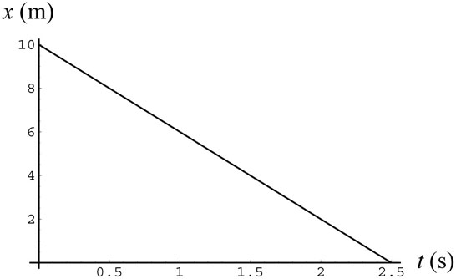

The student reaches the physics building after

57. (a) The function describes a motion with constant acceleration.

(b) The object is initially at (with respect to some reference frame) with an initial velocity of and a constant acceleration

(c) A car is initially 100 m west of an intersection (origin, with east taken to be positive) and heading east at a speed of 30 m/s when the driver notices that the traffic light has turned yellow. He steps on the gas pedal and the car starts to accelerate at 3.0 m/s².

(d) The velocity function of the car is
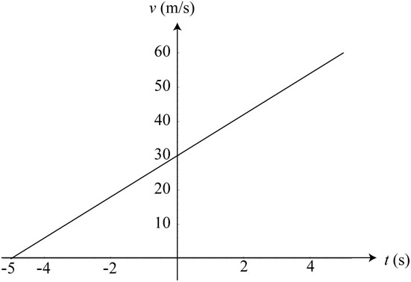

(e) The time is the only time where the speed of the car is zero. It is at One can think of this instant as 5.0 s before some reference time.

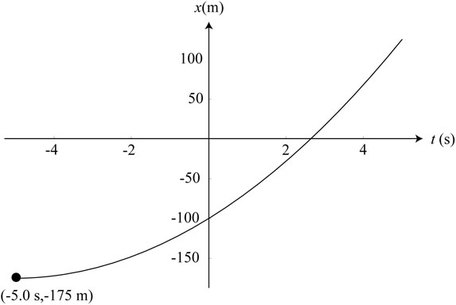

58. (a) From we find the initial position of the object to be at Its initial velocity is and the object is undergoing a constant acceleration with Its velocity can be written as The graphs of position, velocity, and acceleration as function of time are plotted below.

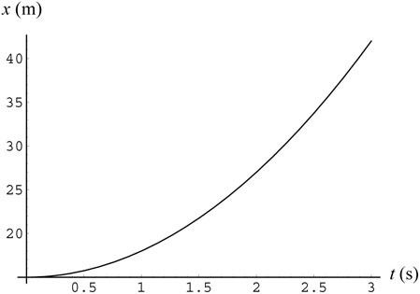 | 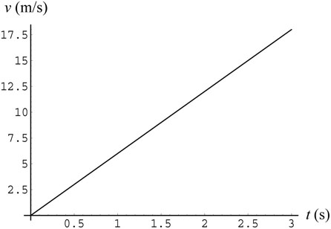 | 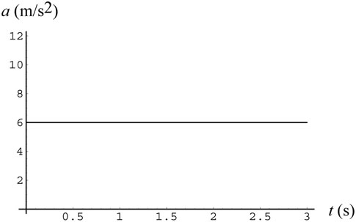

Story: A car is initially parked illegally 15.0 m due east of an intersection (taken to be the origin). Seeing a police car coming, the driver starts his car and moves away (eastbound) with acceleration 3.0 m/s².

(b) From we find the initial position of the object to be at Its initial velocity is with zero acceleration. The graphs of position, velocity, and acceleration as function of time are plotted below.

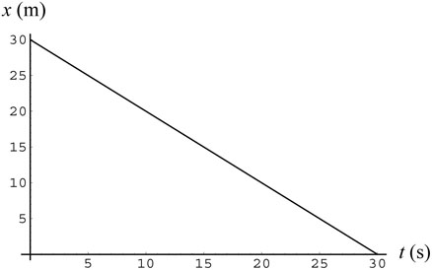 | 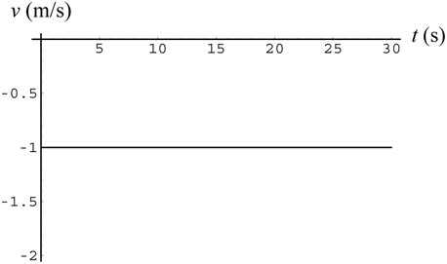 | 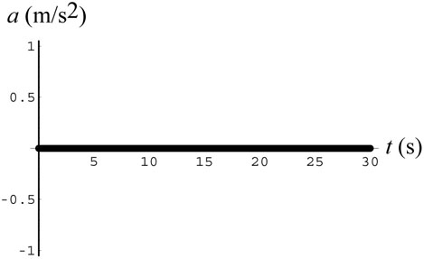

Story: A student is 30 m due east of his classroom (taken to be the origin, with east positive) when he realizes that he forgot to turn in his homework. He starts walking at a speed of 1.0 m/s toward the classroom, and gets there after 30 s.

(c) For the initial position of the object is at (with respect to some reference point). The object is at rest there with zero velocity and zero acceleration.

Story: A car has been parked 10 m due west of a stop sign (the origin, with east being the positive x-direction). The graphs of position, velocity, and acceleration as function of time are plotted below.

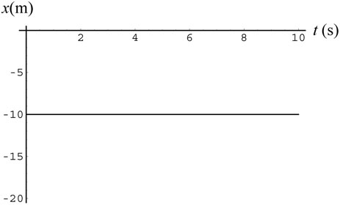 | 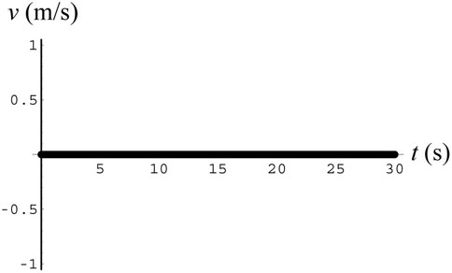

59. Sketch and translate We choose Earth as the object of reference with the observer’s position as the reference point. The positive direction points to the east. We have two objects of interest here – A and B, which we treat as point-like.

Simplify and diagram The initial position of object A is and its constant velocity is (the velocity is negative since it’s moving westward). Object B’s initial position is and its constant velocity is.
The motion diagram of the objects is shown below.

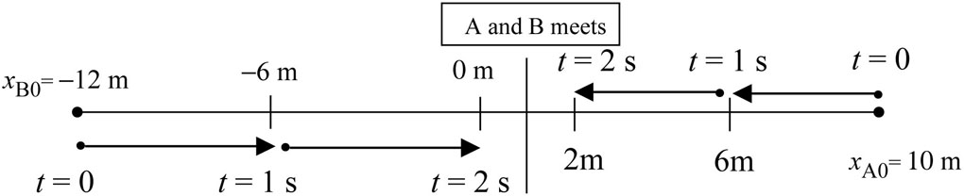

Represent mathematically The positions of objects A and B are given by

Solve and evaluate From the graph shown above, we see that the two objects would meet between 2.0 and 3.0 s later at a position between x = 0 and x = 2.0 m.

We also plot the graphs of position and velocity as function of time.
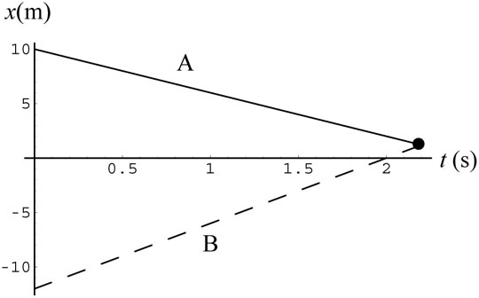 | 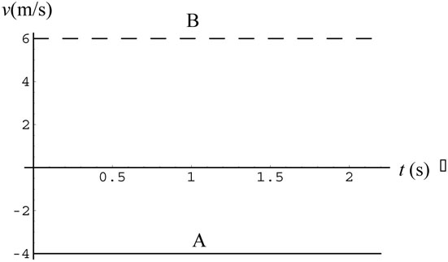
Solving the equation mathematically, we find

which gives So the two object meet at

60. The velocities and positions of the two cars can be written as

and

Using we find that Car 1 stops after 5.0 s, and Car 2 stops after 4.0 s. The distances traveled while stopping are

The graphs below show how their velocities and positions change with time.

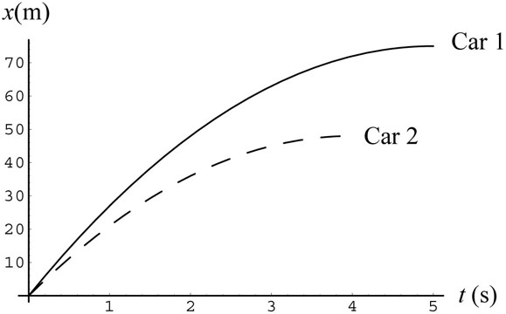 | 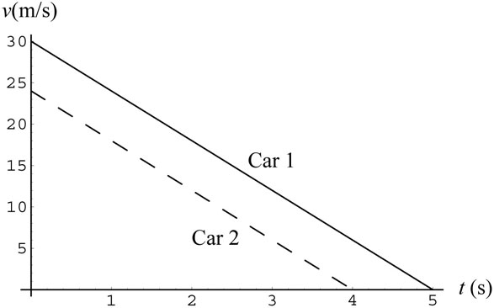

61. (a) At t = 0, a car is moving at a constant velocity of 20 m/s. At t = 8.0 s, the driver begins to slow down by applying a negative constant acceleration, and the car comes to a complete stop at t = 20 s.

(b) The acceleration of the car is So the velocity of the car at is The displacement of the car during a time interval is given by the area under the velocity-versus-time curve. Thus, between 10 s and 20 s, we have

(c) The displacement for the first 8 seconds is

Similarly, from 8.0 s to 20 s, we have

Thus, the total distance traveled is and the corresponding average speed is

62. (a) The following story could be used to describe the graph: At t = 0, the driver of a car that is moving at a constant velocity of −20 m/s due west (with east taken to be the positive x-direction) has just realized that he was going the wrong way. He steps on the brake (which applies a constant deceleration) and the car comes to a stop 30 s later. He quickly turns around and heads east with a constant acceleration, reaching a speed of 10 m/s at t = 45s. Between 45 s and 60 s, the car maintains this speed. At t = 60 s, the driver thinks that he might be late for his appointment and begins to accelerate; the car reaches 20 m/s at t = 70s.

(b) The acceleration between 0 and 45 s is

During this interval, the displacement of the car is the area under the curve:

The same result can be obtained using

The path traveled is

(c) For the next two time intervals, we have

Thus, the total displacement for the first 70 s is

and the average velocity is . On the other hand, the path length the car has traveled is

giving an average speed of

63. From the figure, we see that Car 2 is moving at a constant velocity since the spacing between dots is uniform. On the other hand, the non-uniformity in the spacing between dots for Car 1 implies that it has non-zero acceleration.

Qualitatively, we see that both cars are at the same position at t = 1.0 s and have the same displacement between t =3 and t = 4 s. Thus, the cars should have roughly the same speed at t = 3.5 seconds.

We can also analyze the problem more quantitatively. Let’s assume that the velocity of Car 1 is initially zero, so its position is represented as where a₁ is the constant acceleration. Similarly, for Car 2, we have Now at t = 1 s, both cars are at the same position:

In addition, both cars have the same displacements between 3.0 s and 4.0 s. This gives:

(a) The speeds of the two cars are

We readily see that the two speeds are the same at t = 3.5 s.

(b) The positions of the cars as function of time can be written as (in SI units)

For simplicity, we set so that and Thus, according to this model,

we find that the cars are at the same positions at two different times: t = 1.0 s and However, exactly when both cars would meet again depends on the details of the initial conditions.
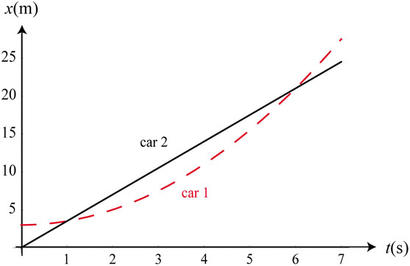

64. A possible story for the processes is as follows: A truck with failed brake begins to slide down an inclined ramp at constant acceleration. At t = t₁, it runs into another parked truck, and finally comes to a complete stop 0.40 s later.

From the two equations given, the speed of the truck before hitting the second truck is With the time it takes for the truck to slide down is and the distance traveled is (Part I)

For Part II, we find the acceleration to stop the truck in 0.40 s to be

The total distance the truck has traveled (relative to its initial position at the top of the ramp) is

65. (a) Using with the time it takes for the eraser to reach the ground (y = 0) is

(b) The speed just before striking the ground is

(c) The result would be which is greater than 15 m. The result is expected since the speed in (b) represents the maximum speed of the eraser.

66. The average speed of the eraser is

which is half of the speed just before impact. Using the average value we obtain which is the height from which the eraser was dropped.

67. Sketch and translate We choose Earth as the object of reference with the ground observer’s position as the reference point (y = 0). The positive direction points up. The tennis ball is our object of interest, which we treat as point-like.

Simplify and diagram The object’s acceleration is on the way up; on the way down; and even at the instant when the object is momentarily at rest at the highest point of its motion. At all times during the object’s flight, its velocity is changing at a rate of each second. The position and velocity as a function of time are plotted below.
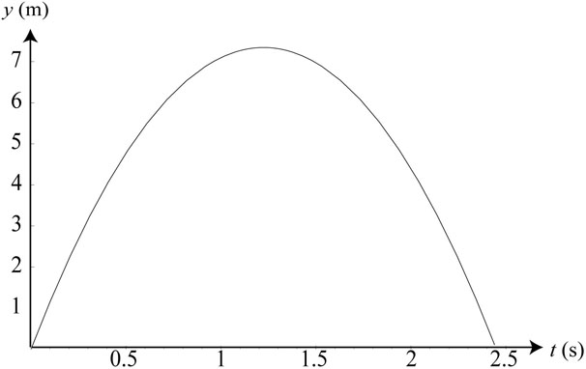 | 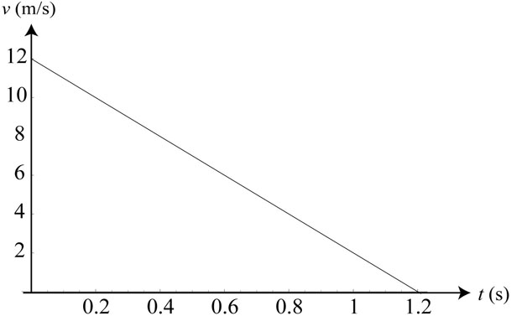

Represent mathematically The vertical motion of the tennis ball can be represented by

Note that y(t) is the position of the ball relative to where it was first released.

Solve and evaluate With an initial speed of the ball reaches its maximum height in

with

The total flight time of the tennis ball is Note that a speed of 12 m/s, or about 27 mi/h, is a reasonable value with a human throw.

68. The acceleration of the parachute is

Using we find the distance fallen to be

The magnitude of the acceleration is or about 5.36g. Since it exceeds the 5g limit, there’s good probability that the skydiver will faint. In our calculation, we have modeled the skydiver as a point-like object and ignored the air resistance, which will greatly reduce the acceleration of the skydiver.

69. The vertical motion of the helmet can be represented by

where upward is the +y-direction. One can show that at the helmet reaches its maximum height With we find the initial speed to be

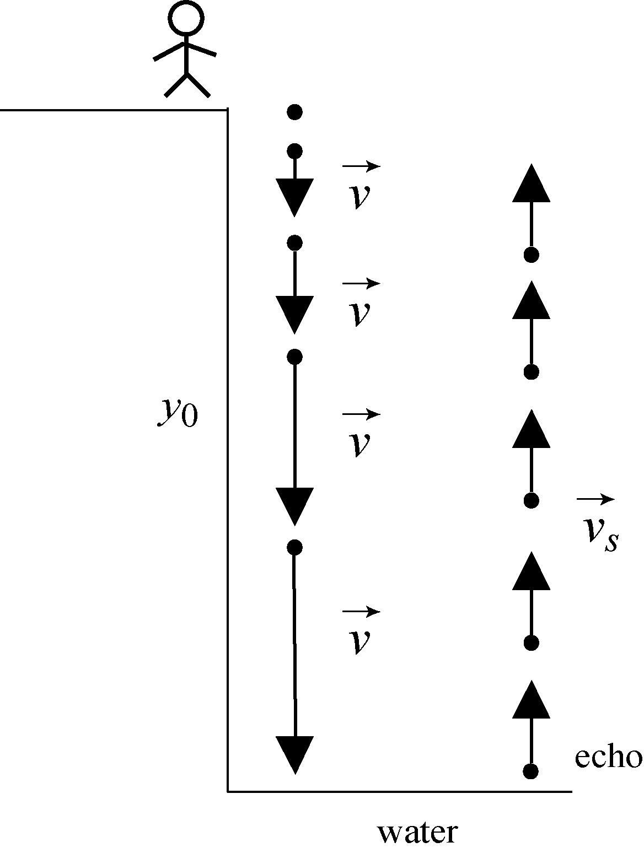
The total flight time is simply

70. Sketch and translate We choose Earth as the object of reference with your position as the reference point (y = 0). The positive direction points downward. The rock is our object of interest, which we treat as point-like. The situation is depicted in the figure to the right.

Simplify and diagram With our convention, the rock’s acceleration is on the way down. After hitting the water, the echo propagates up at a speed of .

Represent mathematically Let (with downward as +y), the time taken for the rock to drop a distance y₀ is . It then takes for the sound to travel back. So the time elapsed before you hear the echo is

Solve and evaluate To solve for y₀, we first bring the second term to the left-hand-side and then square both sides to obtain

With and , after some algebra, we obtain In our calculation, we have ignored air resistance and assumed that the rock and the echo travel in a straight path. Taking these factors into consideration will result in a lower acceleration, and hence a smaller depth. The time it takes for you to hear the echo as a function of canyon depth is plotted below.

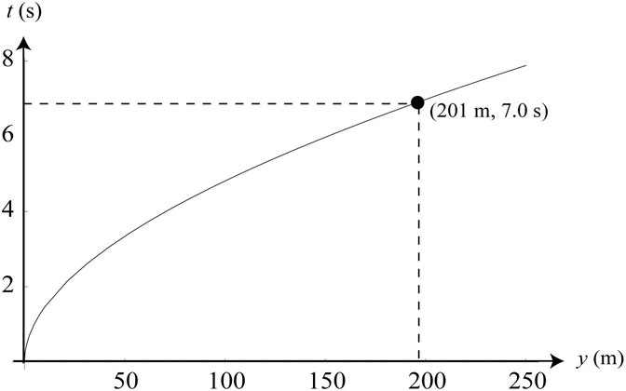

71. The vertical distance fallen t seconds after an object undergoes free fall is Thus, we find the reaction time to be

or about 0.16 s.

72. Using (with downward taken to be +y), the time taken for the diver to fall at a distance y is . With we obtain

The speed of the diver before entering the water is . In this calculation, we have modeled the diver as a point-like object and ignored air resistance. Taking air resistance into consideration would result in a lower speed for the diver.

73. The time required for the first rock to strike the ground is

For the second rock to reach the ground the same time as the first one, its travel time would be Let its initial speed be We then have

which can be readily solved to give
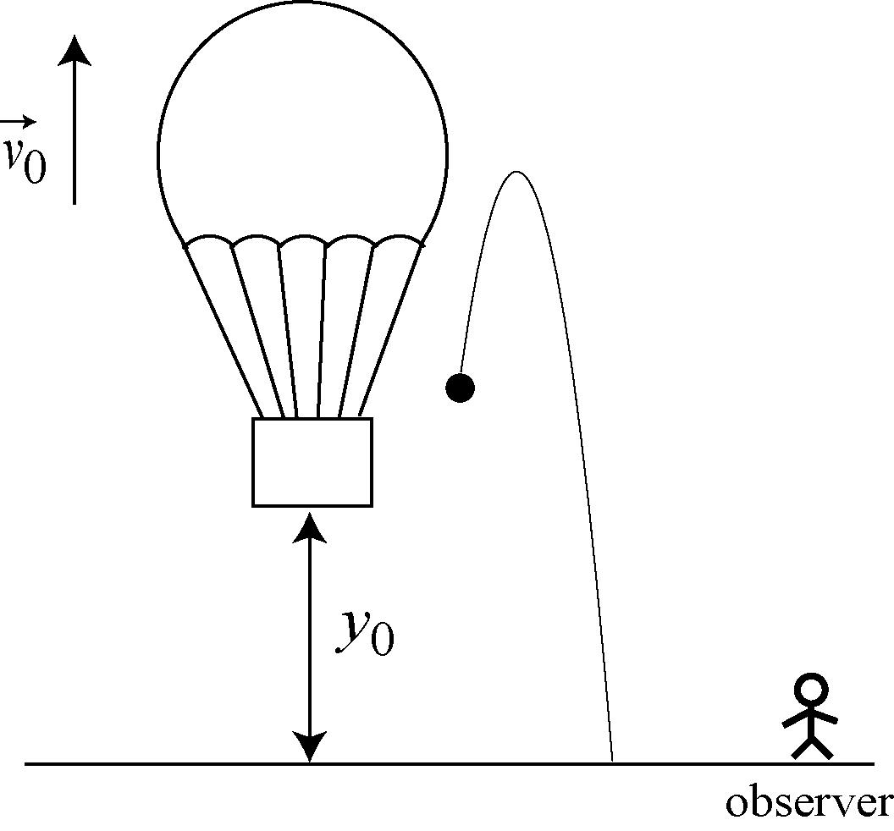
74. Sketch and translate Upon release, the lunch bag
will have an initial upward speed of 7.0 m/s, as the hot air balloon. An observer on the ground will first see the bag go up and then come down. The situation is depicted to the right.
Represent mathematically Using, the position of the bag, the object of interest, can be written as (with upward taken to be the positive y-direction)
Solve and evaluate Solving the quadratic equation for y = 0, the condition that the bag has reached the ground, we obtain (the other solution t = −1.61 s can be rejected). With the velocity of the bag right before hitting the ground is

The negative sign indicates that the bag is traveling in the –y-direction. The speed of the bag is simply +22.8 m/s. The position and velocity of the bag as a function of time are plotted below.
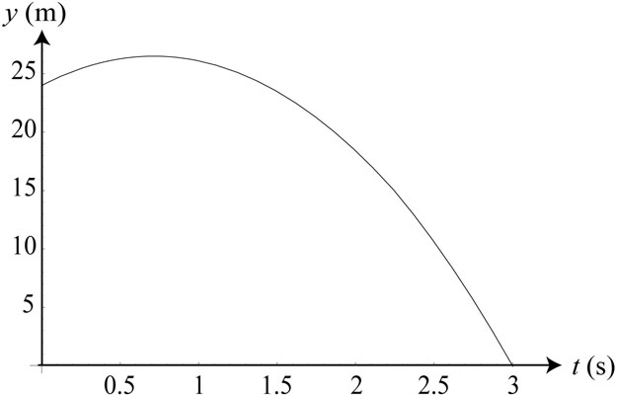 | 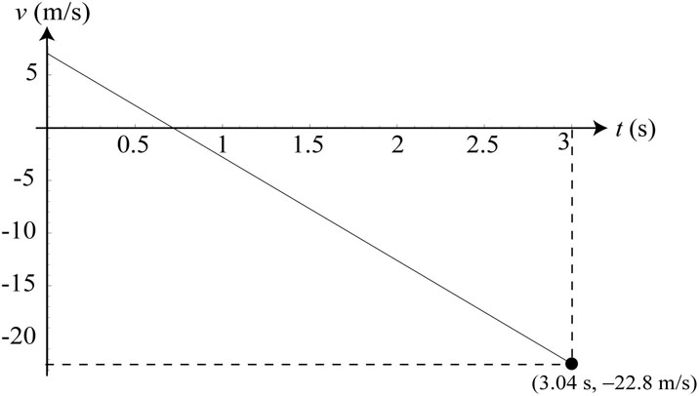

75. The position of the knife can be written as, with upward taken to be positive y-direction, where and Solving the quadratic equation for y = 0, the condition that the knife has reached the ground, we obtain (the other solution t = −3.3 s can be rejected). The velocity of the knife right before reaching the ground is

The negative sign indicates that the knife is traveling in the –y-direction. The speed of the knife is simply +22.2 m/s.

76. Assuming that the driver of the car before you applied an acceleration of to stop his car, it would take for the car to stop, and the distance traveled during this time interval is

Driving at a distance 20 m behind the first car, you have a total of 4.0 s to respond to avoid a collision. With a reaction time of Δt = 0.60 s, your car has advanced a “reaction distance” of This means that you must be able to stop your car within and the “braking distance” be less than The acceleration to stop in 3.4 s is , and the distance traveled is

This is less than 40 m, so a collision can be avoided.

77. Suppose Car 1 traveling with a speed of v₁₀ applies a constant acceleration a₁. It would take (a₁ < 0) for the car to stop, and the distance traveled during this time interval is

Similarly, if Car 2 is traveling with a speed of v₂₀, with a constant acceleration a₂, it would take (a₂ < 0) for Car 2 to stop, and the distance traveled during this time interval is For the driver in Car 2, his reaction time is so his reaction distance is If the initial separation between the two cars is d, then the condition for avoiding a rear-end collision is , with The above expressions can be combined to give

If both cars have the same initial speed, then the condition for stopping would imply

and the above expression can be simplified to Note that this represents the minimum distance required with given above to avoid collision. For example, if the reaction time is with the minimum distance of separation would be , provided that the condition is met (car 2 brakes harder than car 1).

78. The distance traveled during reaction time is After applying the brake, the distance traveled before coming to a stop is

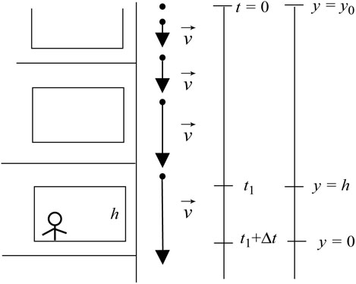
79. Sketch and translate We choose Earth as the object of reference with your position as the reference point
(y = 0). The positive direction points upward. The water balloon is our object of interest, which we treat as point-like. The situation is depicted in the figure to the right.

Simplify and diagram The balloon’s acceleration is as it is dropped. The position of the water balloon can be written as, with upward taken to be positive y-direction,

Represent mathematically The vertical distance traveled between and is

Solve and evaluate With and we solve for t₁ and obtain Therefore, we conclude that the water balloon must have been dropped from a height

above you. So, look for guest that live 5.0 m, or two floors, above you!

80. According to the problem, to incur zygomatic bone injury, the acceleration of the puck must exceed 900 g, with a contact time of 6.0 ms or longer. Suppose the puck hits the cheek and the contact time interval lasts 0.0060 s (6.0 ms), during which its speed changes by Δv. The change of speed needed to have an acceleration of 900 g would then be

or a change of about 118 mi/h. If the puck hits the face and stops, the stopping distance is given by or
0.16 m

This stopping distance is unphysical, as it would mean that the puck has gone inside the skull. Thus, the puck is not likely to be in contact with the bone long enough to break it.

81. Let the speed of the rocket at the end of 1.6 s be v₁. The maximum height it reaches is With we find the speed to be

Thus, the average acceleration during the launch is . Note that we have assumed the rocket to be a point-like object and neglected air resistance. Taking air resistance into consideration would have raised the value of during launch.

82. The results are tabulated below:
Speed  (mi/h) | Speed v₀  (m/s) | Reaction  distance d_{R} (m) | Reaction time t_{R} (s) | Braking  distance d_{B} (m) | Total stopping  distance (m) | Acceleration a (m/s²)
20 | 8.94 | 7 | 0.783 | 7 | 14 | −5.7
40 | 17.88 | 13 | 0.727 | 32 | 45 | −4.99
60 | 26.82 | 20 | 0.75 | 91 | 111 | −3.95
In the above, the reaction time is d_{R}/v₀, while the acceleration is .

83. Suppose the truck is going at v₀ = 55 mi/h (25 m/s), and you’re 20 m behind the truck. You decide to accelerate at to pass the truck in Δt seconds. To pass safely, you also want to pass the truck by 20 m before moving back to the lane. Since the truck has moved a distance in time Δt, the distance you need to travel is

Equating with and solving for we have . This is a reasonable time for passing a truck.

84. We first ignore reaction time. Suppose Car A traveling with a speed of v_{A0} applies a constant acceleration a_{A}. It would take (a_{A} < 0) for the car to stop, and the distance traveled during this time interval is

Similarly, if Car B is traveling with a speed of v_{B0}, with a constant acceleration a_{B}, it would take (a_{B} < 0) for Car B to stop, and the distance traveled during this time interval is Substituting the values given, we find the total distance traveled by the two cars to be

which is less than 100 m. Thus, the two cars will not collide.

Realistically, one should take reaction time into consideration. Suppose for both drivers. Then the total distance traveled during reaction time would be In this case, we would have

which exceeds their initial separation of 100m, resulting in collision.
85. (c) The time interval is .

86. (c) The average speed is .

87. (a) The stopping distance would be .

88. (e) The stopping distance is .
89. (d) Acceleration can be calculated using or . Thus, we see that a longer impact time interval (Δt), a longer stopping distance (Δx), and a smaller initial speed v₀, all reduce the magnitude of the acceleration.

90. (b) From the reading passage, air in the atmosphere absorbs the X-rays before they reach Earth-based detectors.

91. (a) The speed of the rocket at the end of the burn is

92. (b) The height reached at the end of the fuel burn is

or about 10,000 m.

93. (c) The speed of the rocket at the end of the burn is v₁ = 2400 m/s. Its subsequent speed is given by and its instantaneous speed at the maximum height is zero. The time it takes to get there is

or about 250 s.

94. (a) The maximum height the rocket reaches is

or about 300,000 m.

