Concepts of Motion | 1
Conceptual Questions
1.1. (a) 3 significant figures.
(b) 2 significant figures. This is more clearly revealed by using scientific notation:
(c) 4 significant figures. The trailing zero is significant because it indicates increased precision.
(d) 3 significant figures. The leading zeros are not significant but just locate the decimal point.
1.2. (a) 2 significant figures. Trailing zeros in front of the decimal point merely locate the decimal point and are not significant.
(b) 3 significant figures. Trailing zeros after the decimal point are significant because they indicate increased precision.
(c) 4 significant figures.
(d) 3 significant figures. Trailing zeros after the decimal point are significant because they indicate increased precision.
1.3. Without numbers on the dots we cannot tell if the particle in the figure is moving left or right, so we can’t tell if it is speeding up or slowing down. If the particle is moving to the right it is slowing down. If it is moving to the left it is speeding up.
1.4. Because the velocity vectors get longer for each time step, the object must be speeding up as it travels to the left. The acceleration vector must therefore point in the same direction as the velocity, so the acceleration vector also points to the left. Thus, is negative as per our convention (see Tactics Box 1.4).
1.5. Because the velocity vectors get shorter for each time step, the object must be slowing down as it travels in
thedirection (down). The acceleration vector must therefore point in the direction opposite to the velocity; namely, in the +y direction (up). Thus, is positive as per our convention (see Tactics Box 1.4).
1.6. The particle position is to the left of zero on the x-axis, so its position is negative. The particle is moving to the right, so its velocity is positive. The particle’s speed is increasing as it moves to the right, so its acceleration vector points in the same direction as its velocity vector (i.e., to the right). Thus, the acceleration is also positive.
1.7. The particle position is below zero on the y-axis, so its position is negative. The particle is moving down, so its velocity is negative. The particle’s speed is increasing as it moves in the negative direction, so its acceleration vector points in the same direction as its velocity vector (i.e., down). Thus, the acceleration is also negative.
1.8. The particle position is above zero on the y-axis, so its position is positive. The particle is moving down, so its velocity is negative. The particle’s speed is increasing as it moves in the negative direction, so its acceleration vector points in the same direction as its velocity vector (i.e., down). Thus, the acceleration is also negative.
Exercises and Problems
Section 1.1 Motion Diagrams
1.1. Model: Imagine a car moving in the positive direction (i.e., to the right). As it skids, it covers less distance between each movie frame (or between each snapshot).
Solve:

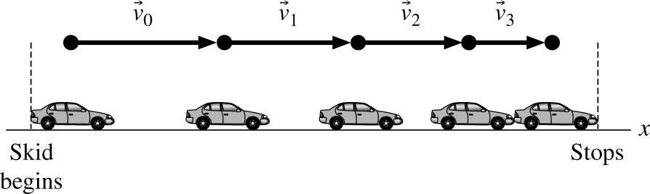

Assess: As we go from left to right, the distance between successive images of the car decreases. Because the time interval between each successive image is the same, the car must be slowing down.
1.2. Model: We have no information about the acceleration of the rocket, so we will assume that it accelerates upward with a constant acceleration.
Solve:

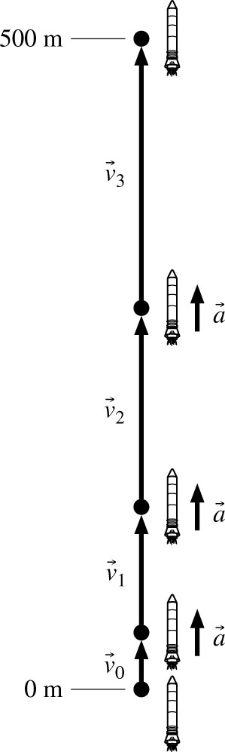

Assess: Notice that the length of the velocity vectors increases each step by approximately the length of the acceleration vector.
1.3. Model: We will assume that the term “quickly” used in the problem statement means a time that is short compared to 30 s.
Solve:

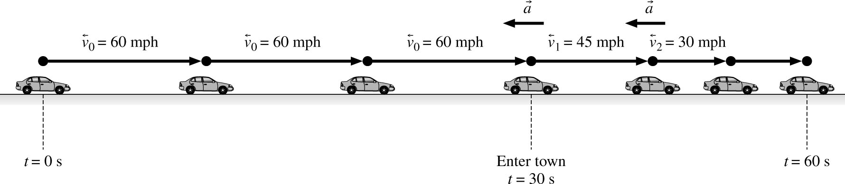

Assess: Notice that the acceleration vector points in the direction opposite to the velocity vector because the car is decelerating.
Section 1.2 The Particle Model
1.4. Solve: (a) The basic idea of the particle model is that we will treat an object as if all its mass is concentrated into a single point. The size and shape of the object will not be considered. This is a reasonable approximation of reality if (i) the distance traveled by the object is large in comparison to the size of the object and (ii) rotations and internal motions are not significant features of the object’s motion. The particle model is important in that it allows us to simplify a problem. Complete reality—which would have to include the motion of every single atom in the object—is too complicated to analyze. By treating an object as a particle, we can focus on the most important aspects of its motion while neglecting minor and unobservable details.
(b) The particle model is valid for understanding the motion of a satellite or a car traveling a large distance.
(c) The particle model is not valid for understanding how a car engine operates, how a person walks, how a bird flies, or how water flows through a pipe.
Section 1.3 Position and Time
Section 1.4 Velocity
1.5. Model: We model the ball’s motion from the instant after it is released, when it has zero velocity, to the instant before it hits the ground, when it will have its maximum velocity.
Solve:

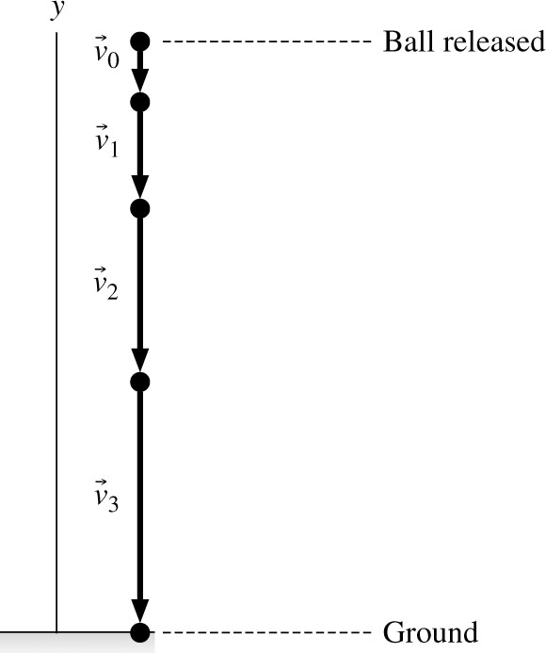
Assess: Notice that the “particle” we have drawn has a finite dimensions, so it appears as if the bottom half of this “particle” has penetrated into the ground in the bottom frame. This is not really the case; our mental particle has no size and is located at the tip of the velocity vector arrow.
1.6. Solve: The player starts from rest and moves faster and faster.

1.7. Solve: The player starts with an initial velocity but as he slides he moves slower and slower until coming to rest.

Section 1.5 Linear Acceleration
1.8. Solve: (a) Let be the velocity vector between points 0 and 1 and be the velocity vector between points
1 and 2. Speed is greater than speed because more distance is covered in the same interval of time.
(b) To find the acceleration, use the method of Tactics Box 1.3:

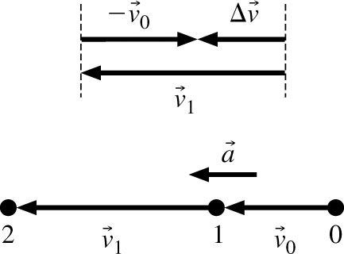

Assess: The acceleration vector points in the same direction as the velocity vectors, which makes sense because the speed is increasing.
1.9. Solve: (a) Let be the velocity vector between points 0 and 1 and be the velocity vector between points 1 and 2. Speed is greater than speed because more distance is covered in the same interval of time.
(b) Acceleration is found by the method of Tactics Box 1.3.

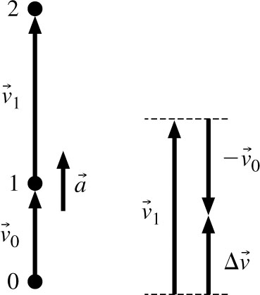
Assess: The acceleration vector points in the same direction as the velocity vectors, which makes sense because the speed is increasing.
1.10. Solve:

(a) | 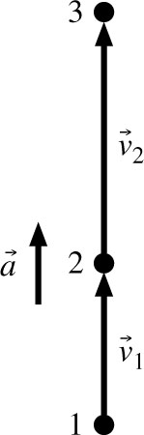 | (b) | 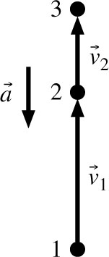
1.11. Solve:

(a) | 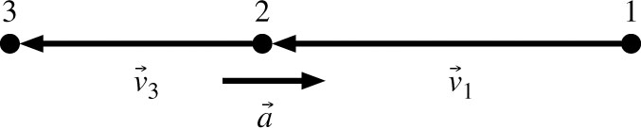 | (b) | 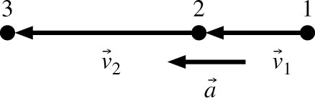
1.12. Model: Represent the car as a particle.

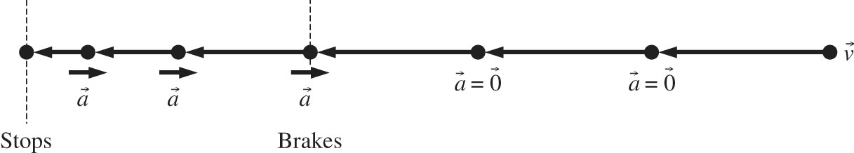

Visualize: The dots are equally spaced until brakes are applied to the car. Equidistant dots on a single line indicate constant average velocity. Upon braking, the dots get closer as the average velocity decreases, and the distance between dots changes by a constant amount because the acceleration is constant.
1.13. Model: Represent the (child + sled) system as a particle.

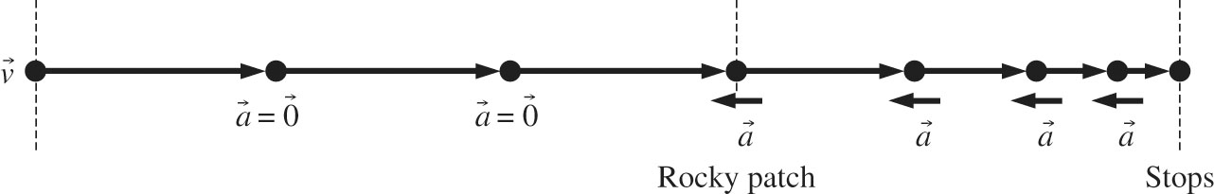

Visualize: The dots in the figure are equally spaced until the sled encounters a rocky patch. Equidistant dots on a single line indicate constant average velocity. On encountering a rocky patch, the average velocity decreases and the sled comes to a stop. This part of the motion is indicated by a decreasing separation between the dots.
1.14. Model: Represent the wad of paper as a particle. Ignore air resistance.

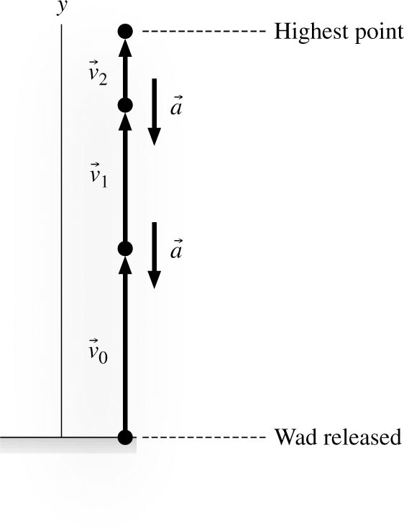

Visualize: The dots become more closely spaced because the particle experiences a downward acceleration. The distance between dots changes by a constant amount because the acceleration is constant.
1.15. Model: Represent the tile as a particle.
Visualize: Starting from rest, the tile’s velocity increases until it hits the water surface. This part of the motion is represented by dots with increasing separation, indicating increasing average velocity. After the tile enters the water, it settles to the bottom at roughly constant speed, so this part of the motion is represented by equally spaced dots.

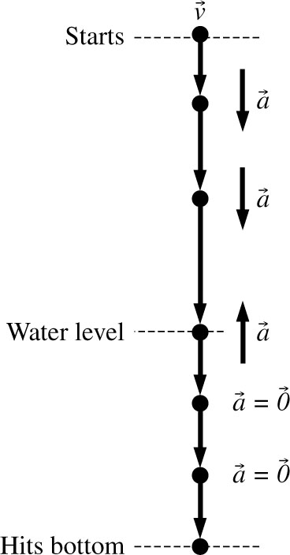
1.16. Model: Represent the tennis ball as a particle.
Visualize: The ball falls freely for three stories. Upon impact, it quickly decelerates to zero velocity while comp-ressing, then accelerates rapidly while re-expanding. As vectors, both the deceleration and acceleration are an upward vector. The downward and upward motions of the ball are shown separately in the figure. The increasing length between the dots during downward motion indicates an increasing average velocity or downward acceleration. On the other hand, the decreasing length between the dots during upward motion indicates acceleration in a direction opposite to the motion, so the average velocity decreases.

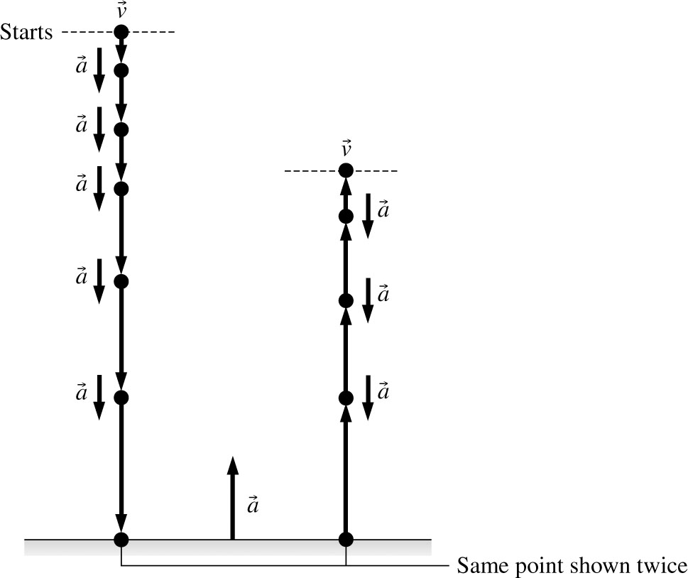

Assess: For free-fall motion, acceleration due to gravity is always vertically downward. Notice that the acceleration due to the ground is quite large (although not to scale—that would take too much space) because in a time interval much shorter than the time interval between the points, the velocity of the ball is essentially completely reversed.
1.17. Model: Represent the toy car as a particle.
Visualize: As the toy car rolls down the ramp, its speed increases. This is indicated by the increasing length of the velocity arrows. That is, motion down the ramp is under a constant acceleration At the bottom of the ramp, the toy car continues with a constant velocity and no acceleration.

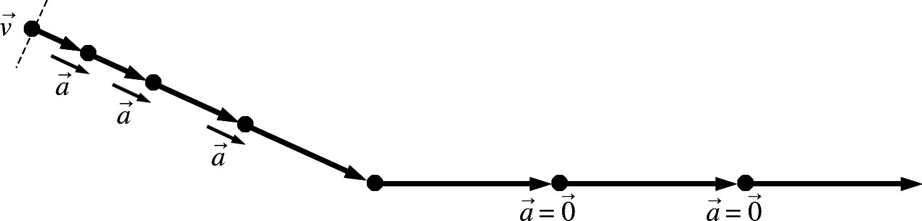

Section 1.6 Motion in One Dimension
1.18. Solve:

(a) | Dot | Time (s) | x (m) |  | (b) | 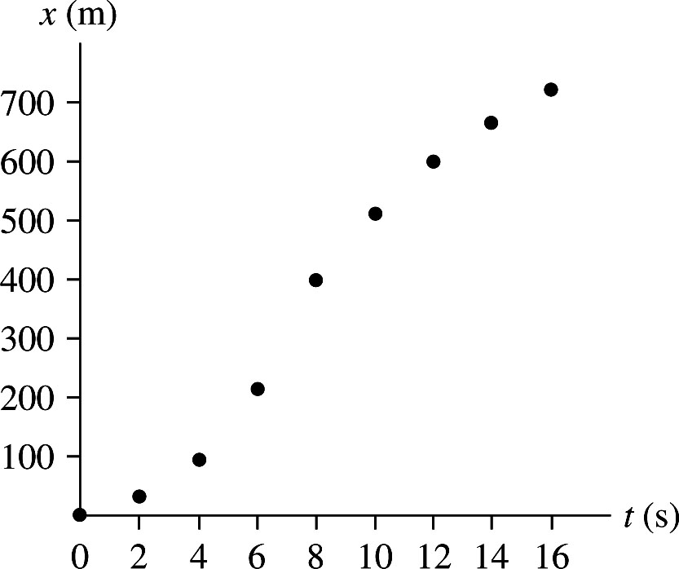
(a) | 1 | 0 | 0 |  | (b)
(a) | 2 | 2 | 30 |  | (b)
(a) | 3 | 4 | 95 |  | (b)
(a) | 4 | 6 | 215 |  | (b)
(a) | 5 | 8 | 400 |  | (b)
(a) | 6 | 10 | 510 |  | (b)
(a) | 7 | 12 | 600 |  | (b)
(a) | 8 | 14 | 670 |  | (b)
(a) | 9 | 16 | 720 |  | (b)

1.19. Solve: A forgetful physics professor is walking from one class to the next. Walking at a constant speed, he covers a distance of 100 m in 200 s. He then stops and chats with a student for 200 s. Suddenly, he realizes he is going to be late for his next class, so the hurries on and covers the remaining 200 m in 200 s to get to class on time.
1.20. Solve: Forty miles into a car trip north from his home in El Dorado, an absent-minded English professor stopped at a rest area one Saturday. After staying there for one hour, he headed back home thinking that he was supposed to go on this trip on Sunday. Absent-mindedly he missed his exit and stopped after one hour of driving at another rest area 20 miles south of El Dorado. After waiting there for one hour, he drove back very slowly, confused and tired as he was, and reached El Dorado two hours later.
Section 1.7 Solving Problems in Physics
1.21. Visualize: The bicycle move forward with an acceleration of Thus, the velocity will increase by 1.5 m/s each second of motion.

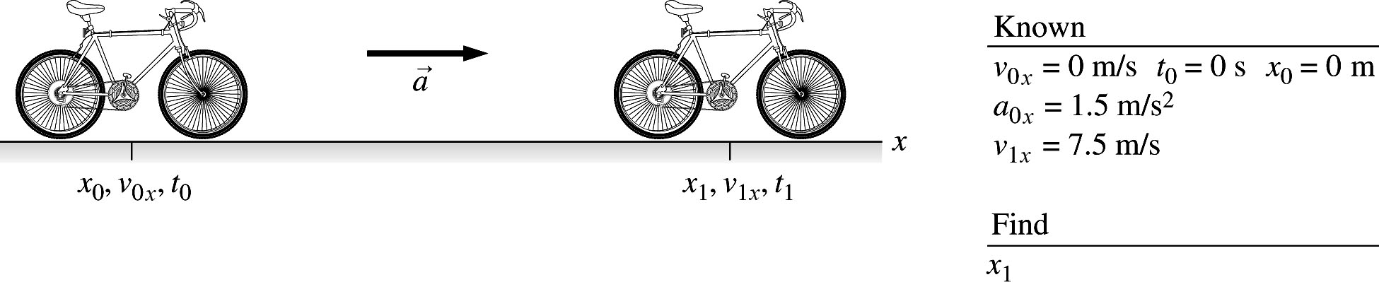

1.22. Visualize: The rocket moves upward with a constant acceleration The final velocity is 200 m/s and is reached at a height of 1.0 km.

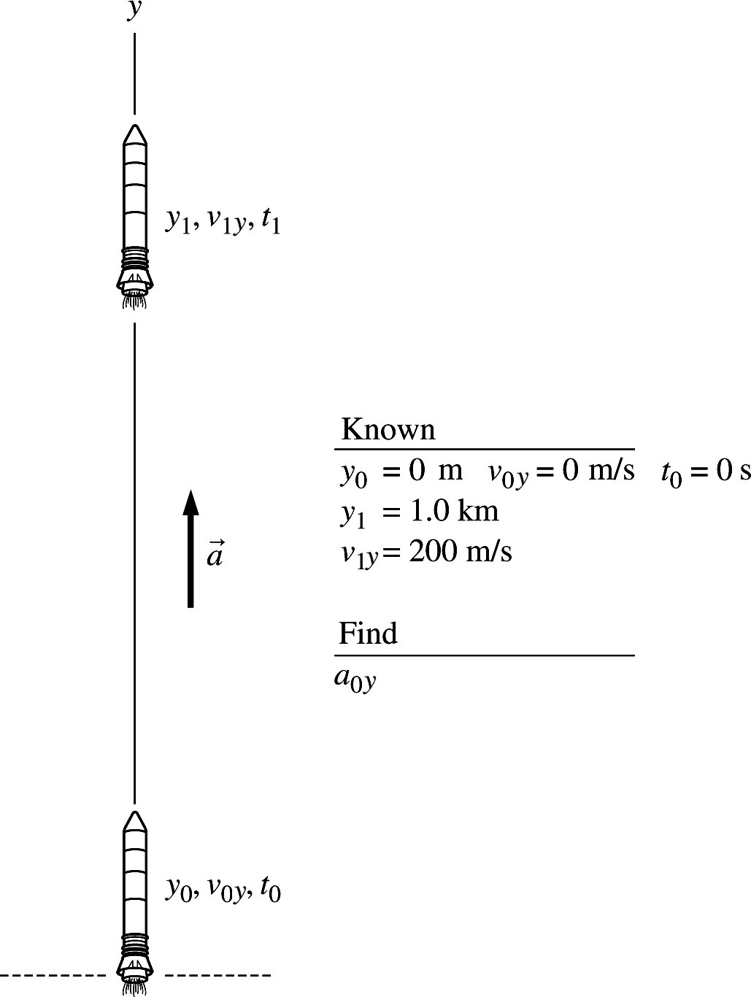
Section 1.8 Units and Significant Figures
1.23. Solve: (a)
(b)
(c)
(d)
1.24. Solve: (a)
(b)
(c)
(d)
1.25. Solve: (a)
(b)
(c)
(d)
Assess: The results are given to appropriate number of significant figures.
1.26. Solve: (a)
(b)
(c)
(d)

1.27. Solve:
(a)
(b)
(c)
(d)
1.28. Solve: (a)
(b)
(c)
(d)
1.29. Solve: (a)
(b)
(c)
(d)

1.30. Solve: The length of a typical car is 15 ft or
This length of 15 ft is approximately two-and-a-half times my height.
1.31. Solve: The height of a telephone pole is estimated to be around 50 ft or (using 1 m ~ 3 ft) about 15 m. This height is approximately 8 times my height.
1.32. Solve: I typically take 15 minutes in my car to cover a distance of approximately 6 miles from home to campus. My average speed is
1.33. Solve: My barber trims about an inch of hair when I visit him every month for a haircut. The rate of hair growth is
1.34. Model: Represent the Porsche as a particle for the motion diagram. Assume the car moves at a constant speed when it coasts.
Visualize:

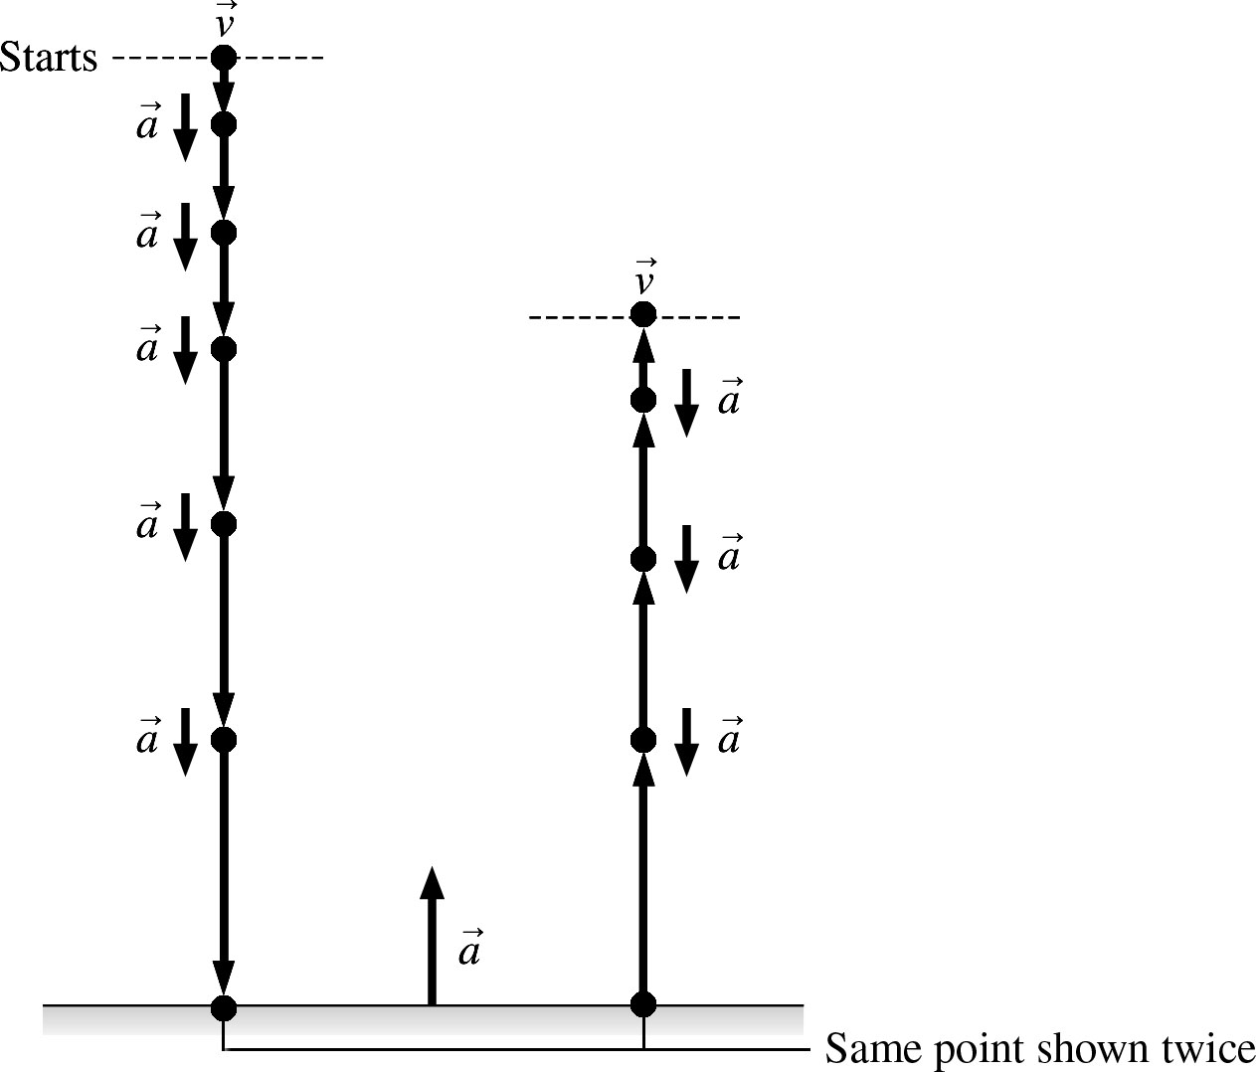
1.35. Model: Represent the jet as a particle for the motion diagram.
Visualize:

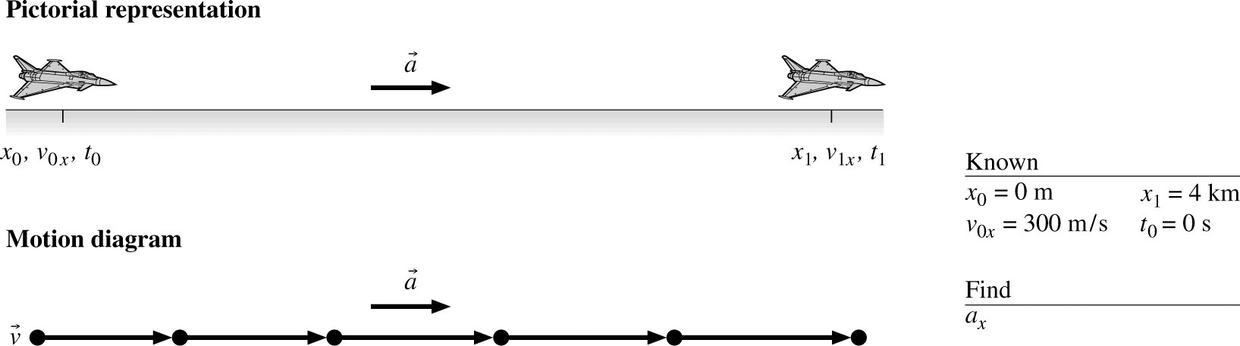

1.36. Model: Represent (Sam + car) as a particle for the motion diagram.
Visualize:

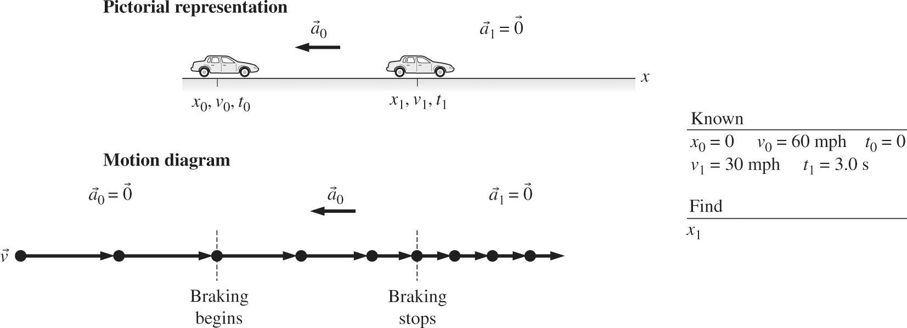

1.37. Model: Represent the wad as a particle for the motion diagram.
Visualize:
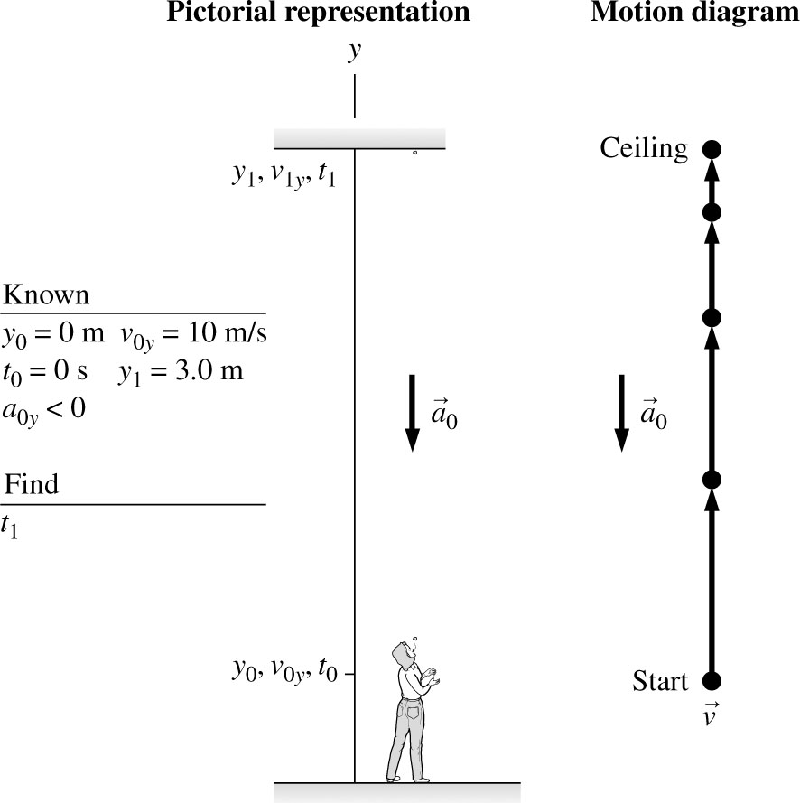

1.38. Model: Represent the speed skater as a particle for the motion diagram.
Visualize:

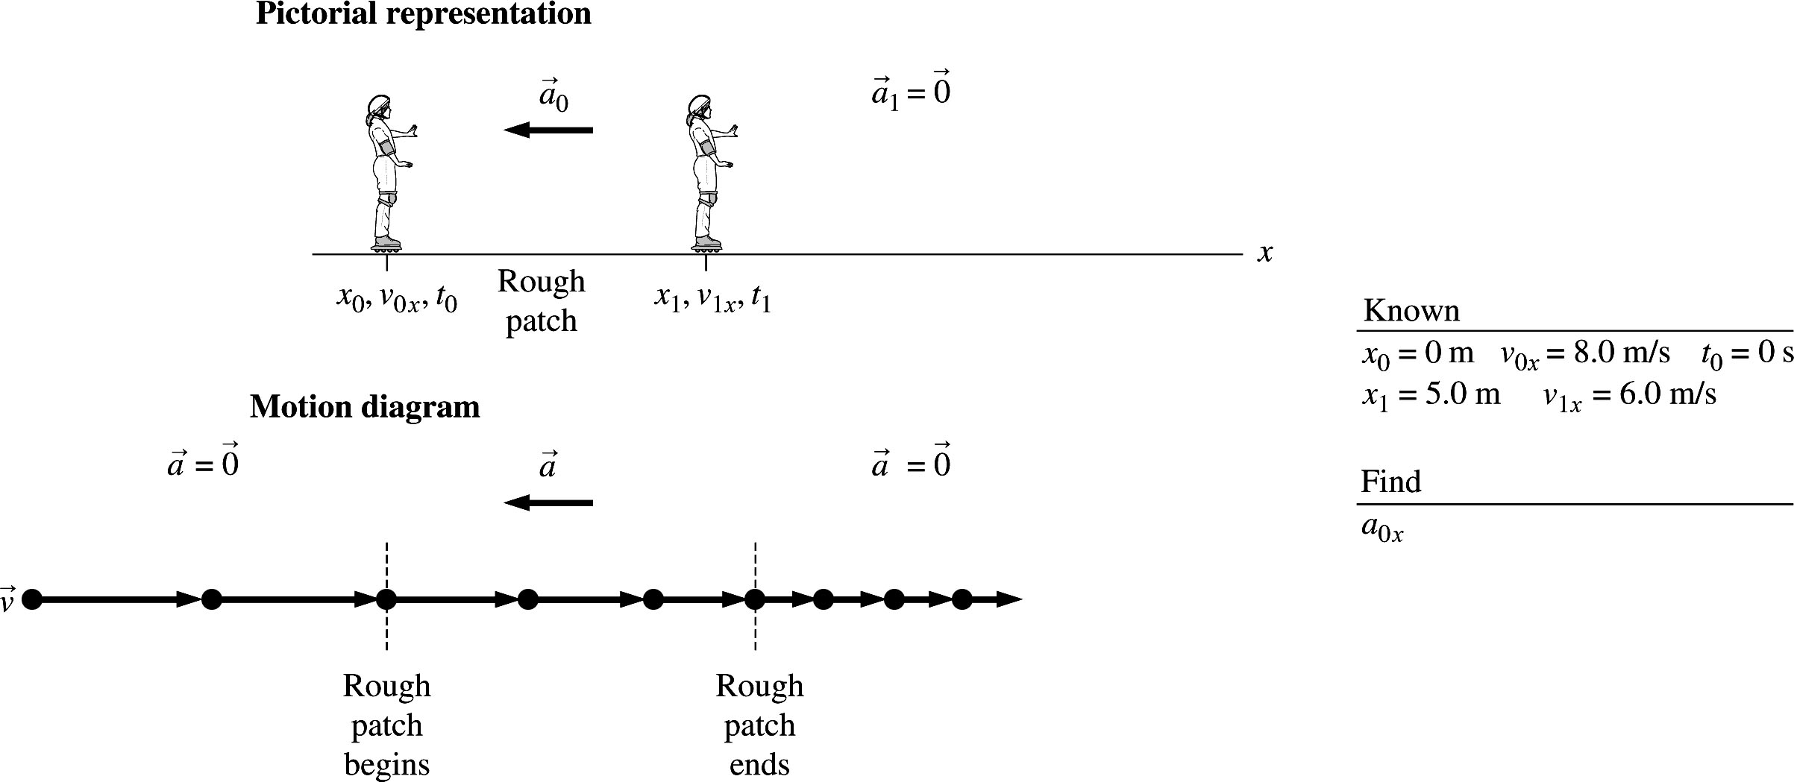

1.39. Model: Represent Santa Claus as a particle for the motion diagram.
Visualize:
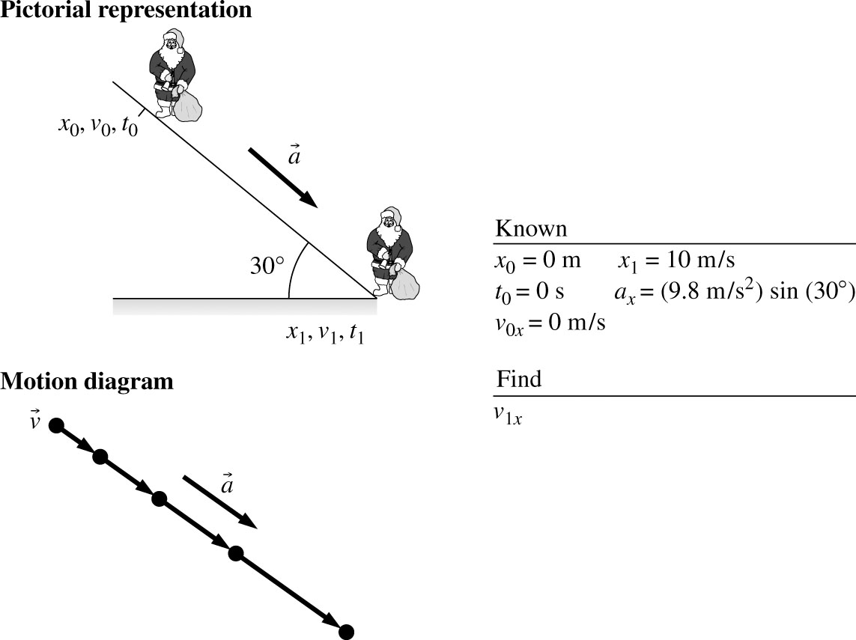

1.40. Model: Represent the motorist as a particle for the motion diagram.
Visualize:

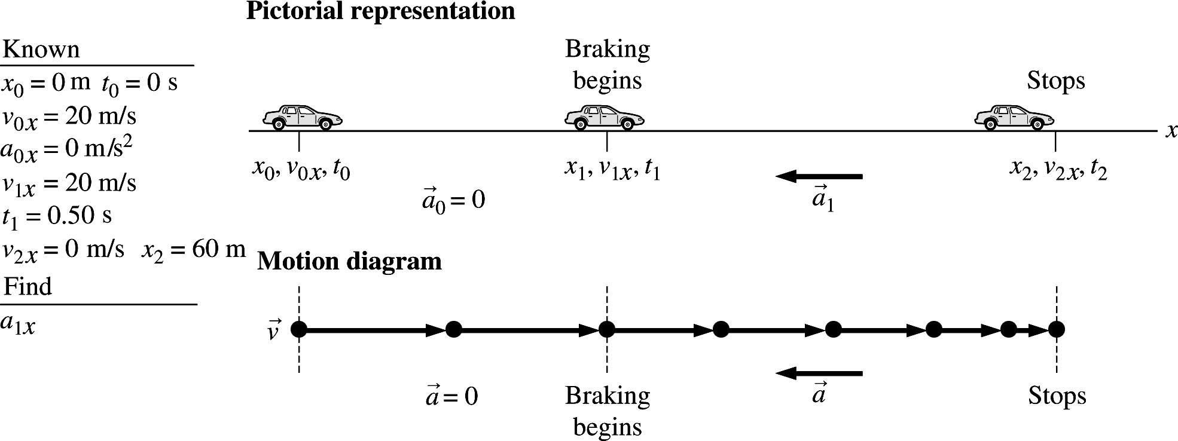
1.41. Model: Represent the car as a particle for the motion diagram.
Visualize:

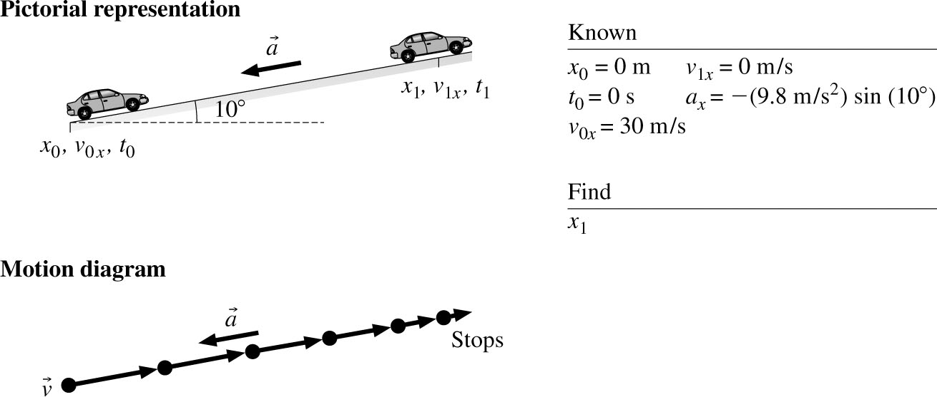
1.42. Model: Represent Bruce and the puck as particles for the motion diagram.
Visualize:
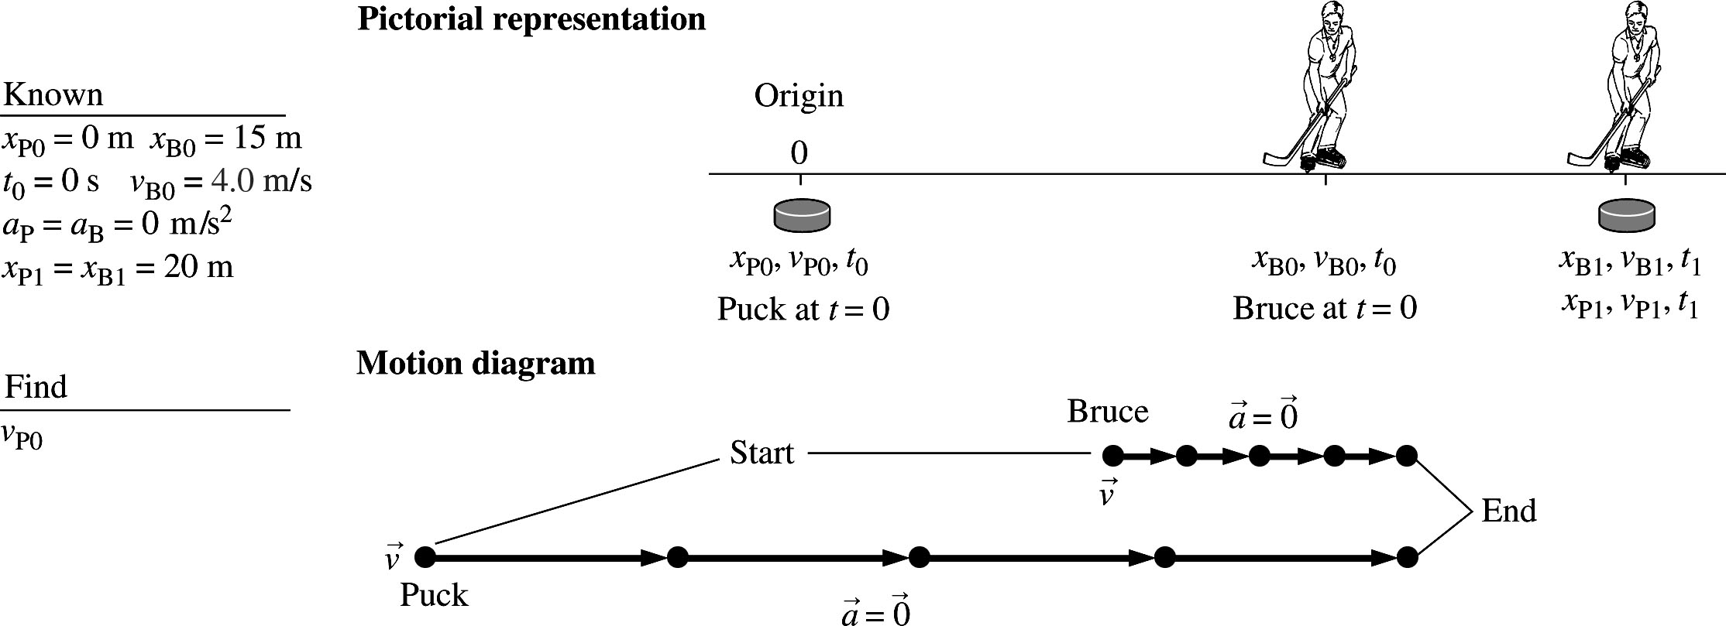

1.43. Model: Represent the cars of David and Tina and as particles for the motion diagram.
Visualize:
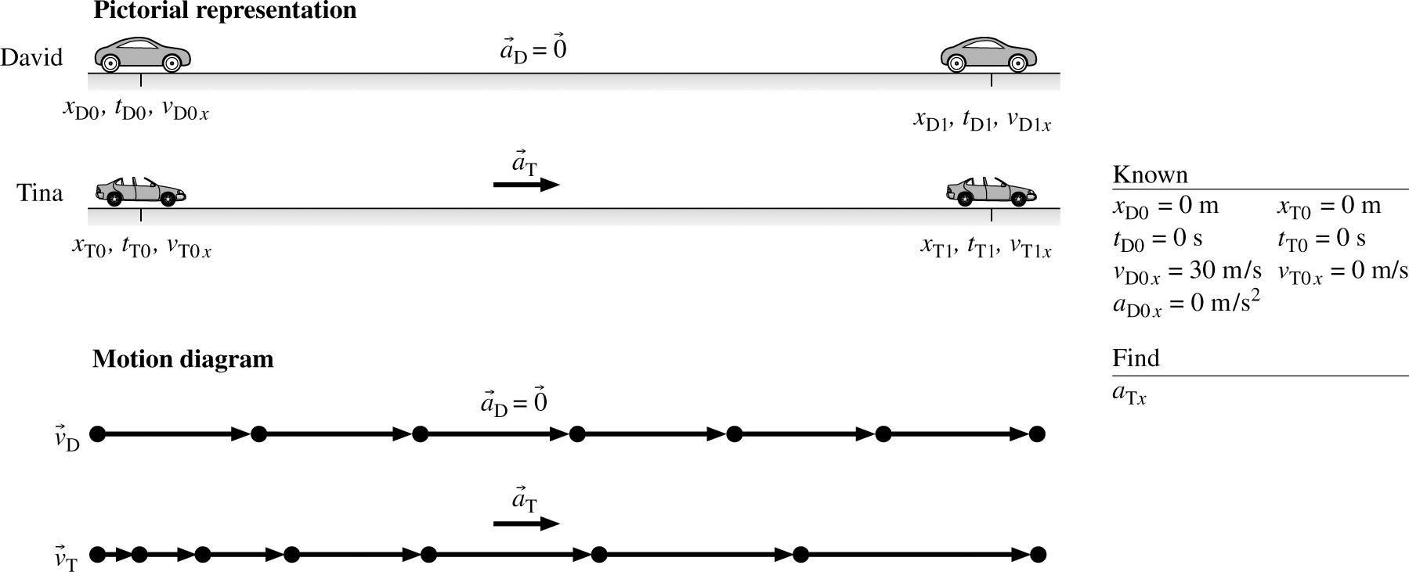

1.44. Solve: Isabel is the first car in line at a stop light. When it turns green, she accelerates, hoping to make the next stop light 100 m away before it turns red. When she’s about 30 m away, the light turns yellow, so she starts to brake, knowing that she cannot make the light.
1.45. Solve: A car coasts along at 30 m/s and arrives at a hill. The car decelerates as it coasts up the hill. At the top, the road levels and the car continues coasting along the road at a reduced speed.
1.46. Solve: A skier starts from rest down a 25° slope with very little friction. At the bottom of the 100-m slope the terrain becomes flat and the skier continues at constant velocity.
1.47. Solve: A ball is dropped from a height to check its rebound properties. It rebounds to 80% of its original height.
1.48. Solve: Two boards lean against each other at equal angles to the vertical direction. A ball rolls up the incline, over the peak, and down the other side.
1.49. Solve:
(a)

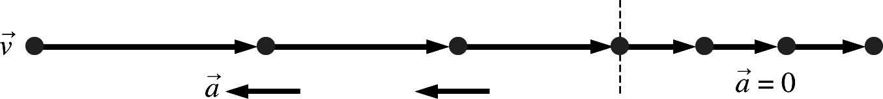

(b) A train moving at 100 km/hour slows down in 10 s to a speed of 60 km/hour as it enters a tunnel. The driver maintains this constant speed for the entire length of the tunnel that takes the train a time of 20 s to traverse. Find the length of the tunnel.
(c)
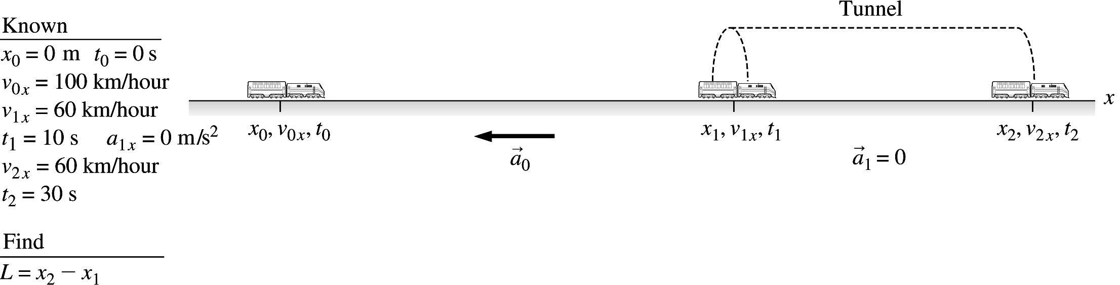
1.50. Solve:
(a)
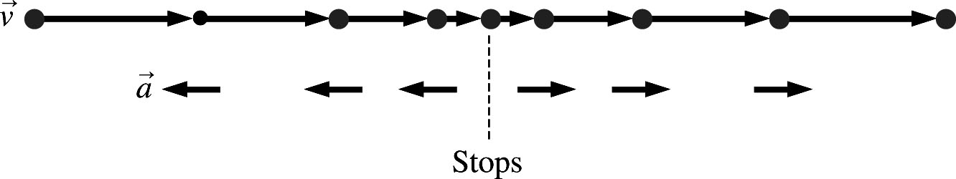

(b) Sue passes 3rd Street doing 30 km/h, slows steadily to the stop sign at 4th Street, stops for 1.0 s, then speeds up and reaches her original speed as she passes 5th Street. If the blocks are 50 m long, how long does it take Sue to drive from 3rd Street to 5th Street?
(c)

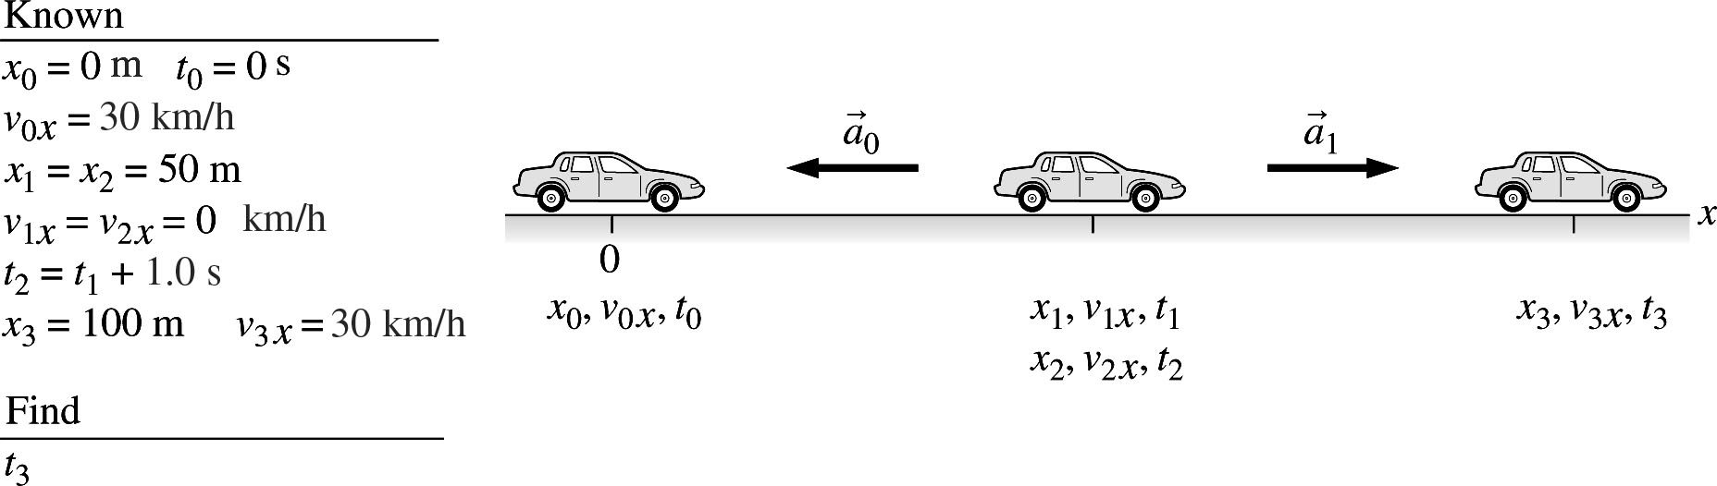
1.51. Solve:
(a)

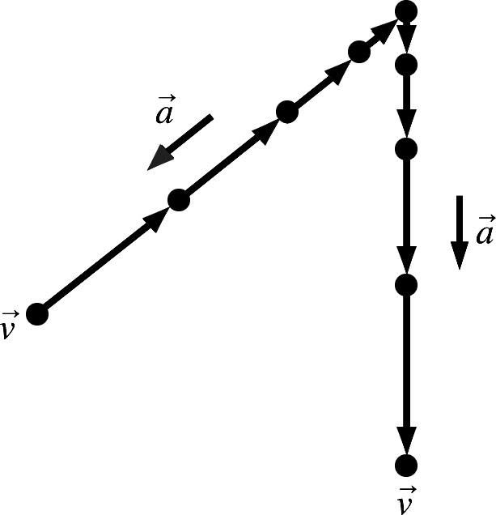

(b) Jeremy has perfected the art of steady acceleration and deceleration. From a speed of 60 mph he brakes his car to rest in 10 s with a constant deceleration. Then he turns into an adjoining street. Starting from rest, Jeremy accelerates with exactly the same magnitude as his earlier deceleration and reaches the same speed of 60 mph over the same distance in exactly the same time. Find the car’s acceleration or deceleration.
(c)

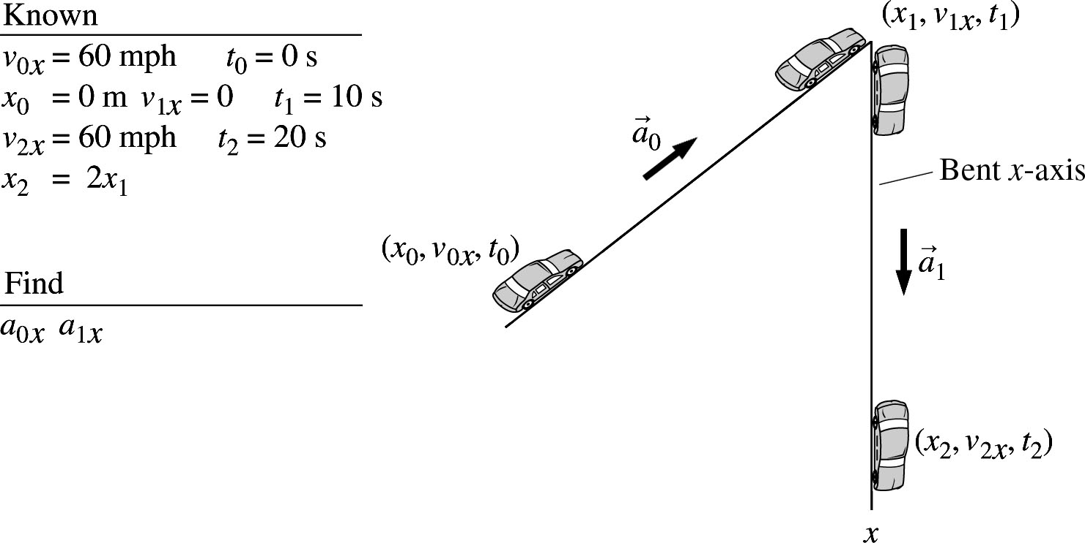
1.52. Solve:
(a)

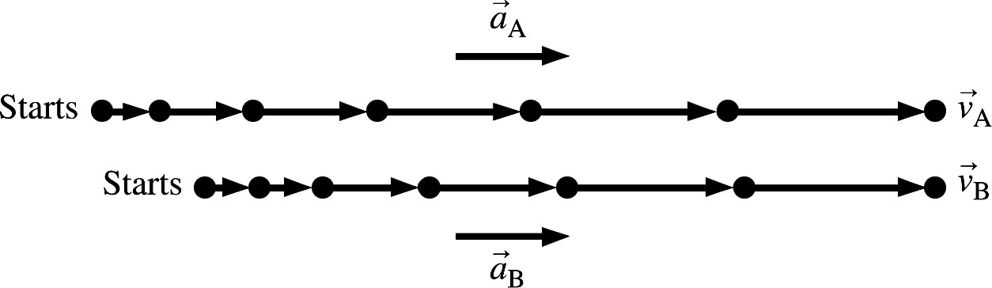

(b) A coyote (A) sees a rabbit and begins to run toward it with an acceleration of 3.0 At the same instant, the rabbit (B) begins to run away from the coyote with an acceleration of 2.0 The coyote catches the rabbit after running 40 m. How far away was the rabbit when the coyote first saw it?
(c)

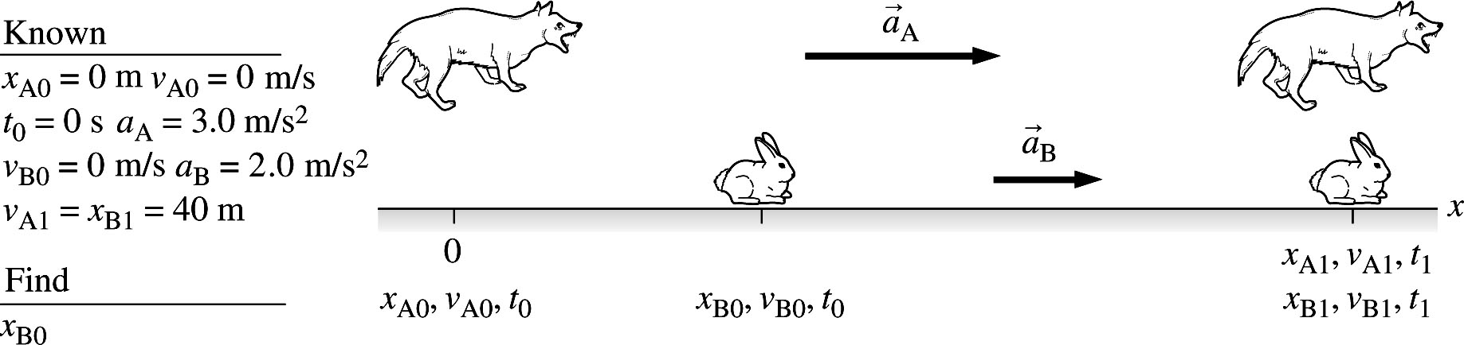

1.53. Solve: Since area equals lengthwidth, the smallest area will correspond to the smaller length and the smaller width. Similarly, the largest area will correspond to the larger length and the larger width. Therefore, the smallest area is (64 m)(100 m) = 6.4 and the largest area is (75 m)(110 m) = 8.3
1.54. Solve: (a) We need There are 100 cm in 1 m. If we multiply by
we do not change the size of the quantity, but only the number in terms of the new unit. Thus, the mass density of aluminum is
(b) Likewise, the mass density of alcohol is
1.55. Model: In the particle model, the car is represented as a dot.
Solve:

(a) | Time t (s) | Position x (m) |  | (b) | 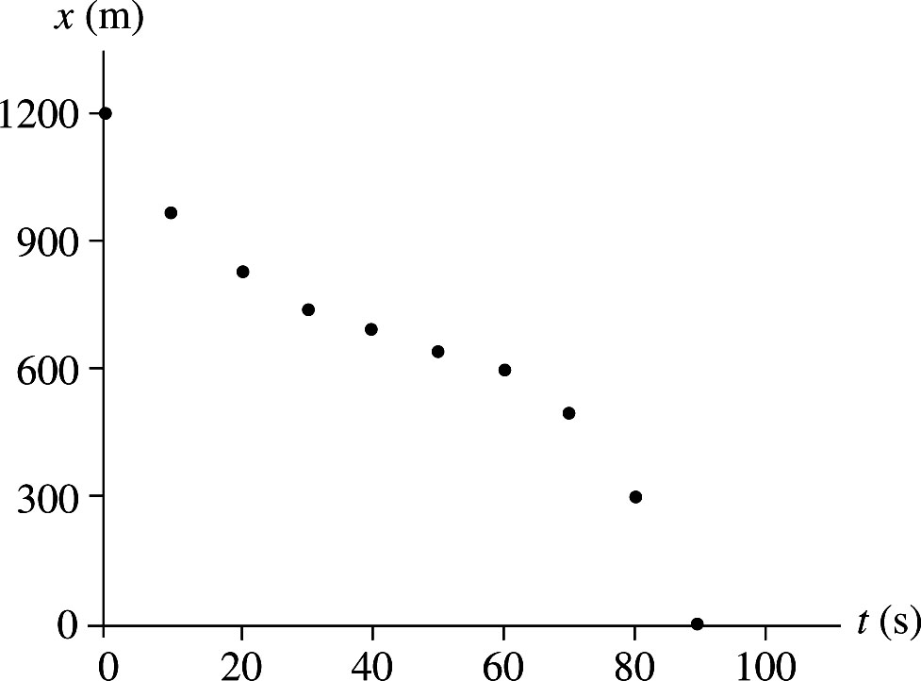
 | 0 | 1200 |  | (b)
 | 10 | 975 |  | (b)
 | 20 | 825 |  | (b)
 | 30 | 750 |  | (b)
 | 40 | 700 |  | (b)
 | 50 | 650 |  | (b)
 | 60 | 600 |  | (b)
 | 70 | 500 |  | (b)
 | 80 | 300 |  | (b)
 | 90 | 0 |  | (b)

1.56. Solve: Susan enters a classroom, sees a seat 40 m directly ahead, and begins walking toward it at a constant leisurely pace, covering the first 10 m in 10 seconds. But then Susan notices that Ella is heading toward the same seat, so Susan walks more quickly to cover the remaining 30 m in another 10 seconds, beating Ella to the seat. Susan stands next to the seat for 10 seconds to remove her backpack.
1.57. Solve: A crane operator starts lifting a ton of bricks off the ground. In 8 s, he has lifted them to a height of
15 m, then he takes 4 s to make a safety check. He then continues raising the bricks the remaining 15 m, which takes 4 s.

