Operations Management: Processes and Supply Chains, 10e (Krajewski et al.)
Chapter 2 Project Management

1) A project is an interrelated set of activities that has a definite starting and ending point.
Answer: TRUE
Reference: Introduction
Difficulty: Easy
Keywords: project activities, start, end

2) Projects often cut across organizational lines.
Answer: TRUE
Reference: Introduction
Difficulty: Easy
Keywords: project, organizational lines

3) Projects, and the application of project management, facilitate the implementation of operations strategy.
Answer: TRUE
Reference: Project Management Across the Organization
Difficulty: Easy
Keywords: project management, operations strategy

4) Project managers should be able to organize a set of disparate activities.
Answer: TRUE
Reference: Defining and Organizing Projects
Difficulty: Moderate
Keywords: project manager, disparate activities

5) A pure project organizational structure houses the project in a specific functional area.
Answer: FALSE
Reference: Defining and Organizing Projects
Difficulty: Moderate
Keywords: pure project, functional structure

6) Scope creep is one of the primary causes of project failure.
Answer: TRUE
Reference: Defining and Organizing Projects
Difficulty: Moderate
Keywords: scope creep, project failure

7) The work breakdown structure is a statement of all work that has to be completed.
Answer: TRUE
Reference: Planning Projects
Difficulty: Moderate
Keywords: WBS, work breakdown structure
8) The network diagram is a planning method that is designed to depict the relationships between activities.
Answer: TRUE
Reference: Planning Projects
Difficulty: Moderate
Keywords: network diagram, activities

9) A relationship that determines the sequence for undertaking activities is a precedence relationship.
Answer: TRUE
Reference: Planning Projects
Difficulty: Easy
Keywords: precedence relationship

10) A critical path is any sequence of activities between a project's start and finish.
Answer: FALSE
Reference: Planning Projects
Difficulty: Moderate
Keywords: critical path activities

11) The earliest start time is never the same as the latest start time.
Answer: FALSE
Reference: Planning Projects
Difficulty: Easy
Keywords: earliest start time, latest start time
AACSB: Analytic skills

12) To obtain the latest start and latest finish time, we must work forward through the network.
Answer: FALSE
Reference: Planning Projects
Difficulty: Moderate
Keywords: latest start time, latest finish time

13) A Gantt chart is a project schedule that superimposes project activities on a time line.
Answer: TRUE
Reference: Planning Projects
Difficulty: Moderate
Keywords: Gantt chart, project schedule

14) Risk is a measure of the probability and consequences of not reaching a defined project goal.
Answer: TRUE
Reference: Planning Projects
Difficulty: Moderate
Keywords: risk, probability measure

15) The optimistic time is the probable time required to perform the activity.
Answer: FALSE
Reference: Planning Projects
Difficulty: Easy
Keywords: optimistic time, probable time
16) The normal cost is the amount of money it normally takes to complete an activity faster than its normal time.
Answer: FALSE
Reference: Planning Projects
Difficulty: Easy
Keywords: normal cost, activity time, normal time

17) A project manager should stop crashing a project if the time budget has been met or if the crash costs have exceeded the savings in indirect and penalty costs.
Answer: TRUE
Reference: Planning Projects
Difficulty: Moderate
Keywords: crash cost, penalty costs, indirect costs
Learning Outcome: Describe the goals and stages of project management.

18) A risk-management plan contains all identified risks to a project plus the ways that they can be circumvented.
Answer: TRUE
Reference: Planning Projects
Difficulty: Moderate
Keywords: risk- management plan

19) The phase of project management that takes the most resources is the execution phase.
Answer: TRUE
Reference: Monitoring and Controlling Projects
Difficulty: Moderate
Keywords: project management, execution phase
Learning Outcome: Describe the goals and stages of project management.

20) Project close out consists of a) completing the remaining deliverables and b) paying the final bills.
Answer: FALSE
Reference: Monitoring and Controlling Projects
Difficulty: Moderate
Keywords: project close out, lessons learned
Learning Outcome: Describe the goals and stages of project management.

21) Which one of these steps in implementing changes comes first?
A) document the process
B) evaluate performance
C) define scope
D) identify opportunity
Answer: D
Reference: Defining and Organizing Projects
Difficulty: Hard
Keywords: project steps, identify opportunity
22) The project's objective statement should contain:
A) slack time and activities.
B) scope, time frame, and allocated resources.
C) manpower and methods.
D) activities, completion times, and incentives.
Answer: B
Reference: Defining and Organizing Projects
Difficulty: Moderate
Keywords: project objective statement, scope
Learning Outcome: Describe the goals and stages of project management.

23) A project organization structure where team members are assigned to the project and work exclusively for the project manager is called:
A) a matrix structure.
B) a fixed structure.
C) a pure project structure.
D) a Functional structure.
Answer: C
Reference: Defining and Organizing Projects
Difficulty: Moderate
Keywords: project, organizational structure

24) In an activity-on-node [AON] network, the nodes represent ________, whereas the arcs represent ________.
A) activities; time
B) activities; precedence relationships
C) events; activities
D) precedence relationships; time
Answer: B
Reference: Planning Projects
Difficulty: Moderate
Keywords: activity-on- node network, node, activity, arc, precedence relationship

25) In a network diagram, an activity:
A) is the largest unit of work effort consuming both time and resources that a project manager can schedule and control.
B) is the smallest unit of work effort consuming both time and resources that a project manager can schedule and control.
C) should always be something the company has had experience with.
D) must always have a single, precise estimate for the time duration.
Answer: B
Reference: Planning Projects
Difficulty: Moderate
Keywords: activity, smallest unit of work
26) Activity times for a project are estimated by all but which of the following methods?
A) Methods-Time Measurement (MTM) data, which includes predetermined time estimates for different activities
B) managerial opinions based on similar prior experiences
C) statistical methods based on actual past experience
D) estimates using learning curve models to improve replications and estimate accuracy
Answer: A
Reference: Planning Projects
Difficulty: Moderate
Keywords: activity times, estimating activity times

27) A project has three paths. A-B-C has a length of 25 days. A-D-C has a length of 15 days. Finally, A-E-C has a length of 20 days. Which one of the following statements is TRUE?
A) A-D-C is the critical path.
B) A-B-C has the most slack.
C) The expected duration of this project is 25 days.
D) The expected duration of this project is 25 + 15 + 20 = 60 days.
Answer: C
Reference: Planning Projects
Difficulty: Moderate
Keywords: project, duration
AACSB: Analytic skills

28) The earliest start time for an activity is equal to the:
A) smallest earliest finish time of all of its immediate predecessors.
B) largest earliest finish time of all of its immediate predecessors.
C) smallest late start time of any of its immediate predecessors.
D) largest late finish time of all of its immediate predecessors.
Answer: B
Reference: Planning Projects
Difficulty: Moderate
Keywords: activity, earliest start time
AACSB: Analytic skills

29) Assume that activity G has the following times:
Early start time = 7 days
Early finish time = 13 days
Late start time = 15 days
Late finish time = 21 days

Which of the following statements is TRUE about activity G?
A) Activity G takes 14 days to complete.
B) Activity G has a slack time of 8 days.
C) Activity G is on the critical path.
D) Activity G takes 2 days to complete.
Answer: B
Reference: Planning Projects
Difficulty: Moderate
Keywords: activity slack
AACSB: Analytic skills
30) Activity slack is defined as:
A) latest start time minus earliest start time.
B) earliest start time minus latest start time.
C) earliest finish time minus latest finish time.
D) latest finish time minus earliest start time.
Answer: A
Reference: Planning Projects
Difficulty: Moderate
Keywords: activity slack, latest start time, earliest start time
AACSB: Analytic skills

31) Which one of the following best describes the critical path of a PERT/CPM network?
A) the sequence of activities between a project's start and finish that takes the longest time to complete
B) the sequence of activities between a project's start and finish that has the maximum amount of activity slack
C) the set of activities that has no precedence relationships
D) the sequence of activities that has the lowest normal activity cost
Answer: A
Reference: Planning Projects
Difficulty: Moderate
Keywords: critical path
AACSB: Analytic skills

Fig. 2.1
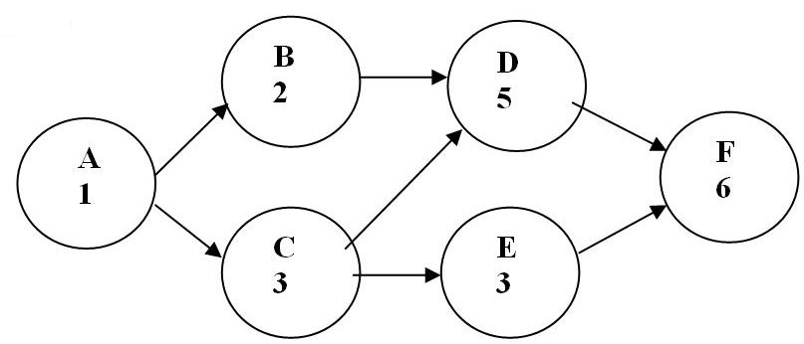

32) For the network shown in Fig. 2.1, which of the following is the critical path?
A) ABCDEF
B) ABEF
C) ACDF
D) ACEF
Answer: C
Reference: Planning Projects
Difficulty: Easy
Keywords: activity network, critical path
AACSB: Analytic skills
33) For the network shown in Fig. 2.1, what is the project duration?
A) 6
B) 15
C) 13
D) 14
Answer: B
Reference: Planning Projects
Difficulty: Easy
Keywords: activity network, critical path, duration
AACSB: Analytic skills

Figure to accompany Table 2.1

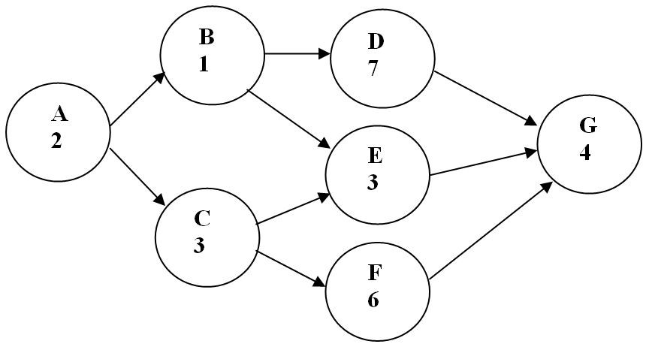

Table 2.1
ACTIVITY | ACTIVITY TIME | EARLIEST START | EARLIEST FINISH | LATEST START | LATEST FINISH | SLACK
A | 2 | 0 |  | 0 | 2 | 0
B | 1 | 2 | 3 | 3 | 4 | 1
C | 3 | 2 | 5 | 2 | 5 | 0
D | 7 | 3 | 10 | 4 | 11
E | 3 | 5 | 8 |  | 11 | 3
F |  | 5 | 11 | 5 | 11 | 0
G | 4 | 11 | 15 | 11 | 15 | 0

34) Using the information shown in Table 2.1, what is the slack time for activity D?
A) 1
B) 4
C) 6
D) 7
Answer: A
Reference: Planning Projects
Difficulty: Easy
Keywords: activity, network, critical path, activity slack
AACSB: Analytic skills
35) Using the information shown in Table 2.1, what is the earliest finish time for activity A?
A) 0
B) 2
C) 3
D) 4
Answer: B
Reference: Planning Projects
Difficulty: Easy
Keywords: activity network, critical path, earliest finish
AACSB: Analytic skills

36) Using the information shown in Table 2.1, what is the latest start time for activity E?
A) 2
B) 3
C) 5
D) 8
Answer: D
Reference: Planning Projects
Difficulty: Easy
Keywords: activity network, critical path, latest start
AACSB: Analytic skills

37) Using the information shown in Table 2.1, what is the activity time for activity F?
A) 5
B) 11
C) 6
D) 1
Answer: C
Reference: Planning Projects
Difficulty: Easy
Keywords: activity network, critical path, activity time
AACSB: Analytic skills

38) Refer to the Figure to accompany Table 2.1. Which one of the following is the critical path?
A) ABDG
B) ABEG
C) ACEG
D) ACFG
Answer: D
Reference: Planning Projects
Difficulty: Easy
Keywords: activity network, critical path
AACSB: Analytic skills
39) Using the information shown in Table 2.1, what is the project duration?
A) 15
B) 14
C) 12
D) 10
Answer: A
Reference: Planning Projects
Difficulty: Easy
Keywords: activity network, critical path, duration
AACSB: Analytic skills

40) When using the beta distribution for estimating activity times:
A) an advantage is that the mode of the distribution is always equidistant from the end points of the distribution.
B) the most likely time estimate can be positioned anywhere between the optimistic and pessimistic time estimates.
C) we assume that the standard deviation is one-third the range between the optimistic and pessimistic time estimates.
D) the most likely time estimate becomes the mean of the distribution.
Answer: B
Reference: Planning Projects
Difficulty: Moderate
Keywords: beta distribution

41) Following are four sets of most optimistic, most likely, and most pessimistic times (in weeks) for an activity. Which one of the four sets will have a mean estimated time equal to the most likely time?
A) 1, 9, 9
B) 1, 5, 9
C) 1, 1, 9
D) 1, 5, 5
Answer: B
Reference: Planning Projects
Difficulty: Moderate
Keywords: optimistic times, most likely times, pessimistic times
AACSB: Analytic skills

42) To calculate the probability of completing a project by a certain date:
A) the expected completion time of the project is taken to be the sum of the activity times on the shortest path.
B) the variance of the distribution of project completion times is taken to be one-sixth the difference between the latest finish time and the earliest finish time of the last activity in the project.
C) we assume that the activity durations are independent of each other so that the normal distribution can be used.
D) we need only the parameters of the beta distribution for the finish node of the diagram.
Answer: C
Reference: Planning Projects
Difficulty: Moderate
Keywords: project completion date, probability
43) Fig. 2.2
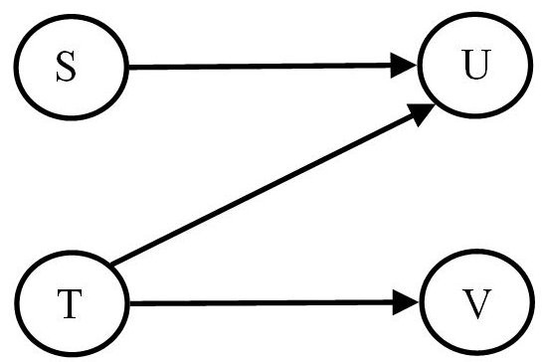

Which one of the following statements regarding Figure 2.2 is TRUE?
A) Activity S cannot finish until activity T finishes.
B) Activity T cannot begin until activity U is completed.
C) Activity U cannot begin until activities S and T have been completed.
D) Activity V cannot begin until activity S has been completed.
Answer: C
Reference: Planning Projects
Difficulty: Moderate
Keywords: activity precedence

44) If a project has exactly one critical path, which one of the following statements is TRUE?
A) Crashing an activity on the critical path will always result in an increase in total project profits.
B) Activities on the critical path cannot be crashed.
C) Crashing an activity on the critical path will always result in a reduced total project completion time.
D) The best schedule is one in which all activities are crashed as much as possible.
Answer: C
Reference: Planning Projects
Difficulty: Moderate
Keywords: crashing an activity, critical path

45) Which one of the following conditions violates the assumptions of PERT/CPM networks?
A) Some activities can have zero variance.
B) Costs increase linearly as activity time is reduced below its normal time.
C) Two activities tied together by an arc are overlapping and can be worked on simultaneously.
D) There can be more than one critical path in a network.
Answer: C
Reference: Planning Projects
Difficulty: Moderate
Keywords: assumption, PERT and CPM networks
46) In making an estimate of the most pessimistic time for an activity, a manager deliberately estimates this time too high (i.e., longer than it should be). What is the result of this action, assuming the beta distribution is being used to make time estimates?
A) The most likely time for this activity will be larger than it should be.
B) The variance of the activity will be smaller than it should be.
C) The beta distribution will be symmetric around its mean.
D) The expected time for this activity will be larger than it should be.
Answer: D
Reference: Planning Projects
Difficulty: Moderate
Keywords: activity, pessimistic time, beta distribution
AACSB: Analytic skills

Table 2.2
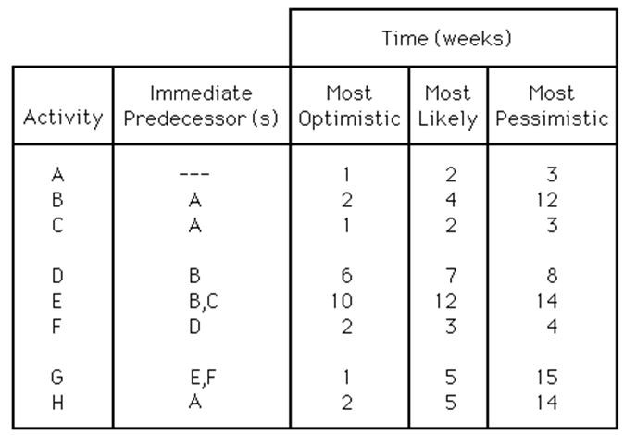

47) Using Table 2.2, what is the earliest expected time of completion of the whole project?
A) fewer than or equal to 19 weeks
B) greater than 19 but fewer than or equal to 21 weeks
C) greater than 21 but fewer than or equal to 24 weeks
D) greater than 24 weeks
Answer: D
Reference: Planning Projects
Difficulty: Moderate
Keywords: project completion time
AACSB: Analytic skills

48) Using Table 2.2, which activity will have the largest amount of slack?
A) Activity F
B) Activity C
C) Activity H
D) Activity A
Answer: C
Reference: Planning Projects
Difficulty: Moderate
Keywords: activity slack
AACSB: Analytic skills
49) Using Table 2.2, if the expected times for activities A, G, and H increased by 2, 3, and 4 weeks, respectively, by how many weeks would the project's earliest expected time of completion increase?
A) fewer than or equal to 2 weeks
B) greater than 2 weeks but fewer than or equal to 4 weeks
C) greater than 4 weeks but fewer than or equal to 6 weeks
D) greater than 6 weeks
Answer: C
Reference: Planning Projects
Difficulty: Hard
Keywords: expected activity time
AACSB: Analytic skills

Table 2.3
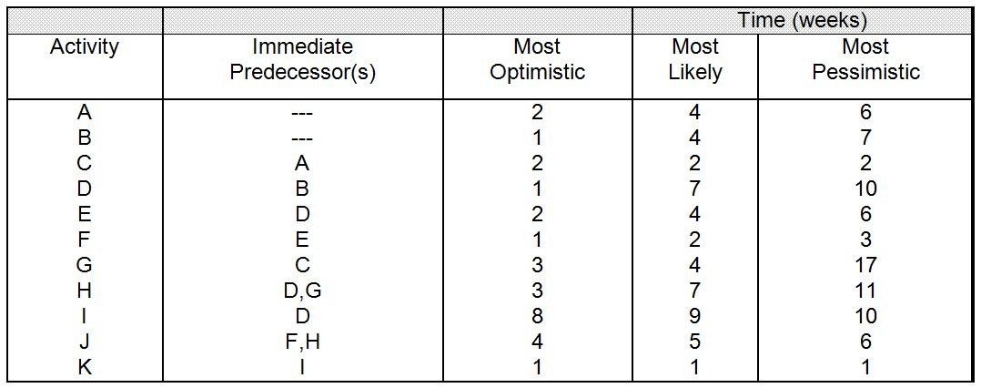

50) Using Table 2.3, what is the earliest expected time of completion of the whole project?
A) fewer than or equal to 21 days
B) greater than 21 but fewer than or equal to 22 days
C) greater than 22 but fewer than or equal to 23 days
D) greater than 23 days
Answer: D
Reference: Planning Projects
Difficulty: Moderate
Keywords: project, expected time of completion
AACSB: Analytic skills

51) Using Table 2.3, which activity is on the critical path?
A) Activity D
B) Activity F
C) Activity G
D) Activity K
Answer: C
Reference: Planning Projects
Difficulty: Moderate
Keywords: activity, critical path
AACSB: Analytic skills
52) Using Table 2.3, if the project is due to be completed in 28 days, what is the probability that the project will be completed on or before the due date?
A) less than or equal to 75%
B) greater than 75% but less than or equal to 85%
C) greater than 85% but less than or equal to 95%
D) greater than 95%
Answer: C
Reference: Planning Projects
Difficulty: Moderate
Keywords: project completion time, probability
AACSB: Analytic skills

53) Using Table 2.3, if the project manager wants at least a 98% probability that the project will be completed on or before the due date, what is the shortest project due date that will satisfy the manager?
A) fewer than or equal to 28 days
B) greater than 28 days but fewer than or equal to 30 days
C) greater than 30 days but fewer than or equal to 32 days
D) greater than 32 days
Answer: B
Reference: Planning Projects
Difficulty: Hard
Keywords: due date, probability of completion
AACSB: Analytic skills

Table 2.4
Activity | Predecessor | Time(weeks)
A | -- | 8
B | A | 6
C | -- | 4
D | C | 9
E | A | 11
F | B | 3
G | D,E,F | 1

54) Using Table 2.4, what is the earliest completion time for this project?
A) 18 weeks
B) 19 weeks
C) 20 weeks
D) 21 weeks
Answer: C
Reference: Planning Projects
Difficulty: Moderate
Keywords: completion time
AACSB: Analytic skills
55) Using Table 2.4, what is the largest amount of slack that any activity in the project has?
A) zero weeks
B) two weeks
C) four weeks
D) six weeks
Answer: D
Reference: Planning Projects
Difficulty: Moderate
Keywords: activity slack
AACSB: Analytic skills

56) Using Table 2.4, what is the minimum number of activities that would have to be delayed to cause an increase in the project's earliest completion date?
A) one activity
B) two activities
C) three activities
D) four or more activities
Answer: A
Reference: Planning Projects
Difficulty: Moderate
Keywords: activity delay, earliest completion time
AACSB: Analytic skills

57) Using Table 2.4, what is the minimum number of activities that would have to be crashed to cause a decrease in the project's earliest completion date?
A) one activity
B) two activities
C) three activities
D) four or more activities
Answer: A
Reference: Planning Projects
Difficulty: Moderate
Keywords: crashing an activity, earliest completion time
AACSB: Analytic skills

58) Using Table 2.4, what is the early start time for activity D?
A) week 9
B) week 4
C) week 7
D) week 0
Answer: B
Reference: Planning Projects
Difficulty: Moderate
Keywords: activity, early start time
AACSB: Analytic skills
59) Using Table 2.4, what is the latest finish time for activity C?
A) week 4
B) week 6
C) week 8
D) week 10
Answer: D
Reference: Planning Projects
Difficulty: Moderate
Keywords: activity, latest finish time
AACSB: Analytic skills

60) Using Table 2.4, what is the slack associated with activity B?
A) 1 week
B) 2 weeks
C) 3 weeks
D) None of these is the correct activity slack for B.
Answer: B
Reference: Planning Projects
Difficulty: Moderate
Keywords: activity slack
AACSB: Analytic skills

Table 2.5
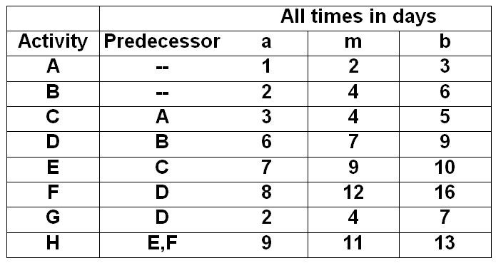

61) Using Table 2.5, the expected time for activity C is:
A) three days.
B) four days.
C) five days.
D) more than five days.
Answer: B
Reference: Planning Projects
Difficulty: Moderate
Keywords: activity, expected time
AACSB: Analytic skills
62) Using Table 2.5, what is the latest finish time for activity D?
A) between 4 and 6 days
B) between 6 and 8 days
C) between 8 and 10 days
D) more than 10 days
Answer: C
Reference: Planning Projects
Difficulty: Hard
Keywords: probabilistic latest finish time
AACSB: Analytic skills

63) Using Table 2.5, what is the variance for activity F?
A) 1.33
B) 1.78
C) 2.34
D) 2.69
Answer: B
Reference: Planning Projects
Difficulty: Moderate
Keywords: activity, variance
AACSB: Analytic skills

64) Using Table 2.5, what is the standard deviation for the entire project?
A) 1.08
B) 1.17
C) 1.71
D) 2.92
Answer: C
Reference: Planning Projects
Difficulty: Hard
Keywords: critical path, standard deviation
AACSB: Analytic skills

65) Using Table 2.5, which activity is on the critical path?
A) Activity A
B) Activity C
C) Activity E
D) Activity H
Answer: D
Reference: Planning Projects
Difficulty: Moderate
Keywords: critical path activity
AACSB: Analytic skills
Table 2.6
Activity | Predecessor | Time (days)
A | -- | 8
B | -- | 6
C | -- | 3
D | A,B | 10
E | C | 8
F | A | 5
G | D,E | 3
H | G | 4

66) Using Table 2.6, what is the earliest completion time of this project?
A) 23 days
B) 25 days
C) 27 days
D) 29 days
Answer: B
Reference: Planning Projects
Difficulty: Moderate
Keywords: earliest project completion time
AACSB: Analytic skills

67) Using Table 2.6, what is the latest start time for activity E?
A) day 8
B) day 10
C) day 12
D) day 14
Answer: B
Reference: Planning Projects
Difficulty: Moderate
Keywords: activity, latest start time
AACSB: Analytic skills

68) Using Table 2.6, what is the earliest that activity D can be finished?
A) 18 days
B) 8 days
C) 13 days
D) 25 days
Answer: A
Reference: Planning Projects
Difficulty: Moderate
Keywords: activity, earliest finish time
AACSB: Analytic skills
69) Disaster strikes and activity F takes 20 days instead of the anticipated 5 days. Using Table 2.6, how much longer will the project last than initially estimated?
A) 15 days
B) 0 days
C) 7 days
D) 3 days
Answer: D
Reference: Planning Projects
Difficulty: Moderate
Keywords: project latest finish time
AACSB: Analytic skills

70) Using Table 2.6, every day the construction crew is on-site costs $1000. What activities would you consider crashing to reduce the project completion cost?
A) Activity E
B) Activity F
C) Activity G
D) All of these activities would be candidates for crashing.
Answer: C
Reference: Planning Projects
Difficulty: Moderate
Keywords: project completion cost, activity crashing
AACSB: Analytic skills

71) Using Table 2.6, how many days can activity C be delayed without changing the whole project's earliest completion time?
A) 0 days
B) 2 days
C) 5 days
D) 7 days
Answer: D
Reference: Planning Projects
Difficulty: Moderate
Keywords: activity slack
AACSB: Analytic skills
Table 2.7
Activity | Immediate Predecessor(s) | Time (weeks)
A | -- | 3
B | -- | 4
C | -- | 2
D | A | 4
E | A,B | 5
F | A, B, C | 2
G | D,E | 1
H | E | 6
I | E, F | 2
J | G, H, I | 4
K | H, I | 3
L | I | 6

72) Using Table 2.7, what is the critical path for this project?
A) B—E—H—K
B) B—E—H—J
C) A—E—G—J
D) C—F—I—L
Answer: B
Reference: Planning Projects
Difficulty: Hard
Keywords: critical path
AACSB: Analytic skills

73) Using Table 2.7, suppose activity D can be shortened from four days to one day. Assume all other activity times remain the same. How much shorter will the total project earliest completion time become?
A) zero days
B) one day
C) two days
D) three days
Answer: A
Reference: Planning Projects
Difficulty: Hard
Keywords: earliest completion time
AACSB: Analytic skills
74) Using Table 2.7, suppose activity I is delayed, taking eight days to complete instead of two days. Assume all other activity times remain the same. How much longer will the total project earliest completion time become?
A) zero days
B) one or two days
C) three or four days
D) five or six days
Answer: C
Reference: Planning Projects
Difficulty: Hard
Keywords: project, earliest completion time
AACSB: Analytic skills

75) Using Table 2.7, what is the latest start time for activity A?
A) day 0
B) day 1
C) day 2
D) day 3 or later
Answer: B
Reference: Planning Projects
Difficulty: Hard
Keywords: activity, latest start time
AACSB: Analytic skills

Table 2.8
Activity | Immediate Predecessor(s) | Time (weeks)
A | -- | 3
B | -- | 4
C | A, B | 5
D | A | 6
E | C | 4
F | D, E | 2

76) Using Table 2.8, what is the earliest completion time of the project?
A) fewer than or equal to 10 weeks
B) greater than 16 weeks
C) greater than 13 weeks but fewer than or equal to 16 weeks
Answer: C
Reference: Planning Projects
Difficulty: Moderate
Keywords: project, earliest completion time
AACSB: Analytic skills
77) Using Table 2.8, what is the critical path of the above project?
A) B—C—E—F
B) B—C—F
C) A—D—F
D) A—C—E—F
Answer: A
Reference: Planning Projects
Difficulty: Moderate
Keywords: critical path
AACSB: Analytic skills

78) Using Table 2.8, what is the slack for activity A?
A) 0 weeks
B) 1 week
C) 2 weeks
D) 3 or more weeks
Answer: B
Reference: Planning Projects
Difficulty: Moderate
Keywords: activity slack
AACSB: Analytic skills
Figure to accompany Table 2.9

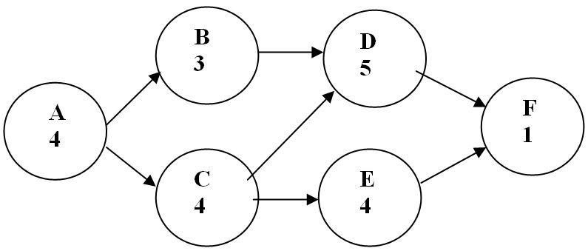

Table 2.9
ACTIVITY | NORMAL TIME | CRASH TIME | NORMAL COST ($000s) | CRASH COST ($000s) | AVAILABLE WEEKS OF CRASHING | CRASHING COST / WEEK
A | 4 | 2 | 8 | 14
B | 3 | 2 | 9 | 11
C | 4 | 4 | 10 | 10
D | 5 | 3 | 10 | 15
E | 4 | 1 | 11 | 14
F | 1 | 1 | 6 | 6

79) What is the critical path for the project shown in the above network and Table 2.9, using the normal times?
A) A-B-D-F
B) A-C-D-F
C) A-C-E-F
D) A-B-C-D-E-F
Answer: B
Reference: Planning Projects
Difficulty: Easy
Keywords: critical path
AACSB: Analytic skills

80) Determine the information missing from Table 2.9; then answer the following questions. How many week(s) of crashing are available for activity D in Table 2.9?
A) 0
B) 1
C) 2
D) 6
Answer: C
Reference: Planning Projects
Difficulty: Easy
Keywords: crash cost / time
AACSB: Analytic skills
81) How many week(s) of crashing are available for activity B in Table 2.9?
A) 0
B) 1
C) 2
D) 3
Answer: B
Reference: Planning Projects
Difficulty: Easy
Keywords: crash cost / time
AACSB: Analytic skills

82) How many weeks of crashing are available for activity C in Table 2.9?
A) 0
B) 1
C) 2
D) 6
Answer: A
Reference: Planning Projects
Difficulty: Easy
Keywords: crash cost / time
AACSB: Analytic skills

83) What is the crashing cost per week for activity A in Table 2.9?
A) $2,000
B) $3,000
C) $4,000
D) This activity cannot be crashed.
Answer: B
Reference: Planning Projects
Difficulty: Moderate
Keywords: crash cost / time
AACSB: Analytic skills

84) What is the crashing cost per week for activity E in Table 2.9?
A) $1,000
B) $2,000
C) $3,000
D) This activity cannot be crashed.
Answer: A
Reference: Planning Projects
Difficulty: Moderate
Keywords: crash cost / time
AACSB: Analytic skills
85) What is the crashing cost per week for activity F in Table 2.9?
A) $2,000
B) $3,000
C) $4,000
D) This activity cannot be crashed.
Answer: D
Reference: Planning Projects
Difficulty: Moderate
Keywords: crash, cost / time
AACSB: Analytic skills

86) If a decision is made to crash activity D in Table 2.9 by one week, what is the cost for this one week of crashing?
A) $3,000
B) $2,000
C) $2,500
D) This activity cannot be crashed.
Answer: C
Reference: Planning Projects
Difficulty: Moderate
Keywords: crash cost / time
AACSB: Analytic skills

87) Which activity should be crashed first for the project shown in Table 2.9?
A) A
B) B
C) C
D) D
Answer: D
Reference: Planning Projects
Difficulty: Hard
Keywords: crash cost / time
AACSB: Analytic skills
Table 2.10
Activity | Predecessor | Normal  Time  (days) | Crashing  Time (days) | Crashing  Cost/day
A | -- | 5 | 1 | $200
B | -- | 7 | 1 | $500
C | -- | 5 | 1 | $200
D | A | 10 | 2 | $300
E | B | 6 | 1 | $400
F | A, C | 7 | 2 | $650
G | B | 4 | 1 | $500
H | E, D, G | 6 | 1 | $350

88) Using Table 2.10, what is the critical path for this project using the normal times?
A) A—D—H
B) C—F
C) B—E—H
D) B—G—H
Answer: A
Reference: Planning Projects
Difficulty: Moderate
Keywords: critical path
AACSB: Analytic skills

89) Using Table 2.10, what is the minimum completion time for this project after crashing?
A) 23 days
B) 21 days
C) 19 days
D) 17 days
Answer: D
Reference: Planning Projects
Difficulty: Moderate
Keywords: project, critical path, minimum completion time
AACSB: Analytic skills

90) Using Table 2.10, what is the minimum crashing cost to finish this project in 18 days?
A) $3,450
B) $850
C) $1,150
D) $1,500
Answer: B
Reference: Planning Projects
Difficulty: Hard
Keywords: crash cost / time
AACSB: Analytic skills
91) Using Table 2.10, what is the activity with the greatest amount of slack?
A) A
B) B
C) C
D) D
Answer: C
Reference: Planning Projects
Difficulty: Moderate
Keywords: activity slack
AACSB: Analytic skills

92) Using Table 2.10, what is the latest start time for activity E?
A) day 7
B) day 8
C) day 9
D) day 10
Answer: C
Reference: Planning Projects
Difficulty: Moderate
Keywords: activity slack
AACSB: Analytic skills

93) Using Table 2.10, what is the earliest possible completion time for activity E after crashing?
A) day 11
B) day 13
C) day 15
D) day 17
Answer: B
Reference: Planning Projects
Difficulty: Moderate
Keywords: activity, earliest completion time
AACSB: Analytic skills
Table 2.11
Activity | Immediate Predecessor(s) | Time (weeks) | Cost to Crash  1 Week
A | -- | 2 | $3,000
B | -- | 4 | 10,000
C | A | 3 | 2,000
D | A | 1 | Impossible
E | B | 3 | 10,000
F | C | 1 | Impossible
G | B, D | 5 | 10,000
H | E | 1 | Impossible
I | F | 3 | 3,000
J | C, G | 2 | 6,000
K | I, J | 1 | Impossible
L | G, H | 4 | 8,000

94) Using Table 2.11, what is the earliest completion time of this project without crashing?
A) fewer than 11 weeks
B) 11 weeks
C) 12 weeks
D) more than 12 weeks
Answer: D
Reference: Planning Projects
Difficulty: Moderate
Keywords: project, earliest completion time
AACSB: Analytic skills

95) Using Table 2.11, if activity B is crashed by 2 weeks, what is the new earliest completion time of the project?
A) fewer than 11 weeks
B) 11 weeks
C) 12 weeks
D) more than 12 weeks
Answer: C
Reference: Planning Projects
Difficulty: Hard
Keywords: activity crashing, earliest completion time
AACSB: Analytic skills
96) Using Table 2.11 and assuming all activities except D, F, H, and K are available to be crashed, what is the minimum cost to be incurred in reducing the total project earliest completion time by one week?
A) $3,000
B) $6,000
C) $8,000
D) $10,000
Answer: C
Reference: Planning Projects
Difficulty: Moderate
Keywords: activity crashing, earliest completion time / cost
AACSB: Analytic skills

Table 2.12
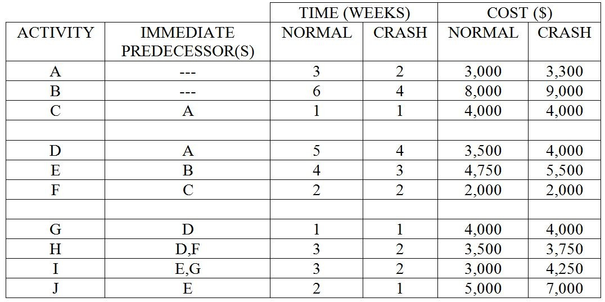

97) Using Table 2.12, what is the earliest completion time of this project if normal times are used for all activities?
A) fewer than 13 weeks
B) 13 weeks
C) 14 weeks
D) more than 14 weeks
Answer: B
Reference: Planning Projects
Difficulty: Moderate
Keywords: earliest completion time
AACSB: Analytic skills
98) Using Table 2.12, what is the minimum time schedule for this project?
A) fewer than 8 weeks
B) 8 weeks
C) 9 weeks
D) more than 9 weeks
Answer: C
Reference: Planning Projects
Difficulty: Hard
Keywords: minimum time schedule
AACSB: Analytic skills

99) Using Table 2.12, if the project completion time has to be reduced by one week, which of the following activities should be crashed to minimize the extra cost of earlier completion?
A) Activity B
B) Activity E
C) Activity H
D) Activity J
Answer: A
Reference: Planning Projects
Difficulty: Moderate
Keywords: activity crashing, project, completion time
AACSB: Analytic skills

100) Using Table 2.12, what is the difference, in dollars, between the minimum-time schedule and the schedule created by crashing all activities to their limits? Assume that there are no indirect or penalty costs.
A) less than or equal to $1,000
B) greater than $1000 but less than or equal to $2,000
C) greater than $2000 but less than or equal to $3,000
D) greater than $3,000
Answer: D
Reference: Planning Projects
Difficulty: Hard
Keywords: project crashing cost / time
AACSB: Analytic skills

101) Using Table 2.12, if the project's normal earliest completion time is to be reduced by two weeks, what is the minimum additional cost that will be incurred in achieving this two-week reduction?
A) less than or equal to $1,000
B) greater than $1,000 but less than or equal to $1,500
C) greater than $1,500 but less than or equal to $2,000
D) greater than $2,000
Answer: B
Reference: Planning Projects
Difficulty: Hard
Keywords: project crashing cost / time
AACSB: Analytic skills
Table 2.13
(All activity times for the project are in weeks.)

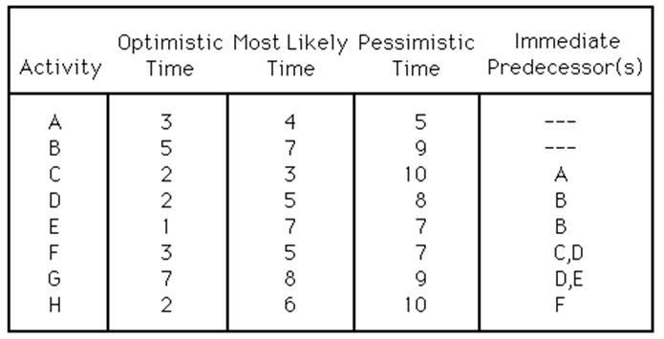

102) Using Table 2.13, what is the critical path of this project?
A) A—C—F—H
B) B—D—F—H
C) B—D—G
D) B—E—G
Answer: B
Reference: Planning Projects
Difficulty: Moderate
Keywords: critical path
AACSB: Analytic skills

103) Using Table 2.13, what is the expected time of completion of the project?
A) fewer than 22 weeks
B) 22 weeks
C) 23 weeks
D) greater than 23 weeks
Answer: C
Reference: Planning Projects
Difficulty: Moderate
Keywords: project expected completion time
AACSB: Analytic skills

104) Using Table 2.13, what is the probability that the project will be completed in 24 or fewer weeks?
A) less than or equal to 55%
B) greater than 55% but less than or equal to 65%
C) greater than 65% but less than or equal to 75%
D) greater than 75%
Answer: C
Reference: Planning Projects
Difficulty: Moderate
Keywords: project completion probability / time
AACSB: Analytic skills
105) Using Table 2.13, if the expected time for activity E is changed to nine weeks, by how many weeks will the project's expected completion time increase?
A) It will not change.
B) It will increase by one week.
C) It will increase by two weeks.
D) It will increase by three or more weeks.
Answer: B
Reference: Planning Projects
Difficulty: Moderate
Keywords: activity, project expected completion time
AACSB: Analytic skills

Table 2.14
You are responsible for managing a project with the following activities (times are given in weeks).

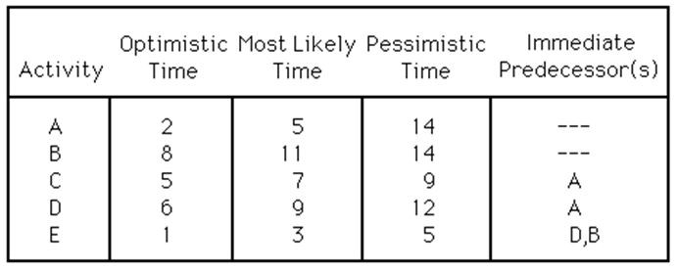

106) Using Table 2.14, what is the critical path and expected completion time for this project?
A) A—D—E; 17 weeks
B) A—C; 18 weeks
C) B—E; 14 weeks
D) A—D—E; 18 weeks
Answer: D
Reference: Planning Projects
Difficulty: Moderate
Keywords: project critical path
AACSB: Analytic skills

107) Using Table 2.14, which activity has the largest slack, and how large is that slack?
A) Activity C; five weeks
B) Activity A; six weeks
C) Activity B; four weeks
D) Activity E; three weeks
Answer: A
Reference: Planning Projects
Difficulty: Moderate
Keywords: activity slack
AACSB: Analytic skills
108) Using Table 2.14, what is the probability of completing the project in 17 or fewer weeks?
A) less than or equal to 40%
B) greater than 40% but less than or equal to 55%
C) greater than 55% but less than or equal to 70%
D) greater than 70%
Answer: A
Reference: Planning Projects
Difficulty: Moderate
Keywords: project, expected completion time
AACSB: Analytic skills

109) Using Table 2.14, what is the probability that the project will take 16 or more weeks to complete?
A) less than or equal to 40%
B) greater than 40% but less than or equal to 55%
C) greater than 55% but less than or equal to 70%
D) greater than 70%
Answer: D
Reference: Planning Projects
Difficulty: Moderate
Keywords: project, expected completion time
AACSB: Analytic skills

110) Using Table 2.14, if the expected time for activity B is changed to 18 weeks, by how many weeks will the project's expected completion time increase?
A) It will not change.
B) It will increase by one or two weeks.
C) It will increase by three or four weeks.
D) It will increase by more than four weeks.
Answer: C
Reference: Planning Projects
Difficulty: Moderate
Keywords: project, expected completion time
AACSB: Analytic skills
Table 2.15
You are responsible for managing a project with the following activities (times are given in days).

Activity | Expected Time | Immeciate Predecessor(s)
A | 3 | ---
B | 6 | ---
C | 2 | ---
D | 5 | A
E | 2 | C
F | 7 | A
G | 4 | B, D, E

111) Using, Table 2.15, what is the critical path and expected completion time for this project?
A) A—F; 12 days
B) A—D—G; 12 days
C) B—G; 10 days
D) C—E—G; 8 days
Answer: B
Reference: Planning Projects
Difficulty: Moderate
Keywords: critical path
AACSB: Analytic skills

112) Using, Table 2.15, which of the following activities has the largest amount of slack?
A) Activity B
B) Activity D
C) Activity E
D) Activity F
Answer: C
Reference: Planning Projects
Difficulty: Moderate
Keywords: activity slack
AACSB: Analytic skills

113) Assuming a beta distribution is being used, if the most pessimistic time for an activity increases by six weeks, what will happen to the expected time for that activity?
A) It will increase by one week.
B) It will decrease by one week.
C) It will increase by six weeks.
D) It will remain the same.
Answer: A
Reference: Planning Projects
Difficulty: Moderate
Keywords: beta distribution, pessimistic activity time
AACSB: Analytic skills
114) The probability that a project will be completed by its earliest expected completion date is:
A) 50 percent.
B) 95 percent.
C) 100 percent.
D) impossible to determine.
Answer: A
Reference: Planning Projects
Difficulty: Moderate
Keywords: probability, project completion date
AACSB: Analytic skills

115) If the sum of the variances on the critical path (and all other network paths) is equal to zero, what is the probability that the project will be completed by its earliest expected completion date?
A) 50 percent
B) 95 percent
C) 100 percent
D) It cannot be determined.
Answer: C
Reference: Planning Projects
Difficulty: Moderate
Keywords: critical path expected variance, earliest expected completion date
AACSB: Analytic skills

116) A project is currently scheduled to be finished on its normal earliest completion date. The project manager has the opportunity to earn a bonus if the project can be completed three weeks ahead of schedule. The increase in project direct costs related to crashing activities would be $40,000. Also, project indirect costs are $15,000 per week. What is the smallest bonus that the project manager should accept if he or she wants to avoid increasing overall project costs?
A) less than or equal to $5,000
B) greater than $5000 but less than or equal to $10,000
C) greater than $10,000 but less than or equal to $15,000
D) greater than $15,000
Answer: A
Reference: Planning Projects
Difficulty: Moderate
Keywords: activity crashing cost
AACSB: Analytic skills
117) You are given the following information about activity A:

Normal time | = 9 weeks
Crash time | = 7 weeks
Normal cost | = $20,000
Crash cost | = $30,000

What will it cost to complete activity A in 8 weeks?
A) less than or equal to $24,000
B) greater than $24,000 but less than or equal to $27,000
C) greater than $27,000 but less than or equal to $30,000
D) greater than $30,000
Answer: B
Reference: Planning Projects
Difficulty: Moderate
Keywords: activity crashing cost
AACSB: Analytic skills

118) You are given the following information about activity B:

Normal time | = 9 weeks
Crash time | = 5 weeks
Cost to crash per week | = $2,000
Crash cost | = $41,000

What will it cost to complete activity B in 6 weeks?
A) less than or equal to $34,000
B) greater than $34,000 but less than or equal to $36,000
C) greater than $36,000 but less than or equal to $38,000
D) greater than $38,000
Answer: D
Reference: Planning Projects
Difficulty: Moderate
Keywords: activity crashing cost
AACSB: Analytic skills
119) You are given the following information about activity F:

Normal time | = 16 weeks
Crash time | = 10 weeks
Crash cost | = $45,000
Cost to crash per week | = $2,000

What is the normal cost for activity F?
A) greater than or equal to $55,000
B) less than $55,000 but greater than or equal to $47,000
C) less than $47,000 but greater than or equal to $40,000
D) less than $40,000
Answer: D
Reference: Planning Projects
Difficulty: Moderate
Keywords: activity crashing cost
AACSB: Analytic skills

120) A company could add $10,000 per week in revenues if the project depicted in Table 2.16 could be shortened.

Table 2.16
Activity | Immediate Predecessor(s) | Time (weeks)
A | -- | 7
B | -- | 9
C | A | 8
D | A, B | 8
E | B | 9
F | C | 10
G | D, E | 5
H | E | 10
I | F, G | 5

Four possible options exist to crash activities: crash A by one week at a cost of $6,000; crash C by two weeks at a cost of $15,000; crash E by one week at a cost of $2,000; and crash I one week at a cost of $7,000. What is the maximum amount of additional profit that can be made by crashing an option (or options)?
A) less than or equal to $4,000
B) greater than $4000 but less than or equal to $8,000
C) greater than $8000 but less than or equal to $12,000
D) greater than $12,000
Answer: B
Reference: Planning Projects
Difficulty: Moderate
Keywords: activity crashing, project completion
AACSB: Analytic skills
121) A good risk management plan will contain which of these elements?
A) the project manager's tolerance level for risk
B) the number of acceptable outcomes
C) a prediction of the impact of each risk on the project
D) the number of unacceptable outcomes
Answer: C
Reference: Planning Projects
Difficulty: Moderate
Keywords: risk management plan

122) A plan that identifies key threats to a project and prescribes ways to circumvent them is called a:
A) project plan.
B) contingency plan.
C) backup plan.
D) risk management plan.
Answer: D
Reference: Planning Projects
Difficulty: Moderate
Keywords: risk management

123) Which of these is NOT one of the four categories of project risk?
A) cost/benefit
B) operations
C) strategic fit
D) project team capability
Answer: A
Reference: Planning Projects
Difficulty: Moderate
Keywords: risk management

124) Information accuracy relative to the completeness of the work breakdown structure and communication of timely information affect the:
A) strategic fit risk of a project.
B) operations risk of a project.
C) service/product attribute risk of a project.
D) cost/benefit risk of a project.
Answer: B
Reference: Planning Projects
Difficulty: Moderate
Keywords: risk management, operations

125) A(n) ________ is an interrelated set of activities that has a definite starting and ending point and that results in a unique outcome for a specific allocation of resources.
Answer: project
Reference: Introduction
Difficulty: Easy
Keywords: project activities
126) Heidi was part of a project team that retained their roles within the organization and was on loan to the project due to her technical expertise. In effect, she reported to two bosses, one in her functional area and also to the project manager. Heidi is operating within a(n) ________ organizational structure.
Answer: matrix
Reference: Defining and Organizing Projects
Difficulty: Moderate
Keywords: matrix

127) The ________ is a statement of all work that has to be completed.
Answer: work breakdown structure (WBS)
Reference: Planning Projects
Difficulty: Moderate
Keywords: WBS, work breakdown structure

128) ________ determines the sequence for undertaking activities.
Answer: Precedence relationship
Reference: Planning Projects
Difficulty: Moderate
Keywords: precedence relationship, sequence of activities

129) The ________ is the sequence of activities between a project's start and finish that takes the longest time to complete.
Answer: critical path
Reference: Planning Projects
Difficulty: Moderate
Keywords: critical path

130) ________ is the maximum length of time that an activity can be delayed without delaying the entire project.
Answer: Activity slack
Reference: Planning Projects
Difficulty: Moderate
Keywords: activity slack

131) The ________ is the shortest possible time to complete the activity.
Answer: crash time
Reference: Planning Projects
Difficulty: Moderate
Keywords: crash time

132) The ________ is determined by starting with the normal time schedule and crashing activities along the critical path in such a way that the costs of crashing do not exceed the savings in indirect and penalty costs.
Answer: minimum-cost schedule
Reference: Planning Projects
Difficulty: Moderate
Keywords: minimum cost schedule
133) A(n) ________ identifies the key threats to a project and prescribes ways to work around them.
Answer: risk-management plan
Reference: Planning Projects
Difficulty: Moderate
Keywords: project risk-management plan

134) The ________ is the shortest time in which an activity can be completed if all goes exceptionally well.
Answer: optimistic time
Reference: Planning Projects
Difficulty: Moderate
Keywords: optimistic time

135) To find the standard deviation of the critical path, you must first add the ________ of all activities on the critical path.
Answer: variances
Reference: Planning Projects
Difficulty: Hard
Keywords: standard deviation, variance, critical path
AACSB: Analytic skills

136) The phase of project management that takes the most resources is the ________, during which managers focus on activities that pertain to deliverables.
Answer: execution phase
Reference: Monitoring and Controlling Projects
Difficulty: Hard
Keywords: execution phase, resources
Learning Outcome: Describe the goals and stages of project management.

137) ________ is an attempt to reduce the peaks and valleys in resource needs by shifting the schedules of conflicting activities within their earliest and latest start dates.
Answer: Resource leveling
Reference: Monitoring and Controlling Projects
Difficulty: Moderate
Keywords: resource leveling

138) The project manager and team can step back and examine how the project work was accomplished during the ________ phase of the project.
Answer: close out
Reference: Monitoring and Controlling Projects
Difficulty: Moderate
Keywords: close out
139) List the three main goals of a project. Use the example of a project to implement a new billing procedure for a small lawn mowing business, describe how project management principles help achieve these goals.
Answer: Goals are: 1. Complete the project on time or earlier; 2. Complete it within budget; 3. Meet specs to satisfy the customer. Project Management is a systemized, phased approach to define, organize, plan, monitor and control a project to achieve these goals. Best answers will include these points, and explain them in the context of the lawn service billing procedure.
Reference: Project Management (chapter introduction)
Difficulty: Easy
Keywords: project management goals
Learning Outcome: Describe the goals and stages of project management.

140) What are the primary responsibilities of a Project Manager? Briefly describe these responsibilities for a project manager whose team is purchasing a new machine and installing it in a manufacturing process.
Answer: Best answers will include the following points, describing the manager's role in the purchase and installation of the new machine: 1. Facilitator: resolves conflicts; leads with a system view; blends project interaction, resources and deliverables with firm as a whole; 2. Communicator: informs senior management and other stakeholders of project's progress and need for additional resources; communicates with project team to achieve best performance; 3. Decision Maker: organize team meetings; define how team decisions will be made; determine how to communicate to senior management; make tough decisions if necessary.
Reference: Defining and Organizing Projects
Difficulty: Moderate
Keywords: Project Manager, selecting

141) What characteristics should be considered when selecting project team members? Briefly describe these characteristics for members of a project team assigned to improve a teller's job in a bank.
Answer: Best answers should include the following in the context on the job improvement project: 1. Technical Competence: capable of completing activities assigned to them; 2. Sensitivity: to interpersonal conflicts within the team; help mitigate these issues and any problems dealing with upper level management; 3. Dedication: capable of solving problems outside immediate expertise by involving others as needed; display persistence and initiative for completing the project in a timely fashion.
Reference: Defining and Organizing Projects
Difficulty: Moderate
Keywords: project team member, selecting
142) Following the project defining and organizing phase, project planning involves five steps. List and briefly describe these five planning steps as applied to writing a term paper for an Operations Management class.
Answer: The following points should be included in the best answers: 1. Define the work breakdown structure: develop a list of all work to be completed on the project; 2. Diagram the network: develop a PERT/CPM diagram showing all activities and precedence requirements for the project; 3. Develop the schedule: define the project's critical path, duration, and earliest and latest start and finish times for each activity; 4. Analyze cost–time trade-offs: determine normal time and costs for the project, as well as crash time and costs; using project crashing techniques, find a minimum cost schedule for completing the project; 5. Assess project risks: develop a risk management plan, including such areas as strategic fit, service/product attributes, team capabilities and operations risks.
Reference: Planning Projects
Difficulty: Moderate
Keywords: project planning, steps
Learning Outcome: Describe the goals and stages of project management.

143) Why is identifying which path is the critical path important in a project management?
Answer: The critical path of activities determines the time duration of the project. Any slippage along the critical path means the project will be delayed. The critical path also defines the activities requiring the team’s attention and focus to assure timely and cost effective completion of the project.
Reference: Planning Projects
Difficulty: Moderate
Keywords: project critical path

144) Why do managers want to know the slack of activities?
Answer: Managers monitor activity slack reports to identify activities that have fallen behind schedule or are dangerously close to doing so. Also, activities with large amounts of slack might afford a reduction in resources so that other activities behind schedule can catch up.
Reference: Planning Projects
Difficulty: Moderate
Keywords: activity slack

145) Describe how time—cost tradeoffs for project activities should be identified and analyzed.
Answer: There are always time—cost tradeoffs in project management situations. Overall project length is driven by the length of the critical path, so if it is necessary to finish the project more quickly, the activities that should be shortened are those on the critical path. Whether the goal is to reduce the project's length to avoid a penalty, meet a deadline, or to reach an incentive, the cheapest activities on the critical path should be attacked first. If the objective is to minimize costs, then the project manager should reduce the critical path by expediting activities until the increase in direct costs exceeds the savings that can be gained. If the objective is to finish the project in a certain number of days, the project manager must continue to reduce activity lengths until that target is reached regardless of expense.
Reference: Planning Projects
Difficulty: Moderate
Keywords: time-cost tradeoffs, expediting project activities
146) A project tracking system should collect information on three topics for the project manager. What are these topics, why are they important, and what actions can the manager take to address any concerns that surface?
Answer: The three topics are open issues, risks, and the schedule status. Open issues consist of any ideas, concerns, or questions that were raised during the project life cycle that have yet to be resolved. The tracking system should permit easy identification of these unresolved concerns for the manager and team members. Similarly, the tracking system should provide the status of each risk and its potential impact on project completion. These risks can be discussed at each project meeting. Finally, the project tracking system should provide periodic monitoring of slack time in the project schedule to help protect the critical path. As progress is made on all constituent activities, the tracking system should provide current information on the level of risks in the project.
Reference: Monitoring and Controlling Projects
Difficulty: Moderate
Keywords: open issues, schedule status, risk

147) What options do project managers have to alleviate resource problems? Briefly describe each method.
Answer: The methods are resource leveling, resource allocation, and resource acquisition. Resource leveling can be used to reduce the peaks and valleys in resource needs by shifting the schedules of conflicting activities within their earliest and latest start dates. Resource allocation attempts to shift resources from activities with slack to those on the critical path where resources are overloaded. Resource acquisition adds more of an overloaded resource to maintain the schedule of activity.
Reference: Monitoring and Controlling Projects
Difficulty: Moderate
Keywords: resource leveling, resource allocation, resource acquisition

148) Draw the network corresponding to the following information. Also, complete the table, identify the critical path, and specify project completion time.

Activity | Immediate  Predecessor(s) | Time  (Weeks)
A | --- | 3
B | --- | 4
C | A | 6
D | B | 9
E | B | 6
F | C, D | 6
G | D, E | 8
H | G, F | 9

Activity | Earliest  Start | Earliest  Finish | Latest  Start | Latest Finish | Slack
A
B
C
D
E
F
G
H

Answer:
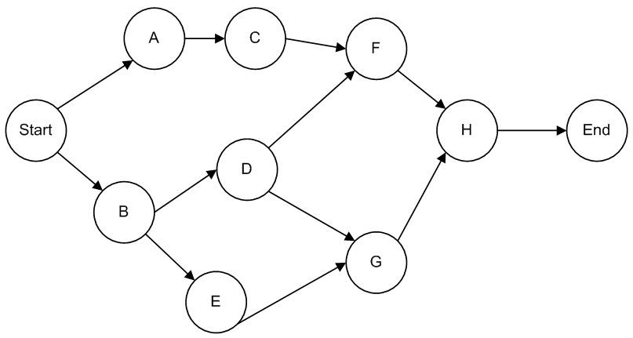

Activity | Earliest  Start | Earliest  Finish | Latest  Start | Latest Finish | Slack
A | 0 | 3 | 6 | 9 | 6
B | 0 | 4 | 0 | 4 | 0
C | 3 | 9 | 9 | 15 | 6
D | 4 | 13 | 4 | 13 | 0
E | 4 | 10 | 7 | 13 | 3
F | 13 | 19 | 15 | 21 | 2
G | 13 | 21 | 13 | 21 | 0
H | 21 | 30 | 21 | 30 | 0

Critical path is B—D—G—H, and project completion time is 30 weeks.
Reference: Planning Projects
Difficulty: Moderate
Keywords: early and late start and finish times, critical path, completion time
AACSB: Analytic skills

149) Consider the activities, durations, and predecessor relationships in the following network. Draw the network and answer the questions that follow.

Activity Description | Immediate  Predecessor(s) | Optimistic  (Weeks) | Most Likely  (Weeks) | Pessimistic  (Weeks)
A | --- | 4 | 7 | 10
B | A | 2 | 8 | 20
C | A | 8 | 12 | 16
D | B | 1 | 2 | 3
E | D, C | 6 | 8 | 22
F | C | 2 | 3 | 4
G | F | 2 | 2 | 2
H | F | 6 | 8 | 10
I | E, G, H | 4 | 8 | 12
J | I | 1 | 2 | 3

a. What is the expected time for activity B?
b. What is the variance for activity B?
c. Based on the calculation of estimated times, what is the critical path?
d. What is the estimated time of the critical path?
e. What is the activity variance along the critical path?
f. What is the probability of completion of the project before week 42?
Answer:
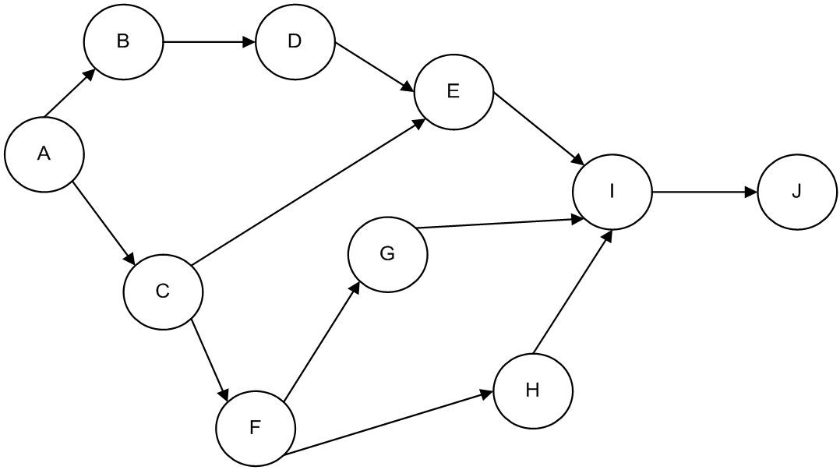

a. $t_{e}$ = $\frac{a+\text{ 4}(m)+b}{6}$ = 9 weeks
b. $σ^{2}$ = ${\left[\frac{(b\text{ - }a)}{6}\right]}^{2}$ =${\left[\frac{(2\text{0 - 2})}{6}\right]}^{2}$ = 9.00
c. A—C—F—H—I—J
d. 40 Weeks
e. 1 + 1.78 + .11 + .44 + 1.78 + .11 = 5.22
f. z = $\frac{{\text{T - T}}_{e}}{\sqrt{σ^{2}}}$ = $\frac{\text{42 - 40}}{\sqrt{5\text{.}\text{22}}}$ = .875; therefore, the probability from the standard normal table is approximately .81. Note that the variability of some non-critical path activities is large. Consideration might be given to those paths.

Activity | a | m | b | Expected  Time | Variance
A | 4 | 7 | 10 | 7 | 1
B | 2 | 8 | 20 | 9 | 9
C | 8 | 12 | 16 | 12 | 1.78
D | 1 | 2 | 3 | 2 | 0.11
E | 6 | 8 | 22 | 10 | 7.11
F | 2 | 3 | 4 | 3 | 0.11
G | 2 | 2 | 2 | 2 | 0
H | 6 | 8 | 10 | 8 | 0.44
I | 4 | 8 | 12 | 8 | 1.78
J | 1 | 2 | 3 | 2 | 0.11

Reference: Planning Projects
Difficulty: Moderate
Keywords: expected time, variance, probability, activity, critical path
AACSB: Analytic skills

150) The following table contains a list of activities, with early- and late-start and finish times and crash costs for the network shown in the figure. All start and finish times and crash costs are on a per-week basis. Each activity can be reduced by one week at the most.
a. Determine the uncrashed activity lengths for activities A though K.
b. Determine the minimum completion cost for this project if each week carries a fixed cost of $1,000.

Activity | ES | EF | LS | LF | Crash Cost/week
A | 0 | 5 | 0 | 5 | $1,100
B | 5 | 9 | 13 | 17 | $250
C | 5 | 11 | 5 | 11 | $1,200
D | 0 | 6 | 1 | 7 | $350
E | 6 | 10 | 7 | 11 | $900
F | 9 | 14 | 17 | 22 | $875
G | 11 | 17 | 16 | 22 | $1,500
H | 11 | 18 | 11 | 18 | $500
I | 18 | 26 | 18 | 26 | $300
J | 17 | 21 | 22 | 26 | $625
K | 26 | 34 | 26 | 34 | $750

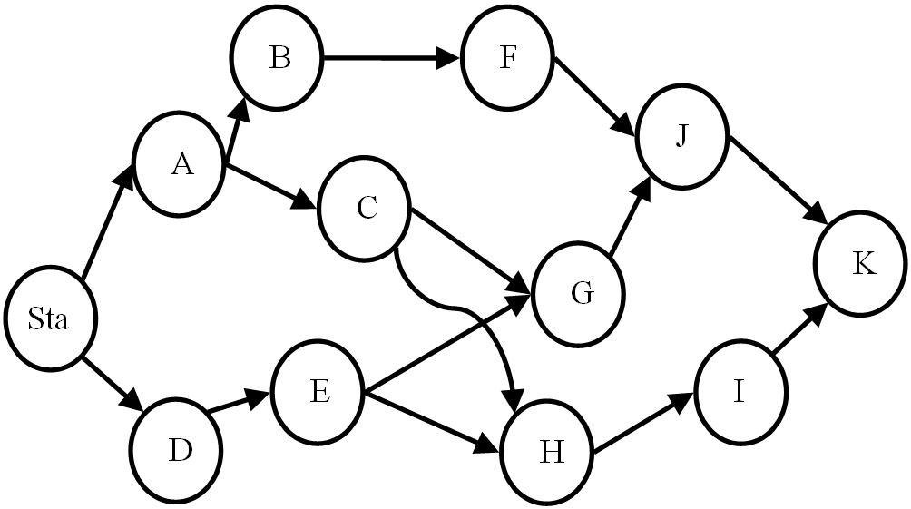

Answer: Activity lengths for A-K can be found by subtracting the early start of each activity from the late start of each activity.
The activity lengths appear in this table:
a.
Activity | Length | LS | LF | Crash Cost/week
A | 5 | 0 | 5 | $1,100
B | 4 | 13 | 17 | $250
C | 6 | 5 | 11 | $1,200
D | 6 | 1 | 7 | $350
E | 4 | 7 | 11 | $900
F | 5 | 17 | 22 | $875
G | 6 | 16 | 22 | $1,500
H | 7 | 11 | 18 | $500
I | 8 | 18 | 26 | $300
J | 4 | 22 | 26 | $625
K | 8 | 26 | 34 | $750

b.
The critical path is ACHIK = 34 weeks. Other paths are DEHIK = 33; ACGJK = 29; DEGJK = 28; and ABFJK = 26. With a fixed cost of $1,000/week, the initial cost is 34 weeks @ $1,000 = $34,000.
The cheapest critical-path activity is I @ $300, so reducing I from 8 weeks to 7 weeks costs $300 but saves $1,000, resulting in a net savings of $700.
The next cheapest critical-path activity is H @ $500, so reducing H from 7 weeks to 6 weeks costs $500 but saves $1,000, for a net savings of $500.
The next cheapest critical-path activity is K @ $750, so reducing K from 8 weeks to 7 weeks costs $750 but saves $1,000, for a net savings of $250.
The other two activities on the critical path are more expensive to crash than the penalty cost, so the cheapest completion time is 34 weeks - 3 weeks (I, H, K) = 31 weeks for a cost of $31,000 plus the crash costs of $300 + $500 + $750 = $32,550.
Reference: Planning Projects
Difficulty: Moderate
Keywords: activity crashing, early and late start and finish times
AACSB: Analytic skills

151) The following table contains a list of activities, with precedence requirements and crash costs. All start and finish times and crash costs are on a per-week basis.
a. Determine the project cost and duration without crashing.
b. Determine the least expensive project cost if the duration is to be 10% shorter than normal project duration.
c. Determine the least expensive project cost if the duration is to be 20% shorter than normal project duration.
d. Create a graph that shows project expediting cost plotted as a function of the reduction in project duration.

Activity | Normal Time | Crash Time | Normal Cost | Crash Cost | Predecessor
A | 10 | 7 | 2000 | 2600
B | 12 | 8 | 1500 | 2000 | A
C | 16 | 12 | 2200 | 3000 | A
D | 8 | 7 | 2500 | 3000 | B
E | 13 | 10 | 1950 | 2275 | C
F | 9 | 8 | 800 | 1000 | D
G | 24 | 29 | 3650 | 4000 | E, F
H | 17 | 14 | 1200 | 1800 | G

Answer:
a. Crash costs per week are shown in the table. The uncrashed project duration is 80 weeks at a cost of $15,800.

Activity | Normal Time | Crash Time | Normal Cost | Crash Cost | Crash cost/week
A | 10 | 7 | 2000 | 2600 | $ 200
B | 12 | 8 | 1500 | 2000 | 125
C | 16 | 12 | 2200 | 3000 | 200
D | 8 | 7 | 2500 | 3000 | 500
E | 13 | 10 | 1950 | 2275 | 108.33
F | 9 | 8 | 800 | 1000 | 200
G | 20 | 15 | 3650 | 4000 | 70
H | 17 | 14 | 1200 | 1800 | 200

b. The least expensive way to reduce the project duration by 10% (eight weeks) is by crashing activity G by five weeks at a cost of $70 per week, followed by activity B for three weeks at a cost of $125 per week. The total cost of the 72 week project is $725 extra, or $16,525.

c. Reducing the project by 20% from normal duration requires the actions indicated in part b, plus these actions. The reduction of activity B by another week for $125, activity A by three weeks at $200/week, activity H for three weeks at $200 per week, and activities E and F for one week each at $108.33 and $200 respectively. The total cost for the 64 week project is $2358.33 above the normal cost, or $18,158.33.

d.
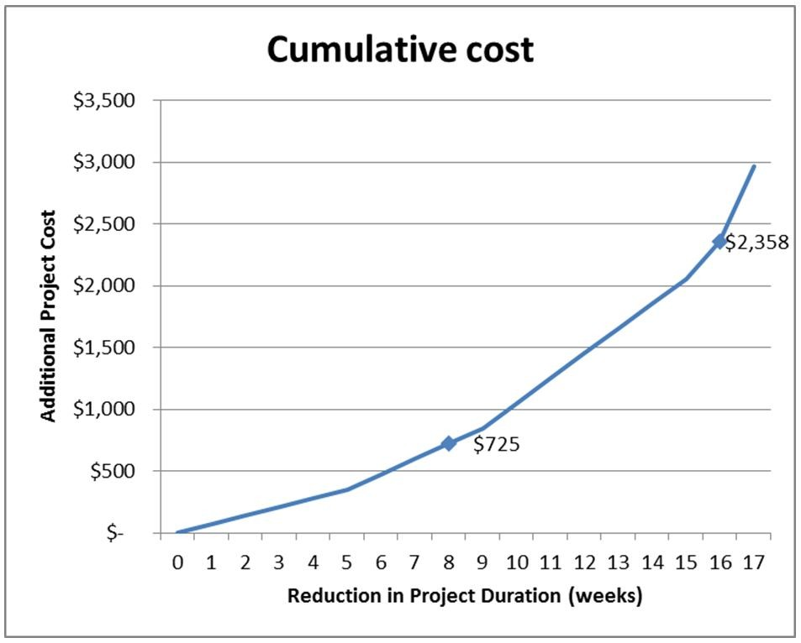
Reference: Planning Projects
Difficulty: Moderate
Keywords: activity crashing, early and late start and finish times
AACSB: Analytic skills
152) Consider a project that consists of three consecutive activities of equal length as shown in the network diagram. The project manager would like to complete the project as quickly as possible and realizes that the diagram's logic is misleading. Instead of waiting until activity A is completed before activity B can begin, he can actually begin activity B once activity A has begun. The same reasoning holds for the relationship between activity B and activity C. The project manager decides to divide each activity in half, a technique known as "laddering". The second diagram shows the new network logic. In this diagram, activity A is divided into activity A1 and A2 where A1 must be finished before A2 can begin and before B1 can begin. The manager still isn't satisfied with the completion time of the project. Derive an expression or draw a diagram that demonstrates the fastest possible completion time of the project.

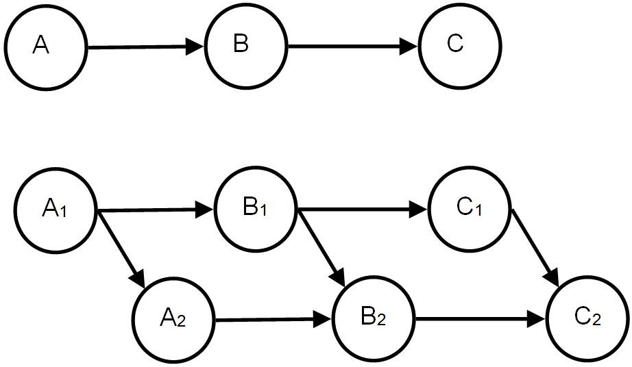

Answer: The original length of the project is A+B+C. When laddering is performed the first time, the project length becomes A1+B1+C1+C2; this is because A2 can be performed concurrently with B1 and B2 can be performed concurrently with C1. Alternatively, you can choose to focus on the completion of activity A and indicate that the new project length is A1+A2+B2+C2 (or even A1+B1+B2+C2).
If the activities are divided again, the project length will be A1+B1+C1+C2+C3+C4; because A2, A3, A4, B2, B3, and B4 can be performed concurrently with other activities.
In general, the project can be viewed as the length of C plus the waiting time while completing the length of subdivided activities A and B. As the number of iterations of laddering these activities becomes large, the length of sub-activity A1 and B1 becomes small, effectively reducing project length to the length of activity C.
Expressed mathematically where P is the project length:

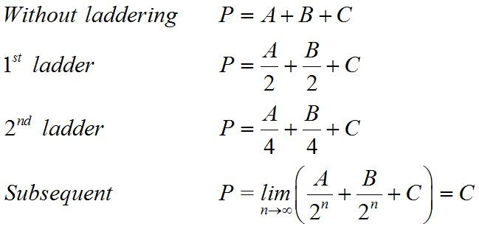

A Gantt chart showing two halvings of the activities is shown below. The three activities were 4 days long before laddering and are now are effectively twelve activities that are each one day in length.

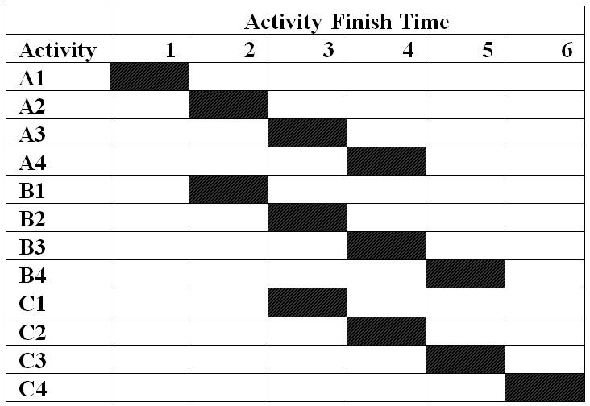
Reference: Planning Projects
Difficulty: Hard
Keywords: critical path, project length, activity crashing
AACSB: Analytic skills

153) Phoebe B. Beebee is constructing a canal for the annual canoe races and has identified eleven activities that are required to complete this important project. She calculated early and late start times and early and late finish times but spilled coffee all over her printout. Use the remaining information to reconstruct the table for Phoebe B. Beebee and her new canoe canal.

Activity | Predecessor | Length | Early Start | Late Start | Early Finish | Late Finish
A | -- |  |  |  | 12
B | A | 20
C | A
D | B, E |  |  | 42
E | C |  | 28 |  |  | 42
F | E |  | 42 |  | 50
G | D |  | 53 | 53
H | G |  | 70
I | G |  |  | 72
J | F | 4
K | H, I, J |  |  | 81 |  | 91

Answer: The completed table appears below:

Activity | Predecessor | Length | Early Start | Late Start | Early Finish | Late Finish
A | -- | 12 | 0 | 0 | 12 | 12
B | A | 20 | 12 | 22 | 32 | 42
C | A | 16 | 12 | 12 | 28 | 28
D | B, E | 11 | 42 | 42 | 53 | 53
E | C | 14 | 28 | 28 | 42 | 42
F | E | 8 | 42 | 69 | 50 | 77
G | D | 17 | 53 | 53 | 70 | 70
H | G | 11 | 70 | 70 | 81 | 81
I | G | 9 | 70 | 72 | 79 | 81
J | F | 4 | 50 | 77 | 54 | 81
K | H, I, J | 10 | 81 | 81 | 91 | 91

Reference: Planning Projects
Difficulty: Hard
Keywords: critical path, network, early and late start and finish times
AACSB: Analytic skills

